THE SPOTLIGHT
M S U D E P A R T M E N T O F C O M M U N I C A T I O N

- S U M M E R 2 0 2 2 •

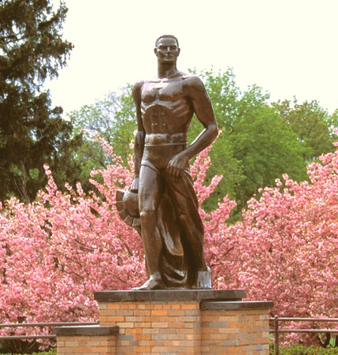

W H A T ' S I N S I D E

Scholarship Recipients

Concentrations in Comm

A Faculty Member's Musical Journey

M O ' S M E G A P H O N E

We have closed out fiscal year 2022! We started this school year by coming back in person (though masked), returning to online teaching in January of 2022, coming back in person with a “masks in classrooms only” policy, and ending the summer with in-person teaching without masks. Wow—that’s exhausting to even type up.

Suffice it to say that the entire COMM family is looking forward to normality at MSU. The problem is that we don’t know what “normal” is. And I do not think we should expect to.
Things have changed in academia. So, I recommend that we all take a deep breath and understand that we are walking into some unfamiliar territory. The thing that will not change is our dedication to training the next generation of communication practitioners!
And you can expect that we are going to double down on engaging our alumni with in-class lectures, meet and greets, and career talks.

We have a great issue for you! You will get to meet and learn about our awesome scholarship winners and you will meet Sadie who has been leading the Undergraduate Communication Association. You will see students who have flourished in our wide variety of concentrations within the department and learn about Jim Dearing’s passion for music and providing guidance to musicians. All of that and then some is packed into this newsletter! We hope you enjoy reading it.

That’s all for now,

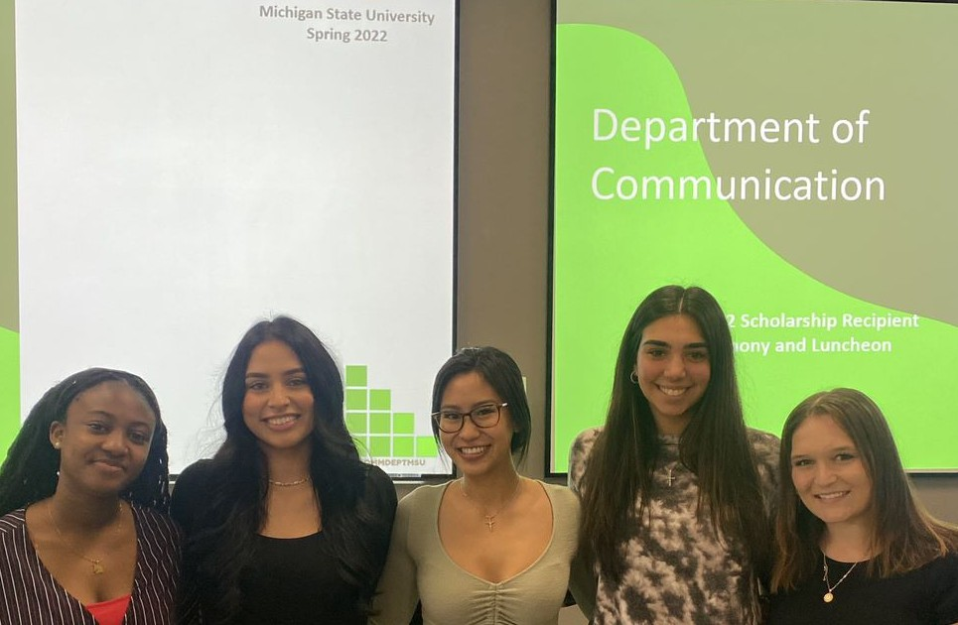
A N I N T E R V I E W W I T H S C H O L A R S H I P W I N N E R , M E G A N C U R R I E
THE SPOTLIGHT • SUMMER 2022

What does being a scholarship recipient mean to you?

I feel both lucky and very appreciative to be awarded this scholarship. Winning this award allows me to further my education and passion for learning communication and sales through ComArtSci, growing as both a student and young professional in the classroom and through professional development opportunities. This year, I am looking forward to getting a “hands-on” experience through the remainder of my degree with the addition of an internship. Without ComArtSci, I wouldn’t have been able to take the steps while in the classroom necessary to prepare me for this immersive experience, I’m excited to get to directly apply what I’ve been learning throughout my education to my internship experience.

What are your favorite aspects of being in ComArtSci?

One of my favorite aspects of being in ComArtSci is meeting so many different people among a variety of majors.
ComArtSci offers a wide range of areas to study, whether it’s communication, public relations, or communicative sciences and disorders, so I love hearing about what my peers are studying and why they’re so passionate about it. None of these majors would be possible without the passionate professors who lead them. They all care about their students and want to see them succeed, while also offering other amazing opportunities to participate in along the way. Something else I really enjoy are the different extracurricular opportunities available to students through ComArtSci. Extracurriculars are such a great way to both meet people and get involved, and ComArtSci offers so many different student groups. Whether honors societies for the different majors, the various undergraduate associations, or the plethora of other clubs that are offered, they allow students to grow in ways different than in the classroom. They provide a more immersive, hands-on experience, and all of the opportunities are unique to whichever club it is! I love learning about and seeing flyers around the building for what the different student groups are up to!

2 0 2 2 S C H O L A R S H I P R E C I P I E N T S

I am a junior studying Organizational and Intercultural
Communication with a minor in Sales Leadership. I am also the president of the Undergraduate Communication Association. Coming from an immigrant family from Vietnam, I am the first college student in my family.
I grew up as a Michigan State fan. My whole family went to MSU so it has always been my dream school. I am currently a junior studying Communication with a minor in Communicative Science Disorders.
One day, I hope to become a speech pathologist.
I am junior pursuing a bachelor's degree in Communication. I enjoy volunteering my time in my community, spending time with my family, and furthering my education with any opportunity provided for me. My future goal is to work as a news analyst for either NBC or CNN.

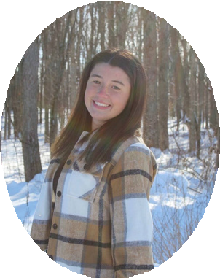
Kori Kloostra
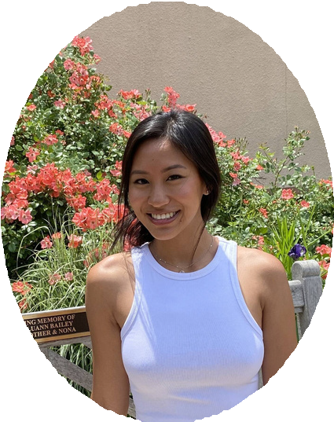
Sadie Nguyen
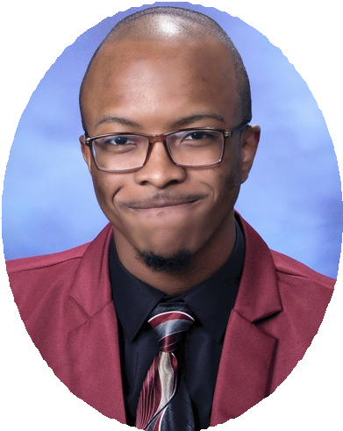
Eli Daniel

2 0 2 2 S C H O L A R S H I P R E C I P I E N T S
I am a first-year Health and Risk Communication graduate. I am pursuing this graduate degree to combine my passion for communication and health.
I enjoy advocating on behalf of audiences and helping those in need with grant proposals.

My name is Marissa and
I am a Junior at MSU. I am majoring in Communication and minoring in Public Relations. I enjoy hanging out with friends and family and being involved with the community. I have been an MSU fan my whole life and enjoy the Spartan pride.
I am a junior from Maryland studying communication with a double concentration in interpersonal and health communication along with a minor in sales leadership. I proudly work as a tour guide for the university and am a member of the Honors College. In my free time, I enjoy playing the ukulele, reading, spending time with my family and friends, and going to the beach! I am so grateful to have received this award to continue my academic pursuits!

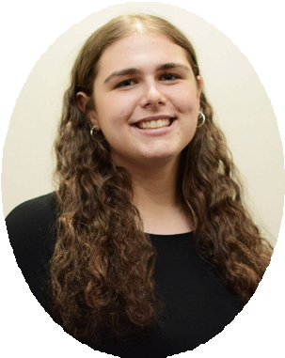
Marissa Rosen
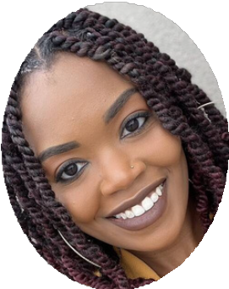
Regina Anderson
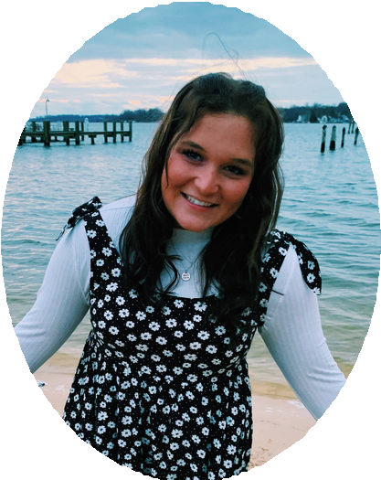
Megan Currie

2 0 2 2 S C H O L A R S H I P R E C I P I E N T S
My name is Xamantha Palomino and I will be an entering
Sophomore at MSU in 2022. I am a hard worker and I have a passion for working in the community. I am so excited to further my education and be able to start my career once I graduate college.
I am a 17 year old. I am from Nigeria, and I am majoring in Communication with a minor in E&I. I am one of the student leaders of the RSO, Bridges, and I just recently joined the
honors college. I am a Christian and a member of the fellowship CRU on campus. I am very skilled in hair braiding and I enjoy talking, baking, cooking, reading novels, and watching movies.
My name is Kayla Arafat and I am majoring in Communication and minoring in Communicative Sciences and Disorders. My end goal is to become a Speech Language Pathologist.
I recently joined MSU Telecasters where I am a part of the Beaumont Bulletin team. Aside from school-related activities, I
love playing soccer, basketball, golf, and running. About two years ago, I began coaching my former high school’s boys’ soccer team, and I have found a true passion in coaching. Hopefully one day I can incorporate that passion into my life.
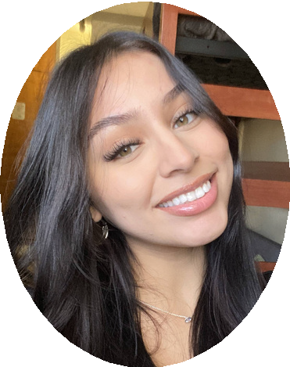
Xamantha Palomino
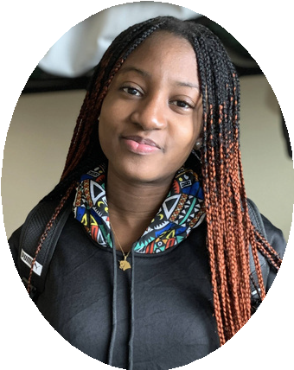
Toluwalase Awosika
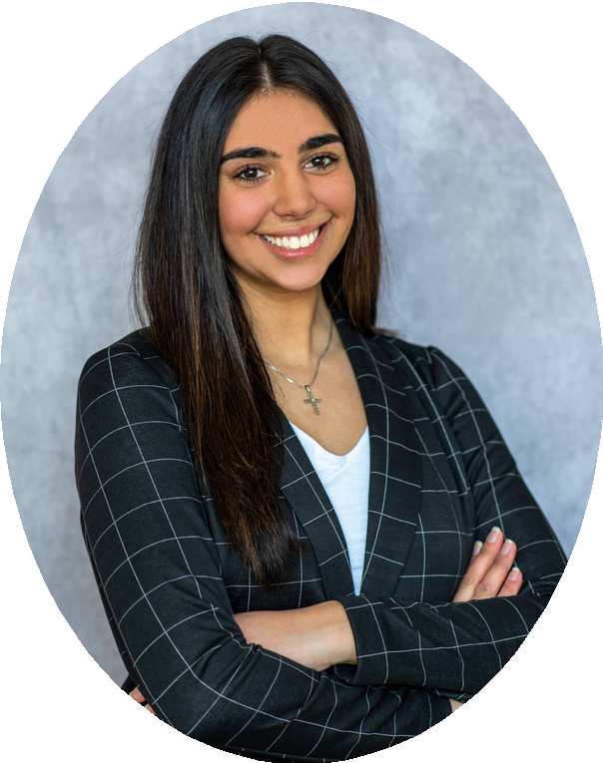
Kayla Arafat
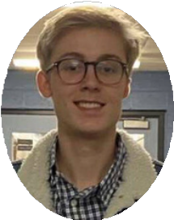
Reid Packan

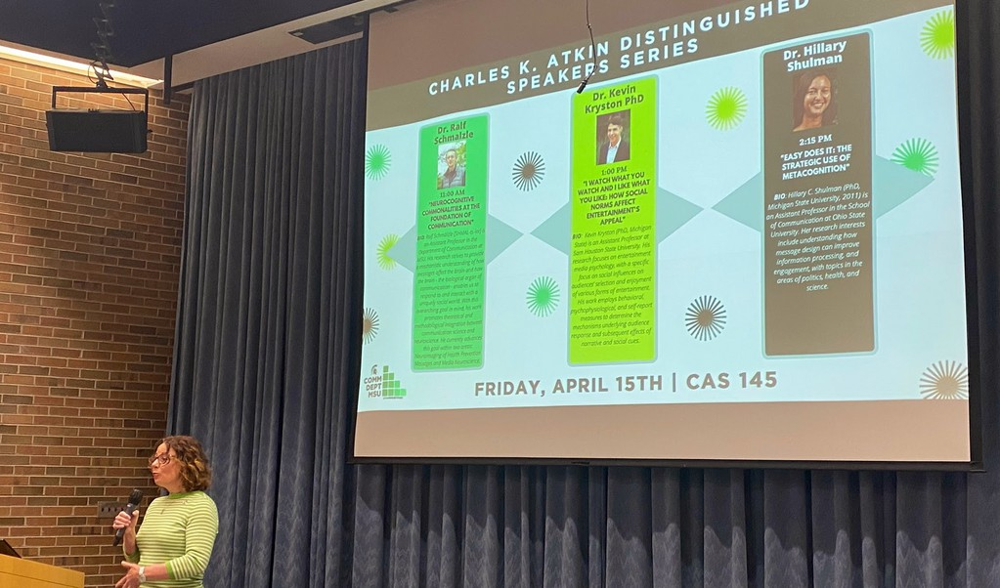
C H A R L E S K . A T K I N
D I S T I N G U I S H E D S P E A K E R S E R I E S

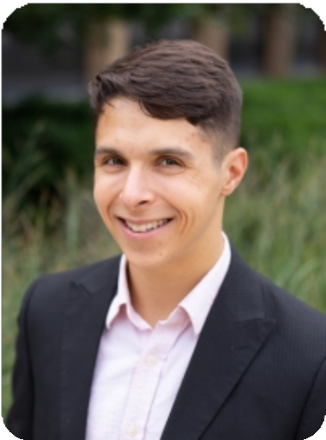
We spoke to Dr. Kevin Kryston about his experience with Charles Atkin and the Distinguished Speaker Series.

"Charles Atkin had a profound positive impact on the MSU Communication community. Though I did not have the privilege to know Dr. Aktin, I know from experience as a graduate student that his kindness, care, and commitment to top-notch scholarship live on through the department’s faculty, staff, and students. As such, the opportunity to present my research, which examines social cues’ influence on entertainment selection and enjoyment, as part of a colloquium bearing Dr.
Atkin’s namesake was a special honor, as was the opportunity to rekindle friendships, have meaningful research discussions, and learn about Drs. Shulman and Schmälzle’s exciting and innovative work. I sincerely hope that I can leave the same positive impact on others as the MSU Communication Department left on me, and I hope the 2022 Atkin Distinguished Speaker Series won’t be my last return to East Lansing!" - Dr. Kryston
DR. KEVIN KRYSTON

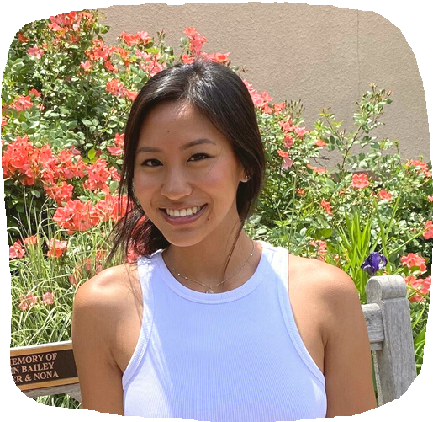
T H E M S U U N D E R G R A D U A T E
C O M M U N I C A T I O N A S S O C I A T I O N
A N I N T E R V I E W W I T H S A D I E N G U Y E N , U C A P R E S I D E N T

The Undergraduate Communication Association is the defining voice of students pursuing communication studies within the college of Communication Arts and Sciences. Our goal is to provide education, leadership, assistance, and unique opportunities to students as they prepare for careers within the communication field. The UCA does this by providing resources, seminars, and advice on topics like graduate school, career preparation, job searches, and internships. We organize opportunities for communication students, and welcome students of all disciplines, to further their crucial networking skills by getting to know the faculty, peers, and alumni.

As a freshman, I had absolutely no idea of what I imagined my career to be after college. After doing some research into MSU, I soon recognized the notability of the Communication department. The skills that I would be learning in Communication would prepare me with the foundational elements that are required in any industry or role. Therefore, I decided to study Communication because of its broad opportunities, and added concentrations in intercultural and organizational communication. I chose to study intercultural communications because of my passion for diversity, equity, and inclusion, which has become a huge value to many companies across the globe. I was interested in organizational communication because of the
crucial role of communication within organizations or companies. By combining these interests, there are vast opportunities for me once I graduate.
My role as president of UCA has been to re- energize our student organization. Working alongside fellow executive board members to bounce ideas off one another while building excitement among us all has been the greatest joy. We are a leadership team, but I have also developed some leadership skills of my own along the way such as how to be an effective communicator to my peers, how to stay informed and be a pillar of information for our members, and how to encourage enthusiasm to my audience. This position is my first executive board position, and as a freshman, I never would have imagined myself as president of a student organization. I believe I’ve come a long way since then, and this position has and continues to help me grow in my leadership and interpersonal skills. One piece of advice I would give to undergraduates first starting in Communication is to fully step into what you are learning and recognize how it relates to you or your experience. While that helps you understand the course materials much better, it also helps you recognize your communication style or effectiveness, so that you can personally grow. Because this is such a great program, take advantage of the information and knowledge that you are being exposed to, and make it relevant to yourself!

C O N C E N T R A T I O N S I N C O M M U N I C A T I O N
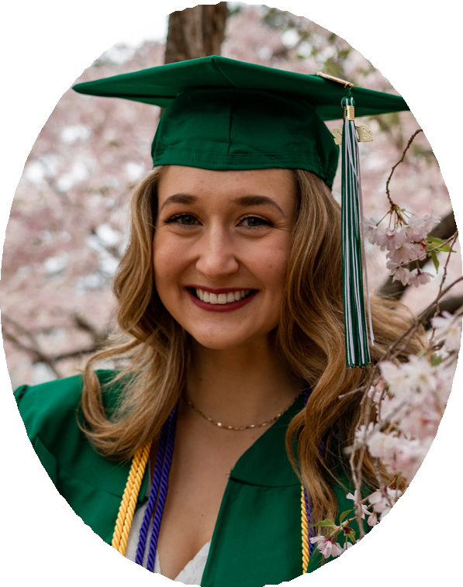
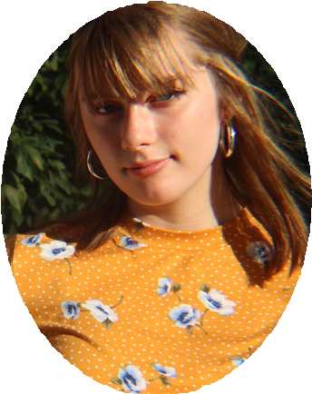
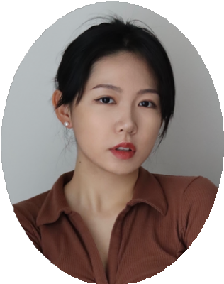

Being in the Health Communication concentration has given me the opportunity to learn more about how various populations can be reached in order to promote greater health in the community. This has prepared me for grad school in Communicative Sciences and Disorders, where I will need to know how to effectively communicate with my patients and their families so that I can provide them with knowledge on their treatment options.
- SIRI NICOL

I am concentrating in both Science, Analytics and Research Methods as well as Organizational Communication. In my classes, I have learned to solve communication-related problems through a mostly quantitative lens, allowing me to analyze issues and find the right solutions that are backed up by real data.
Specifically, in one of my research-focused classes, MI 355, I am soon going to conduct my own study to analyze the impacts of stereotypical media depictions of transgender people. In addition, Dr. Miller, who taught my Intro to Organizational Communication class, has asked me to help him conduct research surrounding employee appraisal interviews! Having declared both of these concentrations has allowed me to explore the aspects of communication science that I am most comfortable with, as well as participate in the solving of real-world problems.
- JILLIAN PLANT

Personally speaking, studying Interpersonal Communication is a journey to reflect on your past relationships and simultaneously explore your future. I am glad that I learned much practical knowledge from the courses, ranging from methods to manage conflicts and the strategies to maintain relationships to the rules of setting up communication privacy.
By achieving this knowledge from these diverse aspects, a variety of my relationships with others are refined, such as family member relationships and friendships. My communication with my mother tended to be lower quality but now changed to be more patient and conflict-avoiding. Overall, it is both a pleasure and a meaningful experience studying within the Interpersonal Communication concentration.
- ZIHAN SUN

C O N C E N T R A T I O N S I N C O M M U N I C A T I O N
(CONTINUED)
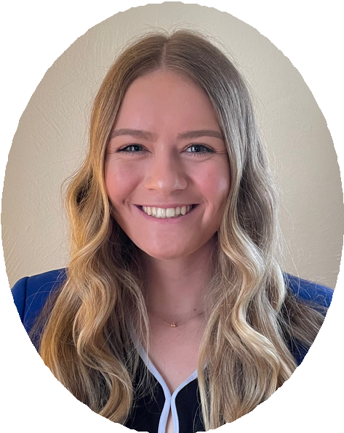
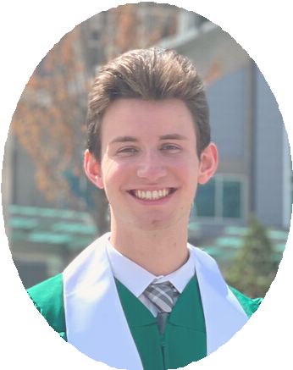
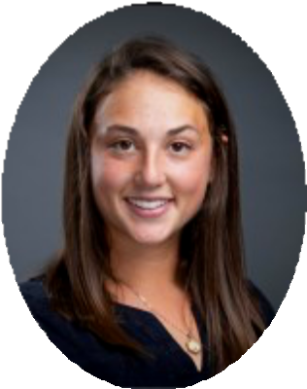

I decided to study Interpersonal Communication because I love working with people. These last four years at Michigan State have taught me how to communicate with so many different groups of people in order to benefit everyone involved. The pandemic has really furthered the importance of face-to-face interactions, and I feel as though I know
how to navigate those conversations better than ever. I believe this degree has prepared me immensely for my postgraduate career. Go Green forever!
- LIZZY VERDUZCO

Being in the Mediated Communication concentration, in addition to the Interpersonal Communication concentration, has taught me a plethora of skills that have set me apart on my
career path so far. Learning about media literacy in the 2020s and
how to deliver a great digital presentation were just a few elements of the fascinating Mediated courses I've taken. In addition, my Interpersonal courses have allowed me to better grasp the dynamics behind a variety of relationship types, in addition to equipping me to communicate more effectively with others whom we may not always have much in common with.
Being able to focus your studies on areas that are important to you is a great joy, so I'm very thankful for the concentrations that our college has available to us.
- JOHNNY MCGRAW
I am in the Intercultural Communication concentration and I’m so glad I picked that specific area to direct my studies. I've learned some very valuable skills dealing with how to better communicate with people from other cultures. In doing so, I have been able to make friends and collaborate with peers from multiple cultures within Michigan State University!
- LORI MACK

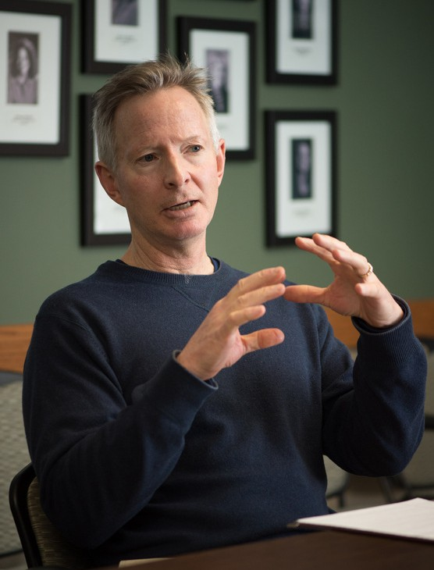

Before he was a faculty member at Michigan State, Jim Dearing was a musician and wrote the book, Making Money Making Music (No
THE SPOTLIGHT • SUMMER 2022
J I M D E A R I N G ' S
M U S I C A L A D V E N T U R E
I N T E R V I E W B Y J O H N N Y M C G R A W
Matter Where You Live). Here is our interview:

At what point in your life did you start playing? What inspired you to do so?

I began playing bongos and maracas when my four adopted Hawaiian siblings came to live with my family in California. I was very young. All the older kids would dance and play instruments for fun. Later, when my older brother was in high school, he bought a drum set and started drumming. I copied him, beginning on congas, then drums.

Were you ever in a band? What kind of music did you play, if so? What is your favorite kind of music to play / listen to in general?

In junior high school band I played the drums. Then in high school we had a talented band director. I led the percussion section in orchestra, and marching band, and played a drum set in jazz band and pep band (the latter was the small group that would play in the stands at basketball and football games along with the dancing cheerleaders). Our high school jazz band went to several competitions and did well. Then in junior college I again played drums in jazz band.

During these same years and afterward, I played drums for 5-6 rock and pop bands. We would play in backyards, at weddings, of course mostly at clubs and bars and restaurants, but I played at a few concerts too, warming up for a couple of (nationally) known bands.
The best of these bands I was in was Horsepower. We had a couple of good songwriters and several good singers. My favorite musical style to play was Latin jazz. There’s so much percussion in great Latin bands that for a drummer it’s heaven.

Does being a musician inform other parts of your life? What are your favorite aspects of being able to play music?

I don’t play drums anymore. I haven’t played for 35 years! I would love to drum again but being good at drumming always required regular (daily) practice for me. So to start again, I would need about 1-2 years of regular practice just to get to the point where I would like what I was hearing. I can hear in my head exactly what I would want to do, but execution is an entirely other thing!

One of the best aspects of playing and
performing music for me was just the closeness of a good band, both musically and relationally.
Hanging out together, travelling together, figuring out fixes to the myriad problems that always crop up whether technological, interpersonal, musical, logistical…. The rock bands I was in had roadies, electronics guys, diehard fans who all were friends.

Aside from developing other interests, I stopped playing drums because I became worried about hearing loss. I had big drum sets, all miked, with a suite of cymbals! And I was first and foremost a rock musician. My ears are ringing right now….

J I M D E A R I N G ' S
M U S I C A L A D V E N T U R E
(CONTINUED)

J I M ' S M U S I C
R E C O M M E N D A T I O N S

What specifically inspired you to write your
book, Making Money Making Music (No Matter Where You Live)?

Musical bands are teams. Teams are goal-directed groups. Many of the musicians (and managers) I worked with were skilled in certain things but not so much in other things. Like they would sometimes argue, quit, hold grudges, negotiate poorly, make poor decisions. This situation wasn’t unique to these bands! So the book that I wrote for musicians was really a small business book, very practical, to help musicians like the friends I knew to have more success with music.

While I was in my late teens and still drumming I took a terrific course at a college called Writing for Publication. I had always loved to write.
Seeing your writing published was not only exciting but it paid money. That was good because I broke a lot of drum sticks. So I started writing query letters to magazine editors, proposing story ideas. Everything I initially proposed was about being a musician because that’s what I knew something about. I sold articles to Guitar Player, International Musician, and was called the Health & Science Columnist for Modern Drummer magazine because all of the manuscripts I wrote for them were about the relationship between drumming and hearing loss, weightlifting, alcohol, tobacco smoke, poor sleep, etc (by then I was receiving shipments of free drum sticks—I’d hit the big time).
FOR JAZZ FANS: PABLO SANCHEZ, OUT OF EAST LOS ANGELES
FOR LISTENERS WHO APPRECIATE HEARTFELT LYRICS AND LOVELY
BLUEGRASS: KIERAN KANE
FOR PERCUSSIONISTS: THE MSU
MARCHING BAND PERCUSSION SECTION
FOR EVERYONE ELSE: ROSANNE CASH, JOHNNY’S TALENTED DAUGHTER

After this modest success, proposing a book, getting an advance, and then writing a book- length manuscript was very doable. The publisher put me on a minor but national interview tour. It was just prior to Christmas. The publisher had the smart idea of printing the cover in holiday colors. It sold like hotcakes, parents buying it for their kids who the moms and dads were worried about as they suffered through instrument practice coming from behind closed bedroom or basement doors.

The message of Making Money Making Music was the parenthetical note after the title (No Matter Where You Live). I showed musicians how to make a living with music without moving to L.A., Nashville, or New York City. One fan showed me his heavily dogeared copy and a photograph of his
$250,000 house that he said was all due to the ideas in that book (he made more money from the book than the author did). The book is woefully out of date now; there are a number of up-to-date guides that musicians or their parents can easily find.

S T A Y I N T O U C H !

Got some great stuff going on? Whether it be a new job, an award you've won, or just an accomplishment you're proud of, let us know! It could get shared in our next newsletter!

Follow us on our
social media!
@commdeptmsu
Here are a few
submissions from our Fall Newsletter:
Keenan Covington (grad. 2012)
VP of Marketing & Communication,
Venture for America
"My most significant accomplishment during my time at Venture For America has been helping to reenvision the role of the marketing function at the organization. Furthermore, I led us through a rebrand process that wrapped in Q2 of last year and helped garner one of the largest Fellowship application pools in VFA’s history."
Kimberly Kvorka (grad. 2010) Director, Kennari Consulting "Kennari recently won the Mentor
Organization of the Year award from GRYP
(Grand Rapids Young Professionals), calling me/my leadership out specifically as supervisor of the program."
Fill out our form here!
