THE SPOTLIGHT
M S U D E P A R T M E N T O F C O M M U N I C A T I O N

- S P R I N G & F A L L 2 0 2 3 •

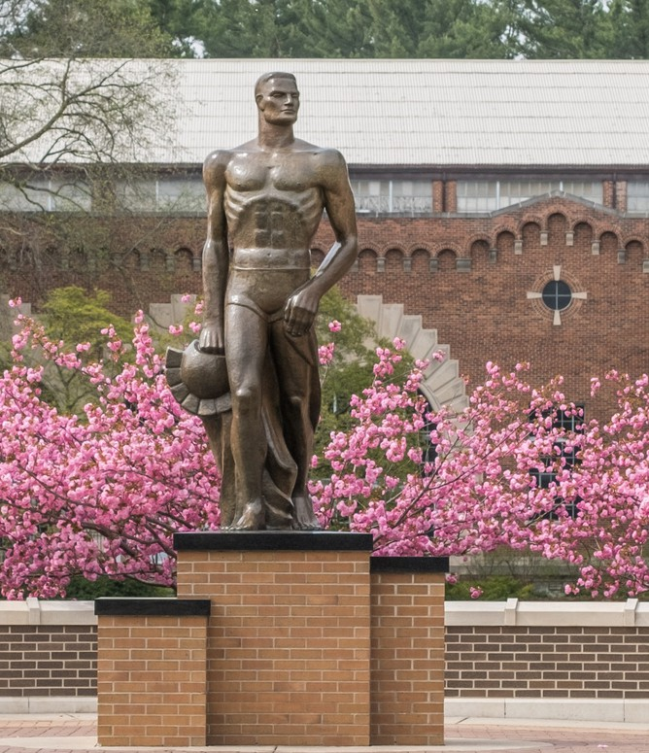
W H A T ' S I N S I D E
A Faculty Member's Prestigious Award
Our Outstanding Alumni
Undergrads Taking the Lead A Warm Welcome to our
New Colleagues

Charles K. Atkin
Distinguished Speaker Series Barbara Bryant Legacy

M O ' S M E G A P H O N E :
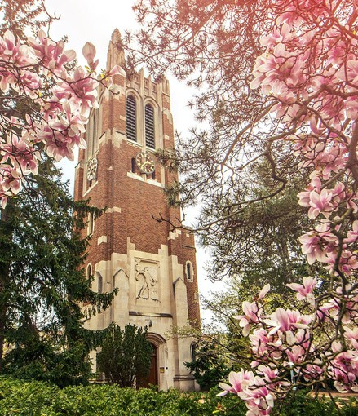
. . . . . . . . . . . . . . . . . . . . .
By Department Chair, Dr. Monique Turner
Welcome to the Spring/Fall 2023 double edition of our Department of Communication newsletter. So much has happened since we last communicated with you in January of 2023. There is no doubt that 2023 tested the strength and grit of Spartans—but we are #SpartanStrong. Through it all, we also celebrated some amazing careers and welcomed new scholars to the department! (Continued)

M O ' S M E G A P H O N E
THE SPOTLIGHT • SPRING & FALL 2023
(CONTINUED)
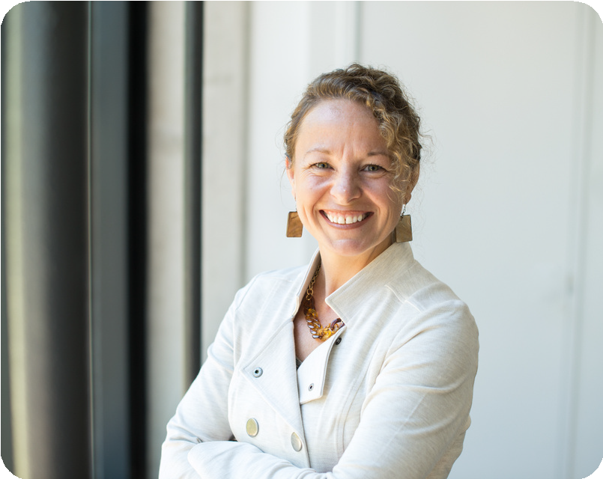
Dr. Sandi Smith, University Distinguished Professor, retired in the Spring of 2023. Since 1990 Sandi has dedicated herself to our department and particularly our students. Sandi still spends much of her time in East Lansing and is still Chairperson, as Professor Emeritus, of our awards committee.

Ms. Marge Barkman, Academic Programs Coordinator, retired in the Fall of 2023. During her 38 years here in the Department of Communication (and 46 total on campus), she has seen hundreds of graduate students through their programs. She served as a curriculum expert, but also a shoulder to lean (sometimes cry) on when the stress of graduate school was high.
We welcomed 4 new faculty members, 1 visiting professor, 1 Professor of Practice and 2 post-doctoral fellows to the department! You can read all about them in this newsletter. We are so lucky to have recruited such amazing COMMunity members to our departmental family!

It is also the case that we collectively mourned after the events of February 13, 2023. Our community lost much on that day. On February 13, 2024, we will take the day away from the classroom and remember the Spartans we lost. Forever changed, Spartans are not looking for ways to forget and move on—we are looking for ways to grow and move forward. As the Chair of the Department of Communication, that means looking for ways to acknowledge and appreciate the faculty, staff and students regularly. It means celebrating the little moments and the big ones. It means having one’s priorities, values and moral code straight.
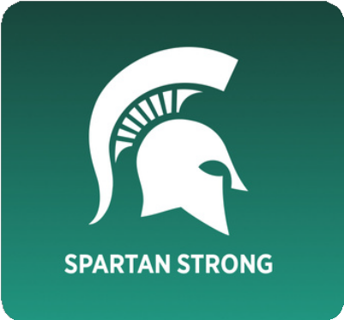
The university launched the campaign “Spartan Strong” in March of 2023. A good friend and colleague and I were talking about the campaign over lunch one day and he mentioned that Spartans are “strong enough”. Strong enough for what? you might ask. Strong enough to talk to people when they recognize the signs of depression. Strong enough to fight for change. Strong enough to call for leadership. Strong enough to put aside projects that are not as important as the people you work with. Strong enough to grow and move forward.

Please enjoy this Spring/Fall issue! We have an amazing crew here and I’m excited for you to hear what we have been up to this past year.
All my best,
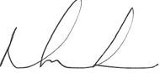
Remember of follow us on:

Facebook: @Michigan State University Communication Department Instagram: @commdeptmsu
LinkedIn: @MSU Department of Communication X: @CommDeptMSU

E X C E P T I O N A L W O R K
THE SPOTLIGHT • SPRING & FALL 2023
B E Y O N D T H E C L A S S R O O M
I N T E R V I E W B Y K E E L Y Z E I G L E R
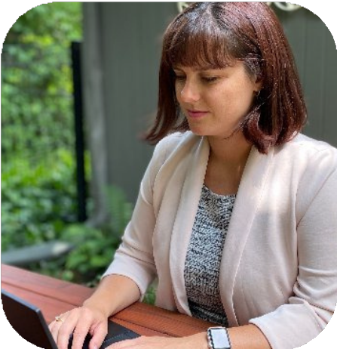
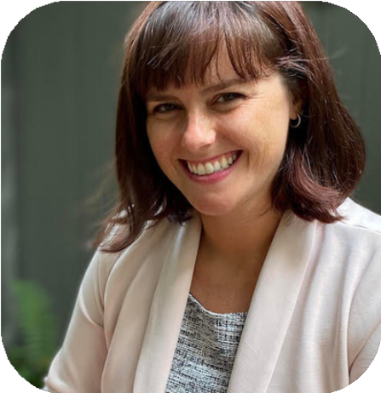

ELIZABETH DORRANCE HALL, PhD

Associate professor in the Department of Communication, Dr. Elizabeth Dorrance
Hall, was awarded an NSF CAREER award in 2023!

The CAREER Program is a prestigious initiative offered by the National Science Foundation to recognize and support outstanding early-
career faculty who have the potential to
become academic leaders in both research
and education. The program aims to empower these talented scholars to make significant
contributions to their fields, universities, and communities through their work, ultimately creating a strong foundation for continued
growth and leadership throughout their careers.

Tell us more about your NSF Career Award; what are you studying?

My CAREER award project will expand our
understanding of parent-child communication about STEM careers. The literature so far has
identified that support is important in getting kids (especially young girls) interested in STEM and sustaining that interest through school
and into their careers. As communication scholars, we know support is not just one thing – but is more nuanced. I will explore
other ways parents communicate about STEM (for example, do some parents pressure their children to pursue STEM?) and delve into
different types of support, support gaps, and
other memorable messages girls recall about STEM. An important aspect of the project is
that participants will include Black, Hispanic, and White families. The literature in our field
often does not represent voices from diverse racial/ethnic backgrounds. This project will
explore cultural and family dynamics that play a role in girls’ STEM interests and persistence
in careers.

THE SPOTLIGHT • SPRING & FALL 2023

E X C E P T I O N A L W O R K
B E Y O N D T H E C L A S S R O O M
(CONTINUED)

What does receiving this prestigious award mean to you personally and professionally? It is a huge honor. The National Science Foundation CAREER award is competitive and prestigious, so I am grateful to have received it. The CAREER award will support my team’s research and outreach
activities for 5 years. It will also support a post-doc and graduate student in our department. Part of the award is to share the findings with community members (an education component) – which is
something I strive to do with my research already. I write for Psychology Today and present at workshops to share what we know as communication scholars. I am looking forward to the
educational activities I have planned including developing a card game for families to play that will raise awareness about different STEM careers and depict women from diverse racial/ethnic
backgrounds in STEM roles.

What advice would you give to aspiring young scholars who are looking to receive a CAREER award? Are there any key strategies or
approaches that you have found particularly effective?

Write, rewrite, seek feedback, and rewrite again.
My proposal was 3 years in the making. Each year I improved my plan by adding details, finding more community partners, and honing my ideas. Join a writing group and find an accountability partner who is also working on a grant proposal. Also, be
sure to choose a topic you would be happy spending 8+ years working on!

Reflecting on your journey and the work you've done leading up to this award, what are some
key experiences or projects that you believe
played a pivotal role in shaping your decision of working within this realm of research and
ultimately led to this recognition?

My dissertation research was on marginalized
family members, or “black sheep” of the family.
Some of the women I talked to as part of that
project told me they felt marginalized from family because they were pursuing advanced degrees
and their families no longer understood them.
Instead of offering support and being proud, their parents would ask “why are you still in school
wasting money” and say “just get a job!”.
This inspired me to start a series of projects on women in traditionally male careers to learn more about the marginalization they face at
work and from their families. So far, I have completed studies on the types of
marginalization women in traditionally male careers experience, their resilience strategies, and the ability of resilience to buffer the
negative effects of marginalization at work on outcomes such as turnover intention and job stress.

With the CAREER award projects I will dig deeper, asking participants to recall
memorable messages from childhood about STEM and careers. My team and I will start off with interviews to identify types of parent
communication about STEM. We will then create a measure and model predictors of
different types of parent-STEM communication.
For example, do parents’ attitudes about science, political views, and education
background predict how they communicate
with their children about STEM? We will talk to parents, young adults, and adults well into their careers to gain a life course perspective on the role of parent communication in STEM
persistence.

THE SPOTLIGHT • SPRING & FALL 2023

A L U M N I S P O T L I G H T : C H A D W I C K " N I L E S " P H I L L I P S
INTERVIEW BY: KEELY ZEIGLER

What have you been up to since leaving Michigan State University?

CLASS OF

Since leaving MSU I went on a journey within a career in music and entertainment. Fresh off of graduation I moved to New York City to
embark on my dreams. As a result of that
ambition I won a talent search that HOT 97 put on and ended up releasing a single on a major label. I worked at BET, CBS and NYC
Fashion Week in the world of film. Then I moved to the Twin Cities and applied
everything I learned in New York to my
endeavor embarking on entrepreneurship.
Now I am the CEO of The Avant Garde music arts & entertainment production company,
along with being the founder of the Hip-Hop, History and The Arts youth artist development program.

Can you share some memorable experiences from your journey in the music industry and how your MSU education played a role in
those moments?

Within my career, I was on a major label as an artist. I was able to do business with some A-
list artists, legends and music business people that ranged from booking to hosting events. I have been able to assist many artists in
reaching goals in their careers. I also presented my first music festival last year called "On The One". My MSU education helped in a way that
it prepared me to interact with people in upper echelon settings.

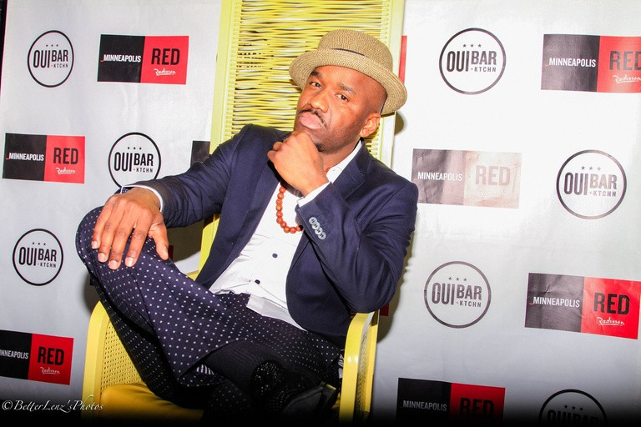
What specific skills or knowledge gained during your time at MSU have proven to be invaluable in your current role within the music industry?
THE SPOTLIGHT • SPRING & FALL 2023
MSU COMM
ALUMNI

Some of the skills and knowledge that I
have gained while I was at MSU that have been invaluable in my current role in the
music industry have a lot to do with when I evolved in my time management,
communication skills, administrative skills, creative skills and tech. All of those
elements I apply to my work to this day.

How did you navigate the transition from being a MSU alum to establishing
yourself in the competitive music industry? Any advice for aspiring professionals in this field?

I was resilient in my approach to going after my passion. I knew that I had something
special and as a result of that, I continued to work hard and pursue my aspirations
regardless of the conditions. For aspiring professionals my advice is to be patient, continue to work hard and any force that
goes against your ambition, use it for fuel.
No successful journey comes without bumps in the road. It is about learning and growing as you go. When you evolve and become
what you have always envisioned, it is an
amazing feeling. You can do it! I believe in

In what ways have you been able to leverage your MSU network and
connections to enhance your career in the music industry?

My MSU network and connections has played a major role in getting me
connected in the music industry.
Relationships are everything in business. A great example is one of my best friends is Ben Williams, a Grammy award winning bassist. We made music while students at MSU and have remained friends since. I
ended up featuring on his latest album
called "I Am A Man". We continue to work together in different capacities. It all
started from us meeting while in college. Overall my experience as a student at
Michigan State University has been a tremendous asset to my career in the music industry. I am thankful to have graduated from MSU.

Overall, how did your Communication degree from MSU prepare you for a
career in the music industry?

My Communication degree prepared me
for a career in the music industry in many ways. The different classes I took covered very diverse aspects of that I applied to
the different fields that I worked in.

you.

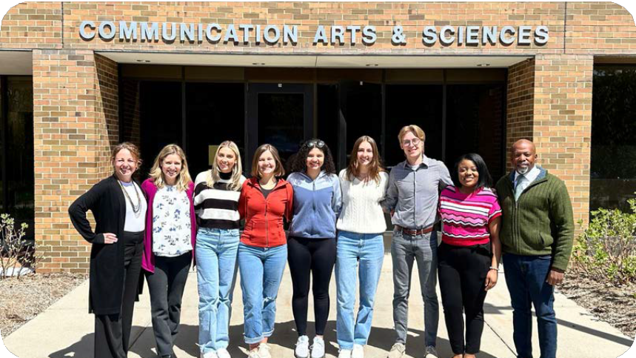
U N D E R G R A D S T A K I N G T H E L E A D
THE SPOTLIGHT • SPRING & FALL 2023

SCHOLARSHIP LUNCHEON
Left - Right: Monique Turner, Amanda Holmstrom, Keller Cowperthwaite, Brooke Larkin, Dajia Burke, Megan Mallie, Reid Packan, Ariel Foster, and
Shawn Turner

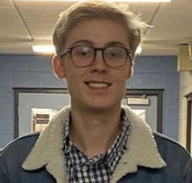
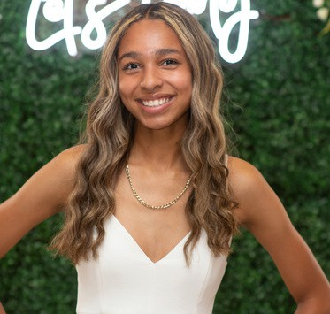
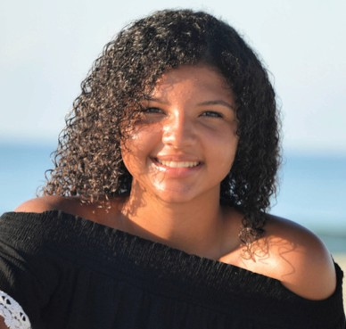
Dr. David and Patricia Nix "Miss MSU" Barron Endowed Scholarship in the College of
Communication Arts and Sciences Recipient
REID PACKAN
Diana Thornhill-Copp and David A. Copp
CAS Scholarship Recipient
WHITNEY WELLS
ComArtSci General
Scholarship Recipient
DAJIA BURKE
Brian P. O'Connor ComArtSci Endowed
Scholarship Fund Recipient
KELLER COWPERTHWAITE

THE SPOTLIGHT • SPRING & FALL 2023
U N D E R G R A D S T A K I N G T H E L E A D
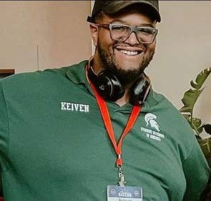
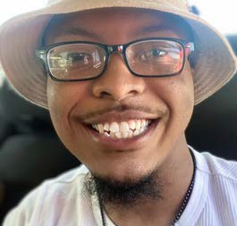
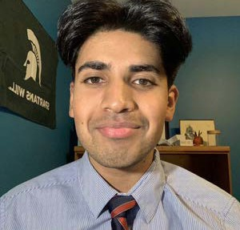
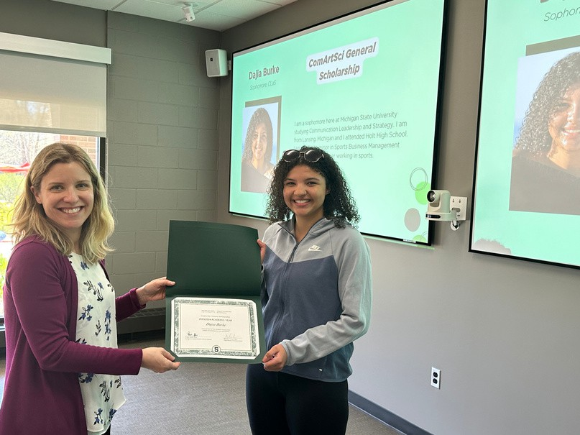
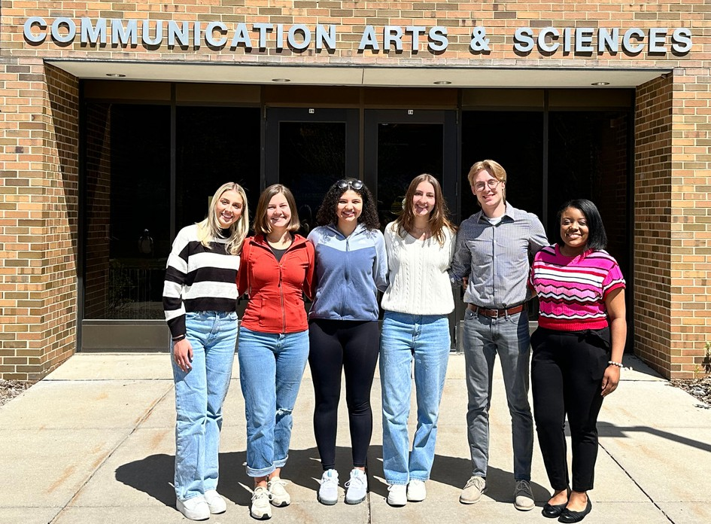
(CONTINUED)

Barbara Greiner Glass Scholarship in Communication Arts and Sciences Recipient
Glenn and Thelma Buell College of Communication Arts and Sciences Endowed Memorial Scholarship Recipients

KEIVEN COLBERT ELI DANIEL MANU SASTRY
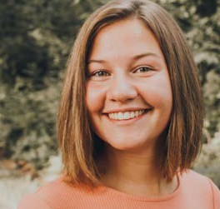
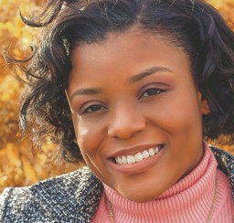
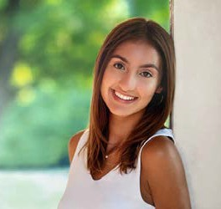
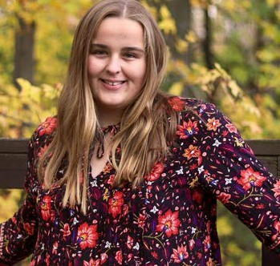

BROOKE LARKIN
Schultz Family Scholarship Recipients
ARIEL FOSTER
MEGAN MALLIE

HARLEY COOK

A W A R M W E L C O M E T O O U R N E W C O L L E A G U E S
THE SPOTLIGHT • SPRING & FALL 2023

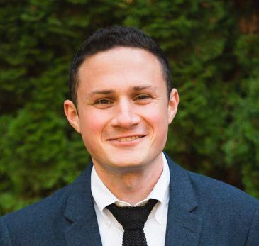
He uses language patterns from natural data bases to inter what people are thinking, feeling, and experiencing psychologically.
Dave M. Markowitz
Associate Professor
Hobbies: Playing and writing music, photography, rooting for lackluster New York sports teams (NY Giants, NY Yankees, NY Knicks), reading, skiing, and hiking

Jacob T. Fisher
Assistant Professor

His research lies at the intersection of cognitive neuroscience and media psychology, using brain imaging, behavioral and digital trace to investigate how (digital) media influences how we direct our attention, and pursue our goals.

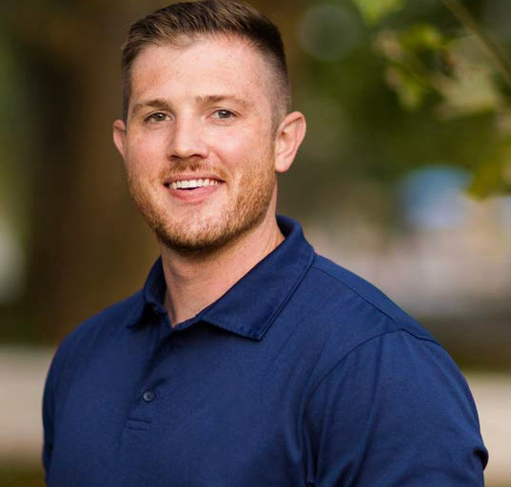
Hobbies: Cooking (and eating) food. I'm also a big music dork. I collect vinyl records and try to stay on top of new music. I enjoy building and designing things. I also like going to the gym.

Dr. Oh, specializes in AI Chatbots. Her research investigates the impact of persuasive AI on human perceptions and behaviors focusing on human perceptions, communication patterns, and the resulting persuasion and relational outcomes of human-AI interaction.
Yoo Jung Oh (Erika)
Assistant Professor

Hobbies: Love traveling, stand-up comedy, movies, and exploring diverse cuisines

A W A R M W E L C O M E T O O U R N E W H I R E S
THE SPOTLIGHT • SPRING & FALL 2023

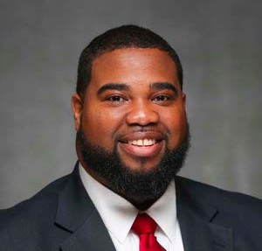
His research focuses on exploring source credibility of online messages. Recently, Professor Spates has focused on exploring the effectiveness of workplace diversity programs.
Steven A. Spates
Assistant Professor

Hobbies: Movies/TV, Music, Celtics Fan, College Football

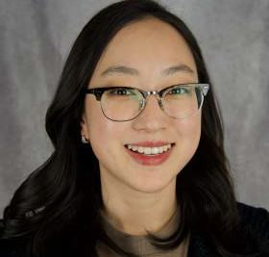
Hyesun Choung
Assistant Professor

Her projects delve into the realm of trust and ethics in AI and algorithmic decision making. Hyesun and her collaborators have initiated the Compassionate Computing Project, which leverages the capabilities of LLMs to establish a platform for advice-giving and human-AI collaborative decision-making.
Hobbies: I enjoy playing tennis.

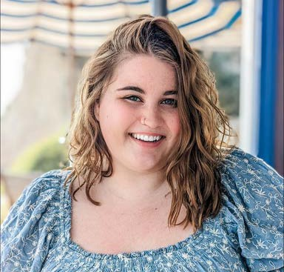
Her research agenda centers around applying elements of strategic communication within family dynamics and how family members use technology to maintain relationships with each other.
America Edwards
Research Associate

Hobbies: Gardening, thrifting, traveling

A W A R M W E L C O M E T O O U R N E W H I R E S
THE SPOTLIGHT • SPRING & FALL 2023

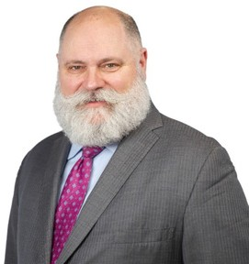
He has been a strategic communication practitioner for more than 25 years with a focus on crisis response and Management. Besides teaching, he has a passion for applied communication research in strategic and crisis communication
William Knowling
Professor of Practice

Hobbies: All things math, beekeeping, Belgian Ale, and wristwatches.

Brooke H. Wolfe
Research Associate

Her program of research focuses on how individuals historically marginalized, and underrepresented, within interpersonal, family, and health contexts engage in processes of social support and resilience as forms of resistance.

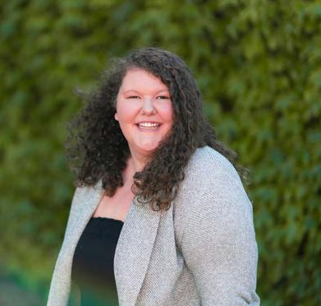
Hobbies: I love watching the WNBA, and really any sports. I also like thrifting, playing board games, traveling to see family in Finland, and trying new coffee shops/restaurants

THE SPOTLIGHT • SPRING & FALL 2023

C H A R L E S K . A T K I N
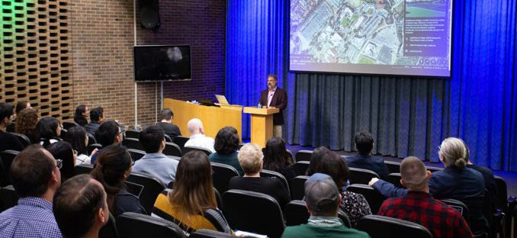
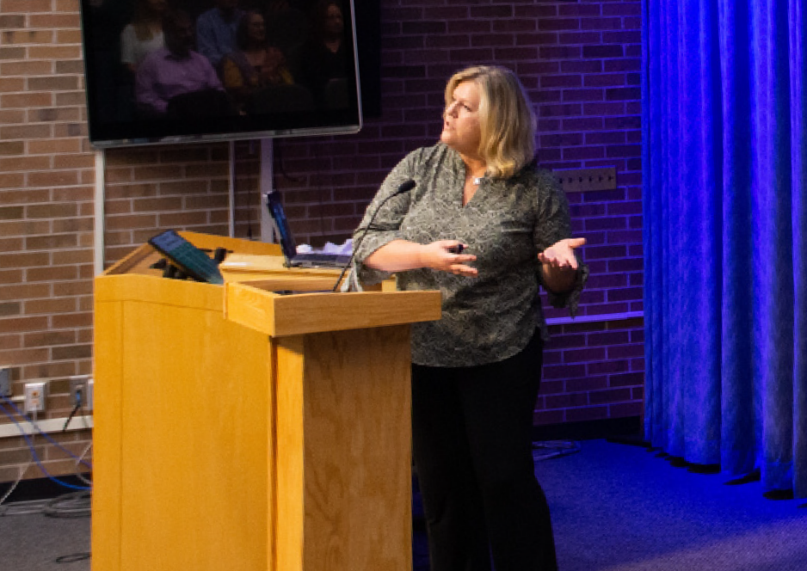
D I S T I N G U I S H E D S P E A K E R S S E R I E S
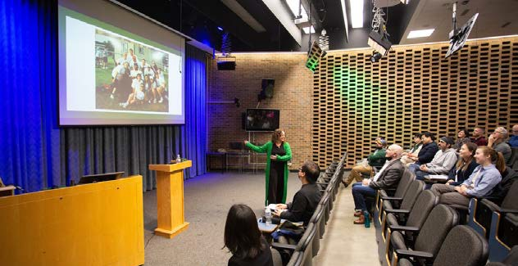
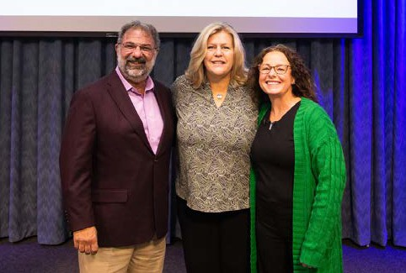
Our third annual Charles K. Atkin Distinguished speaker series occurred on October 13, 2023. We were able to hear great panels from various communication professionals from different universities. Listed below were our speakers and their topic of discussion, as well as their background.

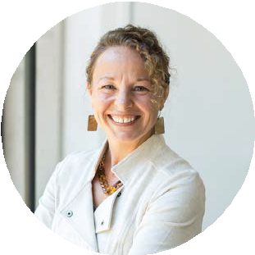
Bio: Dr. Monique Mitchell Turner is Professor and Chair of the Department of Communication at Michigan State University. Turner is trained in persuasion and employs that expertise in health and risk communication; with a particular focus on message design and evaluation, risk perception, and cognitive processing of health risk communication (including risk judgment and decision making). Turner’s main focus is on the role that emotions play in the underlying psychosocial processes explaining message effects; her work has examined the effects of guilt, shame, anger, and fear (etc…) in the cognitive impacts of public health messaging.
CAMPAIGN MESSAGES THAT ANGER AUDIENCES: A BAD IDEA?
Speaker: Monique Turner, PhD

C H A R L E S K . A T K I N
D I S T I N G U I S H E D S P E A K E R S S E R I E S
(CONTINUED)
THE BCERP RESEARCH LEGACY: MSU MEMORIES AND MILESTONES
Speaker: Kami Silk, PhD

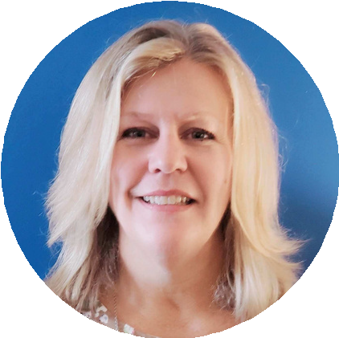
Bio: Kami Silk (PhD, University of Georgia), is the Edward F. and Elizabeth Goodman Rosenberg Professor and Chairperson of the Department of Communication, University of Delaware. She is a health communication researcher who spent 15 years at MSU as a Professor of Communication, Graduate Director of the MA Program in Health & Risk Communication, and various Associate Dean Roles in the College of Communication. Dr. Silk collaborated with both Chuck Atkin and Sandi Smith on the Breast Cancer and Environment Research Program, providing a transdisciplinary research experience for graduate students for almost 20 years. Dr. Silk will discuss BCERP communication research and its trajectory over that time frame.

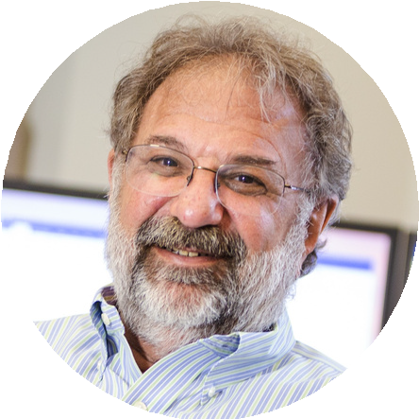
Bio: Joe Walther was a Professor of Communication and of Telecommunication, Information Systems, and Media at Michigan State University from 2006 to 2014. He holds the Bertelsen Presidential Chair in Technology and Society at the University of California, Santa Barbara, and is a Distinguished Professor of Communication. He is currently a visiting scholar at the Institute for Rebooting Social Media, in the Berkman Klein Center for Internet & Society at Harvard University. A Fulbright Scholar, Fellow of the International Communication Association, and Distinguished Scholar in the National Communication Association, his research focuses on the impact of interpersonal and intergroup dynamics in the attitudes and behaviors people develop via mediated interaction, in personal relationships, groups, and inter- ethnic conflict.
ONLINE HATE: THE THINGS WE DO FOR LOVE
Speaker: Joe Walther, PhD

B A R B A R A B R Y A N T L E G A C Y

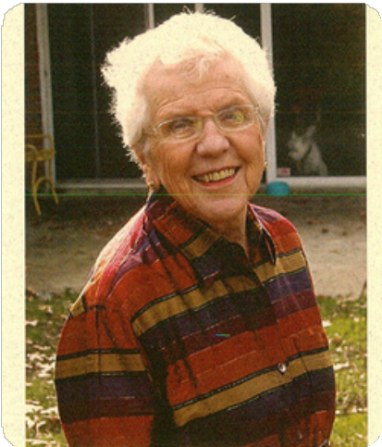
On March 3rd, 2023, Michigan State alumni Barbara Bryant passed. Bryant made history when becoming the first female director of the Census Bureau. President George W. Bush made a recess appointment to Bryant in 1989, making her the director.

While at MSU, Bryant had earned her Master’s Degree in Journalism in 1967 and a PhD in Communication in 1970. She became the first female PhD graduate in the Department of Communication.

In her early life and career, Barbara Bryant was the valedictorian of her high school and studied physics in the undergraduate program at Cornell University. Her passion of studying physics drove Bryant to become a science writer. After graduation, Barbara became a full time editor for the Chemical Engineering magazine.

Barbara Bryant became a fellow of the American Statistical Association 1998 and in 2007, she won the Warren E. Miller award for Meritorious Service to the Social Sciences at the Inter-university Consortium for Political and Social Research.
With co-author William Dunn, Barbara Bryant wrote Moving Power and Money: The Politics of Census Taking (New Strategist Publications, 1995).

Dr. Bryant’s legacy will not be forgotten here in the Department of Communication. We look to the standards she set for greatness and try to rise to those standards every day.

S T A Y I N T O U C H !

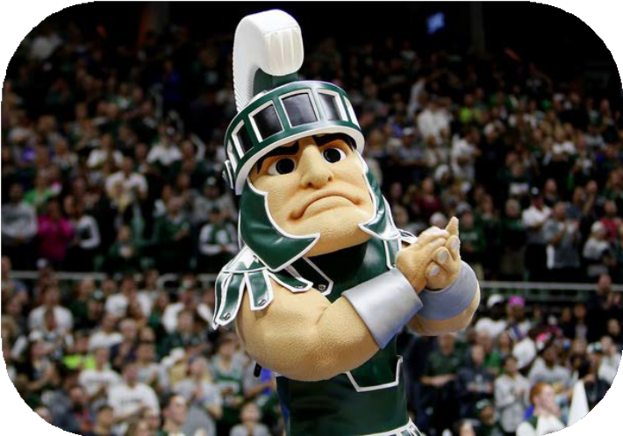
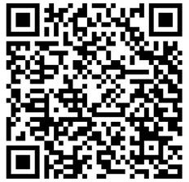
Got some great stuff going on? Whether it be a new job, an award you've won, or just an accomplishment you're proud of, let us know! It could get shared in our next newsletter!

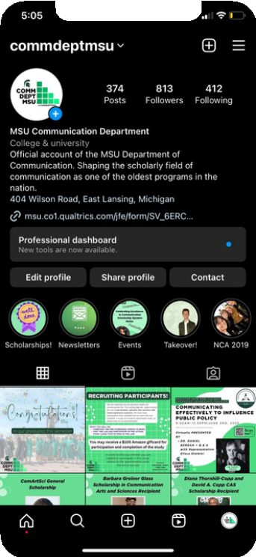
Follow us on our social media! @commdeptmsu
Here are a few submissions from our
Fall 2022 newsletter:
Kimberly Kvorka
Class of 2010
Kennari recently won the Mentor Organization of the Year award from GRYP (Grand Rapids Young Professionals), calling me/my leadership out specifically as supervisor of the program.
Lindsay Hahn
Class of 2018
I recently accepted an assistant professor position at the University at Buffalo, State University of New York! I will begin this position this fall (2020). Woot!
Fill out our form here!

