THE SPOTLIGHT
M S U D E P A R T M E N T O F C O M M U N I C A T I O N

• F A L L 2 0 2 2 •

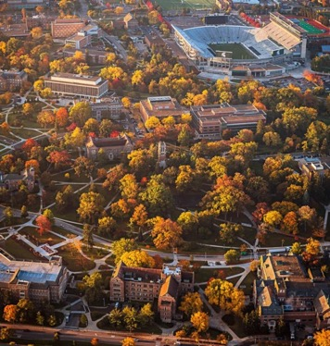

W H A T ' S I N S I D E

Our Amazing Alumni

Atkin Speaker Series

Undergrads Leading the Way

A Faculty Member's Love for Gardening

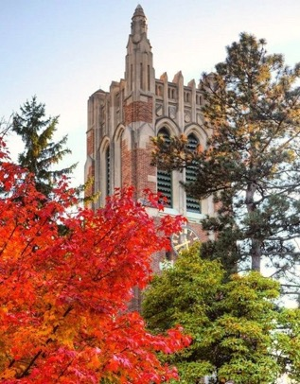
M O ' S M E G A P H O N E : T H E S I X B O X E S
By Department Chair, Dr. Monique Turner
It is Thanksgiving Day as I write this piece — and, indeed, I have much
to be grateful for. I am grateful for my spouse (Shawn Turner) and our incredible daughters (Maya and
Macy). I am grateful for my
COMMunity: our faculty, staff, and
students. And today I want to write about the gratefulness I hold in my heart for the opportunities I have
been afforded. (continued)

M O ' S M E G A P H O N E
(CONTINUED)

The first time I saw the graphic on the right, it hit me in the gut. The graphic reveals that

THE SPOTLIGHT • FALL 2022
giving everyone the same resources is fair — but not necessarily effective. Instead, leaders should focus on what is needed by each
individual to allow them to thrive. Much has been written about this graphic and its
multiple iterations. For many people, what may be needed are financial resources, free preschool, safe playgrounds and
neighborhoods, access to healthful food, or good primary schooling. Sometimes what is
needed are people who believe in you, go out on a limb for you, or simply see your potential.

In this way, I often reflect on the boxes people have given me so that I can see over the fence. I acknowledge and own the privilege I have as a White person who was raised with two
parents in a safe environment. But as a first- generation college student raised in a rural
environment, I might have needed a box or 2 to stand on. See, I attended a small, country
elementary and middle school. I had 12 people in my class—and that was the 7th and 8th
grade combined. When I moved to the public high school, I was not completely prepared. I struggled in basic algebra and the science
courses. I could write well enough — but it was not sufficient. I never took calculus, advanced algebra, or trigonometry. I never took physics. I never took an AP course. I did not take any
prep courses for standardized testing. I could not see my potential. I was unsure of what I would be able to do with my life. But I did
enroll in community college.

My first box was given to me at Northwestern Michigan Community College (NMC). Professor Marty Trapp provided students with personal
attention — myself included. He thought I was
smart and said I should apply to work in the Writing Resource Center. Then he asked me why I was not in the honors college. I was so confused; did he not know that I was not
honors material? In any case, I walked over to the honors building and asked about
enrollment. Professor Trapp saw potential in me, and I graduated with honors from NMC.

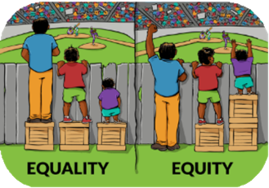

My second box was handed to me when I transferred to MSU. I was an English major, but I decided that communication would be a good cognate area (that is what we
called it at the time). So, I enrolled in COM 200 — Research Methods. Did I even read
the course description? Why was I taking a course in social science research methods? During my time in his class, Dr. Vernon
Miller took me aside to chat with me and tell me that I was doing very well in the
course. He asked me about my future
goals. This conversation propelled me to look into getting an M.A. in
communication. Vernon wrote a letter of
recommendation for me, and I got into the Department of Communication at MSU as an unfunded master’s student. I waited
tables to pay the bills, went to classes, and worked hard to prove to the faculty that
they had not made a mistake in admitting me.

I will thank Dr. Steve Wilson and my
graduate cohort for box number three. He asked me what I wanted to do with my
future, and I said that I would like to get a
PhD in English and teach Shakespeare. He said, “It doesn’t matter what you want to
get your PhD in, if you want to receive a doctorate you need to take our core
methods courses.” So, I changed all my coursework and began taking the core
courses in methods and statistics. These were doctoral level courses. (continued)

Now, remember, I was an English major and had no background in statistics (as in NONE) or social science. But I can follow directions. There I met some amazing doctoral students who took me under their wing and never
THE SPOTLIGHT • FALL 2022
M O ' S M E G A P H O N E
(CONTINUED)
treated me like I did not belong there. These were students with former training at very
good schools (Cornell, Northwestern, etc.) in the social sciences. Particularly, people like Kimo Ah Yun (now Provost at Marquette),
Kenzie Cameron (at the Medical School at Northwestern), and Amy Johnson (COM
Chairperson at Oklahoma) spent their
personal time with me. They did not laugh at me or ignore me — instead they helped me
understand statistics, research methods, social science writing, and more.

Box number four was a life altering box. I had taken a course in Persuasion from Dr. Sandi
Smith, and we had some wonderful
conversations. I started spending more time with her, receiving her mentoring and advice, and she asked me about my life goals and my current situation. And in the summer after my first year as a M.A. student, she asked if I
would be willing to work for her on her new Kaiser Family Foundation Grant (with Dr.
Bradley Greenberg). Thanks to Sandi, I
became a funded graduate research assistant. I quit my job at Bill Knapp’s family restaurant. I received an office in the Department of
Communication, and I loved doing work on this research team. I decided I wouldn’t be
teaching Shakespeare after all, and I applied
for doctoral programs in communication. This was going to be my life!

The thing is, I did not immediately receive an acceptance from MSU’s doctoral program. I was not completely surprised — the
department receives excellent applications from all over the world. So, I called the
Chairperson at the University of California,
Santa Barbara (UCSB), where I had been
accepted, and told her I would be coming. At that time, Sandi Smith was on sabbatical
with Chuck Atkin (actually, it was their
honeymoon!) and they were unaware of what happened. They returned in late March, and
told them I would be leaving for California.
Box number five was a loud drop.
Chuck and Sandi thought this was a mistake; they believed that I would do
well at MSU and should be given a shot.
They saw something in me that not
even I had seen. The next thing I knew,
I was accepted to MSU’s doctoral
program in communication. I had to repair some bridges with UCSB, but I accepted.
That’s when Box number six was
presented. Dr. Frank Boster agreed to continue to advise me (he chaired my master’s thesis as well). Frank invested so much time into my training, my
thought processes, and my writing
style. He pushed me. I spent hours in
his office in Mason, MI, preparing to be a scholar. I came into MSU not sure
what I was doing — and left feeling
ready to be a professor at a research university.
What is the point of this diatribe? It is not about me actually; it is about the
Department of Communication at MSU.
We are so much more than a top
communication program. This is a place where potential is seen. This is a place
that invests in people.
This is a place that looks for who
needs a box - what size they need, what type they need - and delivers it to them. It is a place where a first
-generation student can become the department chair.
Did (does) our COMMunity see potential in you? Do you have a similar story? During this
holiday season, let us all pay it forward. Look for people
you can invest in — invest with time, attention,
mentoring, and
encouragement. Let us show everyone what it means to be a Spartan.
Because, as we all know, Spartans will!

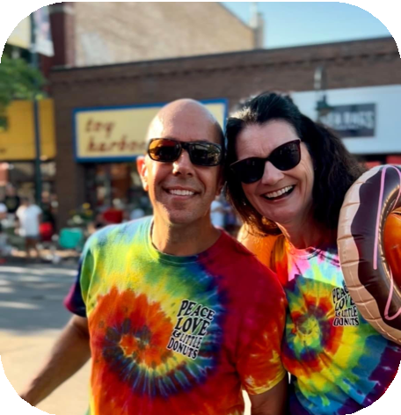
How did your time at Michigan State prepare you for what was to come
THE SPOTLIGHT • FALL 2022
C O M M U N I C A T I O N , L I F E , A N D L I T T L E D O N U T S
I N T E R V I E W B Y J O H N N Y M C G R A W
K r i s t i n a S c h n e p f
M S U C / O 1 991
professionally?

In my opinion, the best preparation for professional situations is exposure to
challenge, opportunities to lead, diverse experiences, and ambiguous situations
requiring quick thinking and problem- solving, The size, scope, and breadth of Michigan State provides a perfect
environment to learn and grow in this way. To be honest, the greatest
preparation came from outside of the
classroom for me. While classes develop discipline, mastery of skills, and critical thinking, it’s your fellow students,
internships, alumni network, study abroad, and student organizations that provide
really meaningful preparation for
professional environments. By the time I graduated, I'd had internships in
government, corporate, healthcare, non- profit, small business, and an on-campus public relations agency. I had worked my way up in leadership in PRSSA and
traveled as much as my finances would allow. Michigan State offers the ideal
setting to try new things with the support and structure of the university around you.
Lead things, travel, create opportunities, build your network — do it all — the university system exists to prepare you for your professional life.

Given all of your experience leading
communication at various well-known companies (Dow, Goodyear, etc.), what
advice would you give to someone hoping to sharpen their leadership skills?

Become a student of good and bad leadership happening around you. Watch and learn from leaders you respect and those you don’t.
Emulate the leadership practices you
appreciate and avoid those that you see and experience as harmful. Then, take every
opportunity to practice leadership. Be a group leader on a project. Test your voice by being a vocal thought leader when appropriate in
classes. Take on leadership roles in clubs and
organizations. Practice articulating a vision and getting others to buy in. Never shy away from
having hard conversations. And never, ever compromise your integrity. Being someone
worth following requires honesty, compassion, clarity, vision, and courage. None of us are
perfect, but in my experience, if we exhibit
these traits more often than not, people will follow.

C O M M U N I C A T I O N , L I F E , A N D L I T T L E D O N U T S
(CONTINUED)

What was your inspiration for deciding to own Peace Love and Little Donuts in Traverse City?

I would love to say that opening Peace Love and
Little Donuts of Traverse City was a highly strategic career move, but to be honest, it was more of a
mid-life crisis moment. I was making the
challenging decision to leave a position as a corporate executive and begin my own
consultancy. The financial uncertainty of that
decision and the confidence it required left me grasping for something concrete and stable. So, my mid-life crisis mind told me to launch two
businesses at once! While it wasn’t a customary
path, the balance between consulting and donut making has proven to be highly rewarding and a great second act to my corporate career. Who
knows what will be next — but I can tell you that reinventing myself gets easier each time I do it!

What are your proudest professional accomplishments?

At this point in my career, I find that my proudest accomplishments aren’t single events, campaigns, or programs, but rather a collection of moments
aggregated into meaningful themes. I’m proud of the relationships that I have built and continue to maintain with fabulous people that I have worked with and for over the last 30 years. I’m proud of
the people I have had the privilege to lead and the small impact I may have had on their subsequent accomplishments.
I’m proud of the lasting impact of some of the innovations I have initiated and executed
throughout my career. I’m proud of the
boundaries I held (and the personal sacrifices I made) that enabled me to be a very present
parent while also advancing my career. I’m
proud of the professional risks I’ve taken that have given me a new perspective and helped me grow.

But if you really want to know — my single proudest moment was hosting then-Vice President Joe Biden at a massive ground
breaking event that I devised and executed for a joint venture of Dow.

You have had a diverse professional career. How has your background in communication helped serve you in your circuitous
professional path?

I contend that a degree in communication
(from Michigan State in particular) is one of the best foundations for a successful career in
nearly any pursuit. When you are trained to
look at the world with a focus on positioning a message with a particular audience and
ensuring accurate and articulate receipt of that message, you can be successful in sales,
marketing, legislating, leadership, negotiation, interviews, fundraising, writing, anything! As an MSU communication major, you’ve already
made the best first choice of your career!

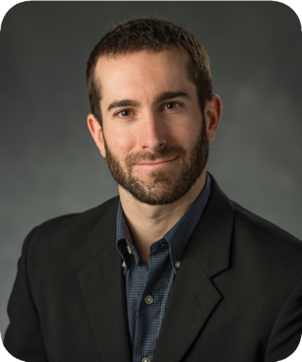
A L U M N I S P O T L I G H T : D A V E K E A T I N G , P H D

CLASS OF

The Department of Communication at
Michigan State University (MSU) has a long history of housing and training some of the most impactful scholars in the field, and
during my time in the graduate program
(2010-2014), I was lucky enough to learn from, be mentored by, and share office and
classroom space with those folks. The
classroom and interpersonal interactions I had
— with faculty, obviously, but also with other
graduate students — shaped how I think about theory, how I design research, and how I
approach data analysis. That training and
those conversations also naturally played a role in my career trajectory.

In my first post-grad job, I spent two years at a behavioral research firm, Fors Marsh Group,
where the majority of my work concerned messaging and campaigns. Among other
things, I conducted formative and evaluative research on behalf of the Food and Drug
Administration’s Center for Tobacco Products, the Federal Trade Commission, and the
Federal Emergency Management Agency’s National Flood Insurance Program.
Following that, I spent four years at California State University, Northridge, which is a
teaching-focused institution, before starting my current position at the University of New
Mexico, which is a research-focused institution.
I’m grateful to the department at MSU for helping to prepare me for each of these
positions.

Regarding what I’ve been up to, the most noteworthy item to report is that I will be
taking over as the editor of Communication
Research Reports in January 2023. The journal publishes quantitative communication science work in a short report format, and I hope that
faculty members and graduate students at and from MSU will submit their work during my
editorship. I would not have been selected as editor without the support of the MSU
community and, most notably, the support of Dr. Sandi Smith. Sandi’s research, mentorship,
and teaching have immeasurably impacted the field—an exemplar of the Department of
Communication at MSU.

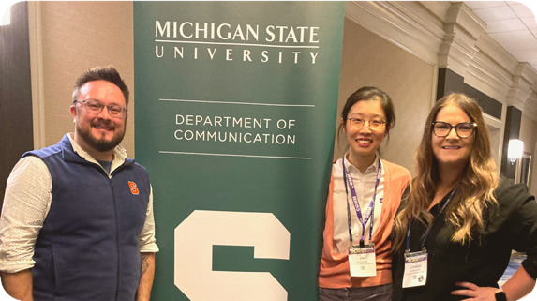
2 0 2 2 C H A R L E S K . A T K I N S P E A K E R S E R I E S

MSU COMM
ALUMNI
L E F T - R IG H T : N IC K
B O WM A N , J IE Z H U A N G , L IN D S A Y H A H N

Returning to the banks of the Red Cedar as a visiting speaker, I expected things to feel differently than they did when I was a PhD student. But in all of the best ways, things did not feel different at all. The entire reunion – with Thomi and
Marge, all of the faculty and students, and spirited chats with everyone over Two-Hearted beers at Reno’s – reminded me why MSU’s Communication
Department is so special. Sure, some things have changed since I was a student (RIP to the CAS building Sparty’s), but the feeling of community that makes the department so remarkable is still manifest. MSU’s work-hard, play-hard, ask-
questions-hard model is as strong as ever, and that was evident throughout the weekend’s social gatherings and talks. And like always, it was apparent that the faculty and students are deeply invested in the work that all of us ‘visitors’ are doing – because they’re rooting for us to succeed and because they care deeply for us. My visit was a palpable reminder that the reason things didn’t feel
different while I was visiting is because I wasn’t actually a ‘visitor’ at all – I was just a kid who came home for the weekend.

- L IN D S A Y H A H N

2 0 2 2 C H A R L E S K . A T K I N S P E A K E R S E R I E S

I remember getting the initial email invitation to be part of the Charles K. Atkin’s Speakers Series. I was in a rented van, and I had just crossed the
New York border on the way to my new position at Syracuse University—wearing an MSU
Communication of course (nearly all of my “choring clothes” are MSU t-shirts). On the cusp of a new
adventure and the next chapter in my career, the invitation was an opportunity to both look deep
into the past and look directly into the future. That was pretty special.

Heading back to East Lansing was exciting, inspiring, and… a bit humbling. I’ve not been back much since leaving in
2009, and there was something about coming back into that building. Stepping into CAS and down into the auditorium where I sat as a student and listened to so many visionaries in our field was special. Perhaps more so, seeing so many of
my peers and mentors in the audience — in true MSU fashion, ready with questions and critiques, that were
insightful and provocative as I continue to work through this research. I came back with more notes than I arrived with,
and this is perhaps the best compliment that the audience for this talk could have given me: a genuine interest in the work.

- N IC K B O WM A N

During my 10-year academic journey at Comm Arts & Science at MSU, many distinguished scholars have visited and presented their research. Many of the talks have left a long-lasting impact on how I conduct research and search for answers to satisfy my intellectual curiosity. Coming back to Comm Arts & Sciences as a guest speaker
for this year's Atkin Speaker Series is a singular honor. A lot has
changed since I left MSU in 2017, but a lot more remains the same
— the inspiring and hardworking faculty, the caring staff, and the motivated and engaged students, all of which are at the core of the true MSU spirit. I was excited and a bit intimidated by the thought
of presenting my research in front of this group of distinguished scholars. However, I was touched by the inspiring questions and
constructive feedback that the audience asked and offered at the presentation and afterward. The visit reminded me of why I wanted
to pursue this career path from the beginning.

- J IE Z H U A N G

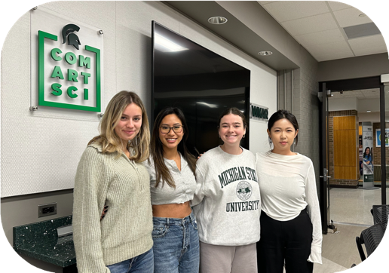

L e ft - R i g h t : A n n a K o z le s ki ( S o c i a l
M e d i a C h a i r ) , S a d i e N g u y e n
( P r e s i d e n t) , L a u r e n H a r d g r o v e ( V P ) , Z i h a n S u n ( T r e a s u r e r )

U N D E R G R A D U A T E S L E A D I N G T H E W A Y

UCA Purpose: The Undergraduate Communication Association is the defining voice of students pursuing communication studies within the College of Communication Arts and Sciences. Our goal is to provide
education, leadership, assistance, and unique opportunities to
students as they prepare for careers within the communication field.
The UCA does this by providing
resources, seminars, and advice on issues such as graduate school,
career preparation, job searches, and internships. We organize
opportunities for communication students to further their crucial
networking skills by getting to
know the faculty and their peers.

UCA President Sadie Nguyen on why she is passionate
about leading UCA:

"I am excited for this
organization to grow to where it
once was, before the pandemic. Our recent events have been led by impressive and successful
alumni who are inspiring all our members, with majors ranging
from communication to
advertising management to
political science! UCA's future is bright. With our spectacular
schedule of resourceful events and alumni for the upcoming year, we have so much to look forward to."

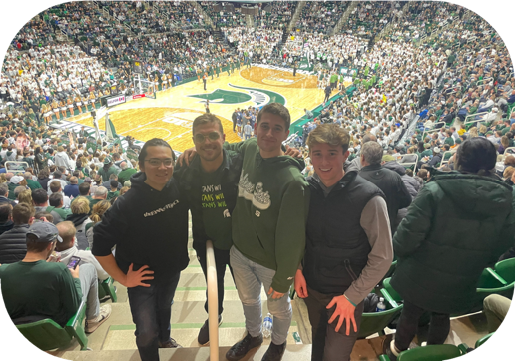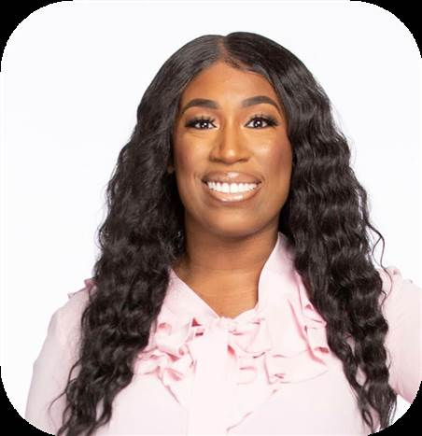
L e ft - R i g h t : K o s u ke N a ka mu r a ( E v e n ts C h a i r ) , J a me s C a me r o n ( P r e s i de n t) , J o e y S o a v e ( S o c i a l
M e di a C h a i r ) , a n d T o mmy G a r de l la
( V P )
G a bby R e e d
F orme r D V C P re s ide nt

U N D E R G R A D U A T E S L E A D I N G T H E W A Y

DVC Purpose: Diverse Voices
in Communication (DVC) gives students a voice surrounding
issues of equity and diversity
across the board in the area of communication. DVC is a safe place for students to voice
their opinions, thoughts, or concerns about campus life, regardless of sexual
orientation, gender identity, race, religion, etc. We aim to provide fellowship, activities, and a place where all student
members can feel comfortable.
"It has been such an honor to be able to help bring more
DEI efforts to the Department of Communication. DVC
started as an idea between Dr.
Monique Turner and me
during Summer 2021. From there, it has expanded to
include guidance from our DEI Chair Dr. Elizabeth
Dorrance Hall and an amazing group of young people. As the outgoing President of DVC, my only hope is for DVC to
continue to grow, evolve, and expand." - Gabby Reed

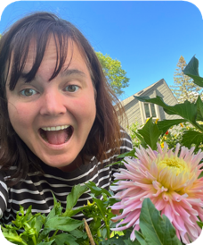
D R . A L L I S O N E D E N ' S G R E E N T H U M B
I N T E R V I E W B Y J O H N N Y M C G R A W

D r . A l l i s o n E de n
A s s o c i a te P r o fe s s o r , M S U
D e p a r tme n t o f C o mmu n i c a t i o n

Please provide some backstory on how you initially got into gardening and then discuss how it grew (pun intended) into a passion for you.

When I was little – about 8 or so – my mother gave me a small section of the garden to tend,
and a magazine article about what plants work well in what spaces. I picked some out and
when they grew and did well, it was very
exciting. After that, I always liked helping out in the yard. One of my first jobs was at a retail
greenhouse selling plants and baskets. I moved from there to landscape design and sales for
several years and then worked at another
garden center while I went to college. The only time I didn’t garden was when I lived in an
apartment, and even then I’d eventually collect a bunch of houseplants. It’s just something
that I’ve always enjoyed.

How has gardening benefitted you? Whether it be giving you peace, having a
fun project to always tend to, or something else.

I like learning new things, and there’s always something changing in a garden. Every year is a different set of challenges. It’s also a unique
combination of planning and letting things go that appeals to me. For instance, I do a lot of garden planning and design work, but
eventually you just have to pop plants in the ground and see how they do. Plus I really love flowers. There is no better place to be than a garden in full bloom.
What advice would you give to someone just starting out with gardening?

You will likely kill a bunch of stuff when you first start out, don’t let that stop you, just try
not to do it again. If cost is an issue, try things like seeds and cuttings to make this process
cheaper, ask friends to help, or look in the community for resources. We are lucky
because the Lansing area has multiple garden resource centers for beginning gardeners, plus MSU has a huge horticulture school and
student farm.

Also, not everyone likes growing the same
things, and things grow differently for different folks. You have to find out what works for you
and your situation. I want to love growing
vegetables but I do it somewhat begrudgingly because I can and I like fresh veggies. But
honestly, I’m more into flowers.

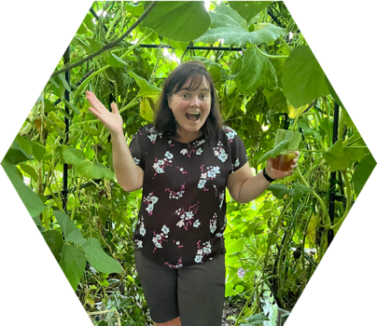
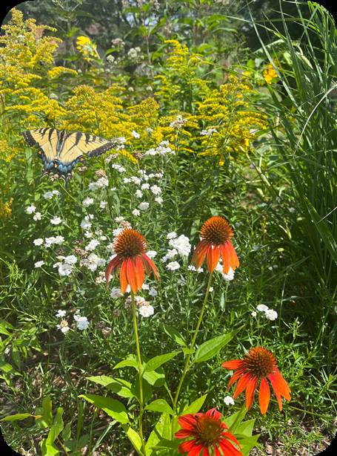
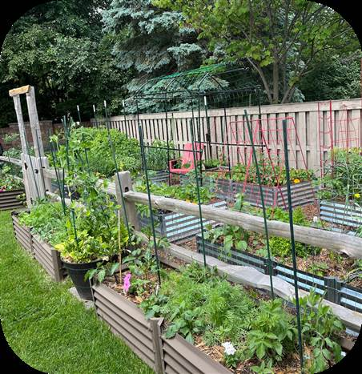

A L L I S O N E D E N ' S G R E E N T H U M B
(CONTINUED)

How is gardening in Michigan different than in other states you’ve lived in?

Well, the season here is much shorter than in Maryland, where I’m from. I’ve gotten creative with winter seed
starting indoors and out, overwintering tender plants like figs and geraniums, and digging, storing, and then potting up dahlias. This year I made a winter
M A K I N G A D I F F E R E N C E W I T H G A R D E N I N G
THIS YEAR A FRIEND OF MINE AND I TEAMED UP TO DO GIFT BOUQUETS FOR LOCAL NURSING HOMES AND HOSPITALS. I GREW THE FLOWERS AND SHE ARRANGED AND DELIVERED THEM. THAT WAS SOMETHING I’D ALWAYS WANTED TO DO AND I WAS REALLY
HAPPY SHE SUGGESTED IT.
tunnel, a kind of winter shelter, so I can get a jump on spring. I’ve also accepted that tomatoes just won’t
match their MD counterparts, but we make up for it by being able to go
outside all summer without dying of heat exhaustion or humidity. Plus, we have fewer pests here thanks to the winter freezes.

S T A Y I N T O U C H !

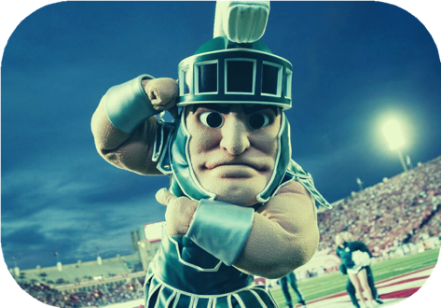
Got some great stuff going on? Whether it be a new job, an award you've won, or just an accomplishment you're proud of, let us know! It could get shared in our next newsletter!

Follow us on our social media!
@commdeptmsu
Here are a few
submissions from our Spring newsletter:
Johnny McGraw (grad. 2022)
Communications Manager,
WKAR Public Media
"Leading up to my December '22 Master's graduation, I had been searching for the perfect job to suit my post-grad skillset. I was happy to not only land on an organization that does such important work in the local community, but one that is under the wonderful ComArtSci umbrella that has been my home for the past 5 years. Beginning in January '23, I will be the new Communications Manager at MSU's very own WKAR!"
Dr. Samantha Shebib (grad. 2020)
Assistant Professor,
University of Alabama Birmingham "I won the Dean’s Giraffe Award for recognizing faculty who have tried
something risky to better teaching, further
research, and improve the college."
Fill out our form here!
