THE SPOTLIGHT
M S U D E P A R T M E N T O F C O M M U N I C A T I O N

- S P R I N G 2 0 2 4 •
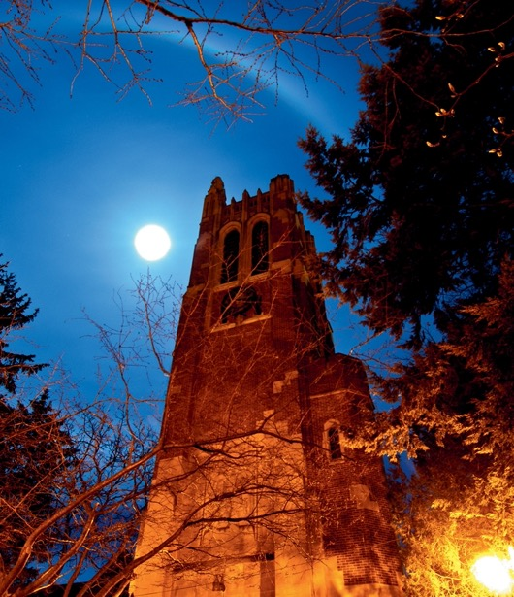
W H A T ' S I N S I D E

Amazing Awards
Chef Vernon Miller Alumni Spotlight:
Johnny McGraw

Spectacular Scholarships

Excellence in Communication Speaker Series
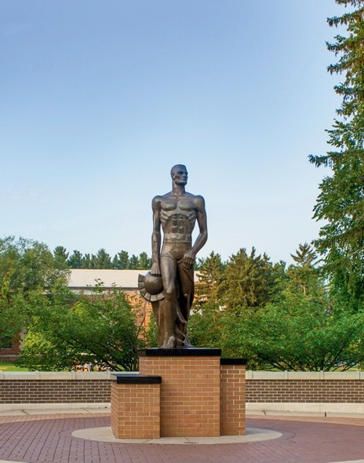
M O ' S M E G A P H O N E:

By Department Chair, Dr. Monique Turner
This might be an odd thing to proclaim, but I love the end of Spring Semester. This is not because I like ending it; rather I love looking forward to what is next. As soon as I see tulips popping up around campus. I know it is time to finalize plans for the following school year. In the Department of Communication, we are always asking: How can we engage our students and alum more fruitfully? What kinds of collaborations we should be leveraging? How can the student experience be better? What is next on the horizon of pushing the boundaries of science?

M O ' S M E G A P H O N E
(CONTINUED)

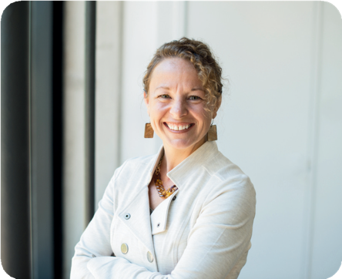
Later this month, the Department is hosting the inaugural “Communication Science Futures” conference here in East Lansing. This conference will bring together the best scholars on the globe to discuss the future of research, methodology, and theory. It seems that people around the world finally know what we have always known: Communication is a fundamental ingredient to a prosperous, healthy, collaborative and altruistic society.
Yet, in a society that is divided, rife with misinformation, and full of toxicity and conflict—we need to speed up new scientific findings that can assist with progress (we will update you on the conference in our Fall/Winter newsletter).

In August, our faculty will come together to discuss the future of our 3 major programs (undergraduate, masters, and doctoral) at our yearly planning retreat. We are launching a new concentration in advanced methods within the MA program, and we have a new core course in the doctoral program focusing on advanced methods (computational, neuro, network etcetera). We are in our fourth year of the new undergraduate major in Communication, Strategy and Leadership and now have 100+ students in the program. Yet, as we evolve and keep our eyes focused forward, we will never forget our intellectual legacy and what makes us great: Evidence and theory. Our students need to enter the job market understanding what types of communication foster healthy work and interpersonal relationships, the effects of the media, persuasive and campaign strategies, presentation skills, leadership, and group work, and more. We believe that the most important thing we can teach our students is how to think critically, work with others, analyze the evidence and put it to practice. This is what we have taught our students since our inception—and that will never change.

So, what are the Communication Science Futures? I don’t know. But I plan to take a seat at the table and find out. And I guarantee you—whatever the future holds, The Department of Communication will lead the way

That’s all for now, Monique Turner
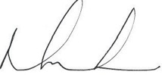

A M A Z I N G A W A R D S : C S C A C O N F E R E N C E
The Central States Communication Association (CSCA; held in April in Grand Rapids, MI) honored several of our spectacular faculty with awards for their scholarship. We are beyond proud of our COMM Department family!

Listed below are all of our award winners from the 2024 CSCA convention.

CSCA TOP PAPER/PANEL AWARDS
STEPHEN SPATES BROOKE WOLFE WILLIAM NOWLING

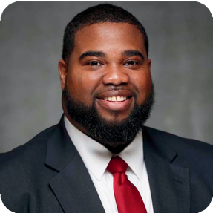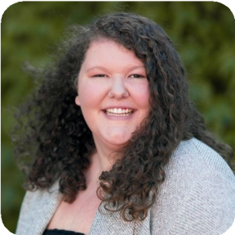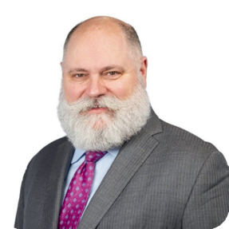

Communication and Technology:
Top Three Faculty Paper Undergraduate Education and Administration:
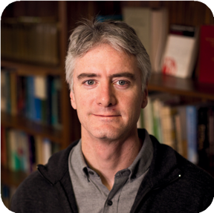
Interpersonal and Family Communication: Braithwaite Award and Top Paper Award
Strategic & Applied Communication:
Top Panel Award

Top Panel Award

Political Communication:
Top Four Paper
DANIEL BERGAN LU TEINOWITZ

Political Communication:
Top Four Paper

Political Communication:
Top Four Paper

A M A Z I N G A W A R D S : C S C A C O N F E R E N C E
(CONTINUED)

CSCA: THE FEDERATION PRIZE

The Federation Prize promotes intellectual development and communication scholarship by awarding a cash prize of (up to) $3000 to a selected proposal authored by CSCA member(s).

HYESUN CHOUNG
BROOKE WOLFE
YOO JUNG (ERIKA) OH

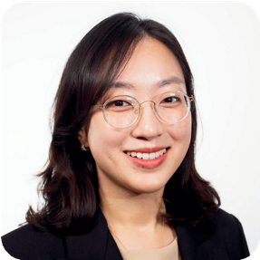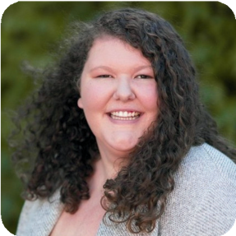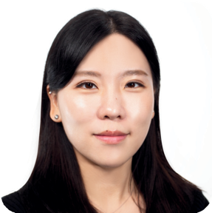

CAROLYN CALLOWAY-THOMAS INCLUSIVITY SPEAKER
SERIES KEYNOTE ADDRESS

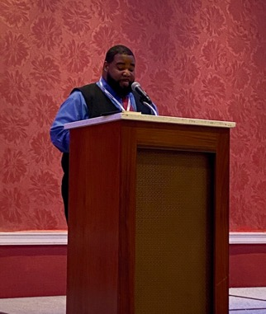
One of our new faculty members, Dr. Stephen Spates, was invited to give the Carolyn Calloway-Thomas Inclusivity Keynote Address. The topic Spates covered was titled: Buyer’s Remorse: The Incoherent State of DEI in Higher Education. Congratulations Stephen for your excellent address during the conference!

A M A Z I N G A W A R D S : K E N T U C K Y C O N F E R E N C E F O R H E A L T H C O M M U N I C A T I O N

Dr. Ralf Schmaelzle’s research team received a top paper award at the Kentucky Conference for Health Communication for their VR- & Health Communication research.

SUE LIM HEE JUNG CHO MOONSUN JEONG
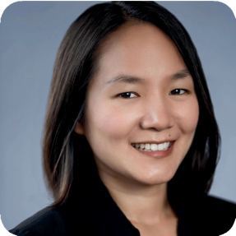
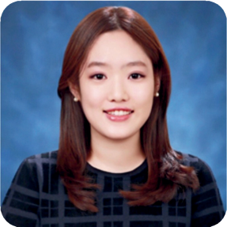
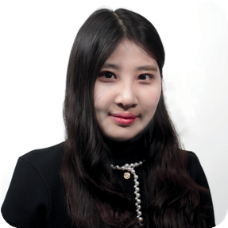

XIAORAN CUI DR RALF SCHMAELZLE
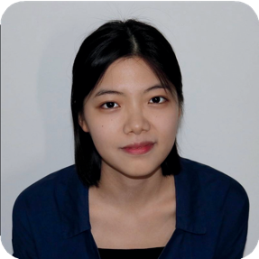
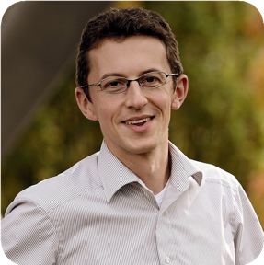

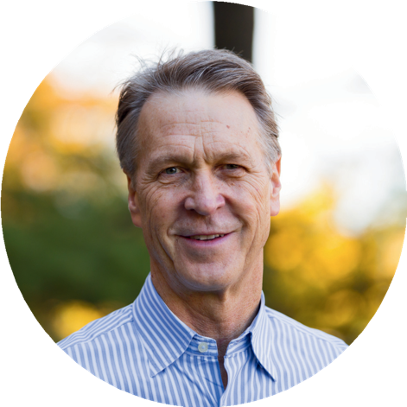
THE SPOTLIGHT • SPRING 2024
C H E F V E R N O N M I L L E R
INTERVIEW BY: EMILY DICKERSON

What inspired you to start cooking?

My parents would often prepare special meals on the weekend. They were early followers of Julia Child on PBS and tried her recipes.
They’d regularly try to emulate dishes that
they had at restaurants (some of which were amazing, others I refused to eat!). When I was in high school, I was given a small role in
preparing crepes suzette’s on New Year’s Eve. The cups and cups of sugar hooked me.

What has been your favorite meal to
prepare and why?

I was told you’d be asking easy questions! This question is so difficult to answer!!! My go-to is rack of lamb. Prepare a simple rosemary and garlic paste, add a touch of salt, throw in the oven, serve along with puréed parsnips or
roasted potatoes, a little salad, maybe some cornbread with diced jalapeños, add a
beverage…. A poached salmon is also hard to beat but that’s for another feast.

How can cooking help you as a professor?

To be honest, cooking a great meal after a
hard day’s work is reward in itself. It’s also an opportunity to try something new; to step
outside my comfort zone. However, getting
into the “zone” and cranking out a meal for 8
or 10 guests has clear transference into
working under pressure, where you have to shut out distractions and concentrate on
delivering an interesting lecture or preparing a research article.

C H E F V E R N O N M I L L E R
(CONTINUED)

What advice an you give to others who want to learn how to cook?

First, cook what you like to eat. No need to embark on a meal that sounds so-so. I’m a visual learner so I’m a sucker for pictures of
food in magazines or online. Second, attempt to replicate a favorite meal that your parents cooked for you or even that you had at a
restaurant. Third, cook with others (i.e., a good friend, a date, other couples). It’s a great way
to get to know someone else and they’ll be no shortage of laughs. Fourth, trust your instincts.
If you’re following a recipe and something doesn’t appeal or make sense, just skip it or improvise.

Any cooking stories you would like to share?

I’m sure the steak au poivre story will scare the faint-hearted from taking on new cooking
challenges (the steak was amazing btw, singed eyebrows and all). Still, I’d like to encourage
others to consider a New Year’s Eve cooking
party with good friends. Assign everyone a dish (that they are known for) to prepare at the
host’s residence – don’t prepare ahead of time but bring the ingredients and cook there. It’s chaotic with folks in and out of the kitchen,
cramped or spacious. Sometimes you are preparing a dish solo; other times with a
partner. Having too many cooks in the kitchen has been a hilarious experience – and
delicious! Cheers!
PS. I can’t bake worth a damn.

Have you ever had a funny lesson from a cooking fail?

You mean the time that I almost burned down the house?

I overheated an iron skillet when cooking steak au poivre (i.e., steak with ground
peppercorns). The braising of the steaks went perfectly. Pulled them to a plate while leaving the liquid from juices and sauces to reduce on the gas burner – except that I turned up the
heat rather than down.
Steaks returned to the skillet for a final
basting. Wondered for a second if the skillet was too hot, yet I tossed in a half of cup of
brandy – a huge fireball singed my eyebrows and hair (like in a movie comedy)!! I ran
through the house and checked the attic to make sure nothing else was on fire.

I lucked out. Only my pride was injured, but I took a long break from cooking steak au
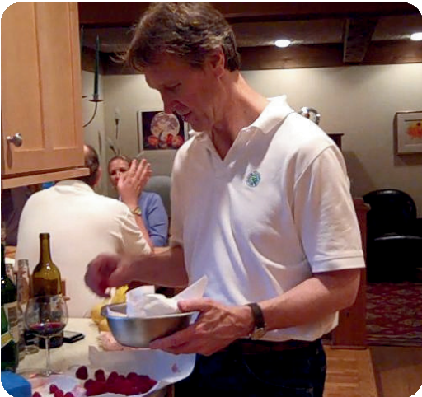
poivre.

C H E F V E R N O N M I L L E R
(CONTINUED)

U L T R A L I G H T P A N C A K E S F R O M S C R A T C H

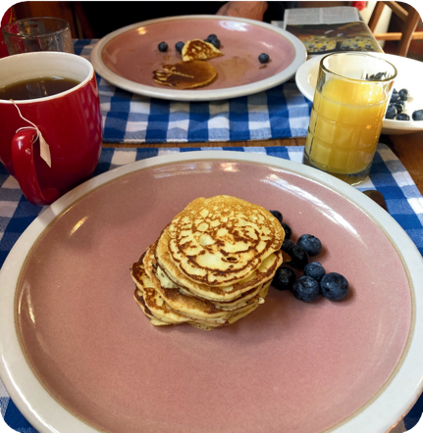
Ingredients
3 eggs
½ cup oil (wesson, vege, olive oil - your choice)
½ teaspoon salt
½ teaspoon sugar 1 cup regular flour
¾ to 1 cup milk (more milk for thinner batter)
1 tablespoon baking powder
blueberries or other fruit as a side or for adding into batter
maple syrup

Directions
Set a skillet on a burner, low temperature.
Mix egg, oil, sugar, and salt, blend briefly. Let rest for 2 minutes.
With blender on, add sifted flour in small portions while concurrently adding milk in small portions.
Blend in baking powder.
If mixture seems to thick (due to egg size, age of flour, type of oil), add small amounts of extra milk until satisfied.
Toss a few drops of water onto the skillet. If the water sizzles and quickly evaporates, the skillet is ready. If not, increase the temperature slightly and repeat until water drops dissipate immediately.
Pour your preferred portion size of batter onto skillet.
(When batter is on the skillet, add blueberries or other fruit if so desired).
When bubbles appear in the pancakes, flip pancakes. Cook to desired degree. Serve with maple syrup.

A L U M N I S P O T L I G H T : J O H N N Y M C G R A W
INTERVIEW BY: EMILY DICKERSON

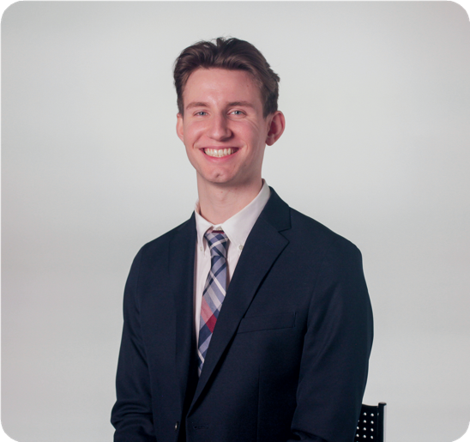

What have you been up to since graduation?

Since graduating from Michigan State University, I have had the pleasure of serving as the communications manager for WKAR Public Media. Landing a position at an organization as well-known and respected as WKAR was a goal of mine after graduating with my M.A. in 2022. I knew I wanted to work somewhere that would allow me to use all of my favorite elements of communication, such as design, writing, and marketing strategy. In my current role, I get to plan and execute on communication strategy every day, delivering content and messaging that is in service of WKAR’s core mission and values.

Can you share any memorable experiences during your new journey into the broadcasting world with WKAR?

Some of my favorite experiences with WKAR thus far have been photographing our family- focused events like PBS KIDS Day. In 2024, we had around 1,500 children and their families come to the WKAR Studios to enjoy fun activities, pose with popular PBS KIDS characters, and more, so capturing moments at an event as joyful as that one is always a blast. I’ve also enjoyed seeing all of the teamwork that goes into creating and launching a television program. The storytellers at WKAR are experts in their craft, so getting an inside look at what they do is a special sight to behold.

Overall, how did your communication degree prepare you for working at WKAR?

My bachelor’s degree and subsequent M.A. in communication helped prepare me a great deal not just for my career, but for life in general. The media and PR classes I took equipped me with the communication skills needed to excel in my field, and classes in political communication and interpersonal communication have helped me navigate my day-to-day life when it comes to exercising media literacy and thoughtfully interacting with those around me. A communication degree from Michigan State University provides students with a toolkit of useful resources that are sure to equip them in their lives and careers.

S P E C T A C T U L A R S C H O L A R S H I P S
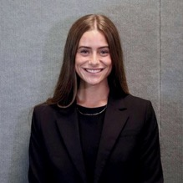
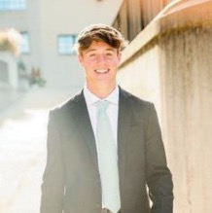
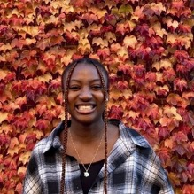
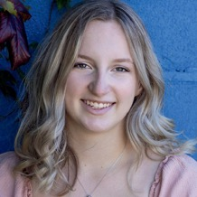
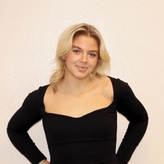

ELLA O’NEILL

SAM LEWINSKI
CATHY W. KIERNAN EXPENDABLE SCHOLARSHIP

TOLUWALASE AWOSIKA
GLENN AND THELMA BUELL COLLEGE OF
COMMUNICATION ARTS & SCIENCES ENDOWED MEMORIAL SCHOLARSHIP

TAYLOR NITZ
DR. DAVID AND PATRICIA NIX “MISS MSU” BARRON ENDOWED SCHOLARSHIP IN THE COLLEGE OF
COMMUNICATION ARTS AND SCIENCES

PARKER BEAVENS
EPKER FAMILY SALES SCHOLARSHIP

S P E C T A C T U L A R S C H O L A R S H I P S
(CONTINUED)
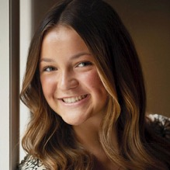
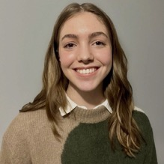
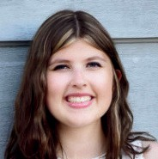
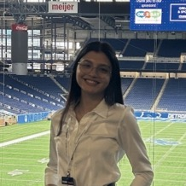
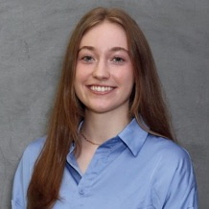
COLLEGE OF COMMUNICATION ARTS AND SCIENCES ENDOWED SCHOLARSHIP

MACKENZIE BROWN
DONALD AND ANNETTE NEAL SCHOLARSHIP

MYA LEGEL
JOHN G. WALSH SCHOLARSHIP

LAUREN WADIE
BRIAN P. O’CONNOR COMARTSCI ENDOWED SCHOLARSHIP FUND

SIDDHI CHOUBEY

AMELIA LALLY

S P E C T A C T U L A R S C H O L A R S H I P S
(CONTINUED)
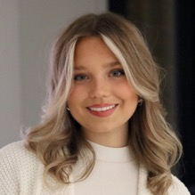
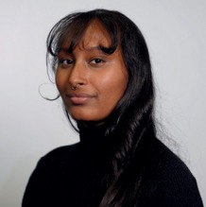
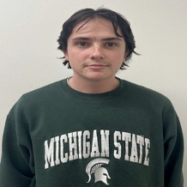
COMARTSCI GENERAL SCHOLARSHIP

EVIE TURJANSKI
DIANA THORNHILL-COP AND DAVID A. COPP CAS SCHOLARSHIP

SUMEYA OSMAN
SCHULTZ FAMILY SCHOLARSHIP

ADEN TAYLOR

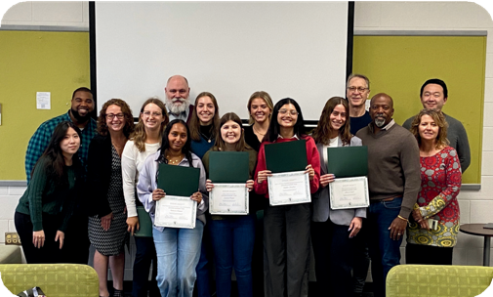
In April, the faculty and staff held a Scholarship Luncheon to honor the many talented students who were awarded with scholarships. Department Chair Monique Turner presented each student with their designated scholarship and honored their hard work.

All of the students were also able to meet and greet with faculty. This allowed them to expand their networking and gave the faculty a chance to honor them in person.

Congratulations scholarship winners!

E X C E L L E N C E I N C O M M U N I C A T I O N S P E A K E R S E R I E S

On Friday, March 8, we were able to hear some amazing speakers in our Excellence in Communication Speaker Series. Dr. Munba Saleem joined us from UC Santa Barbara and
Dr. Pranav Malhorta joined us from University of Michigan.

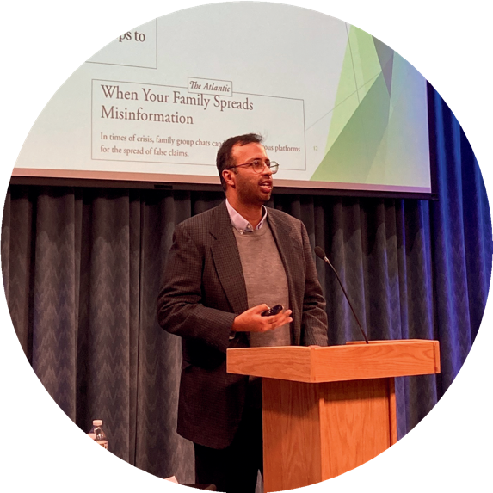
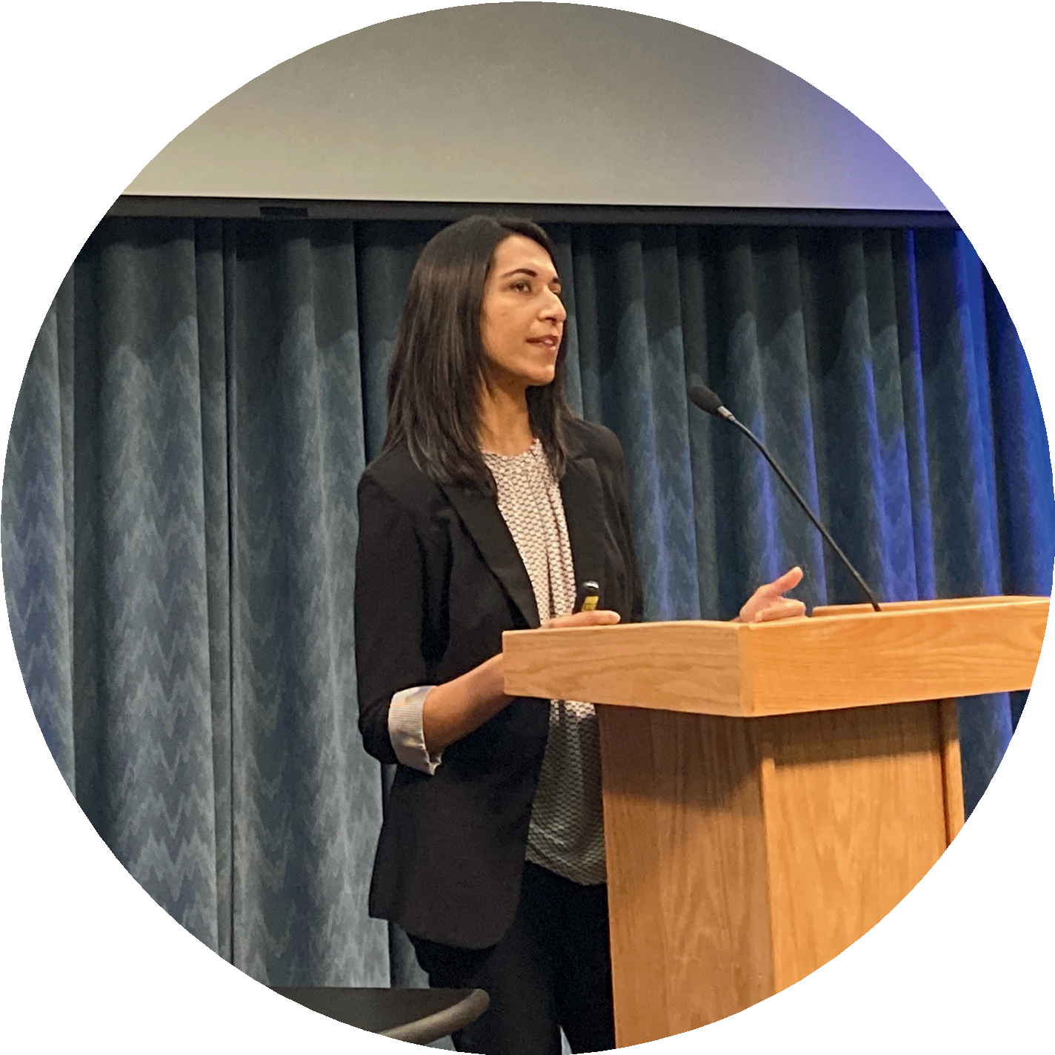

DR. PRANAV MALHORTA
Internationalization in Communication
Research: Experiences Studying Social and Mobile Media Across the Globe

DR. MUNIBA SALEEM
Media’s Influence on Intergroup Relations

S T A Y I N T O U C H !

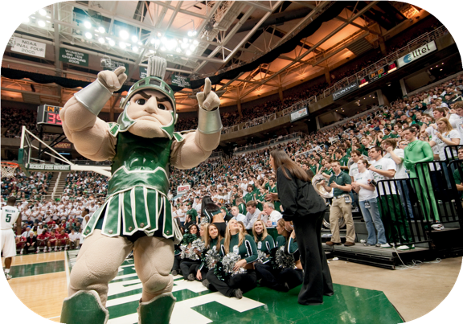
Got some great stuff going on? Whether it be a new job, an award you've won, or just an accomplishment you're proud of, let us know! It could get shared in our next newsletter!
Follow us on our social media! @commdeptmsu
Fill out our form here!

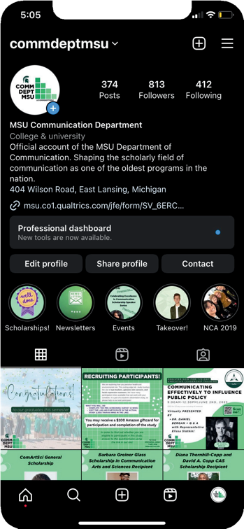
Here are a few submissions from our past newsletters:

Lauren Tamboer
Class of 2018
Earned a position with WA State Department of Ecology helping to implement the nation’s most stringent law related to reducing toxic chemicals in consumer products and preventing their release into the environment.
Jake Arens
Class of 2019
I've got cerebral palsy, which is a disorder that effects my legs. I'm not supposed to walk normally, but as we say Spartans Will. Last year I hiked 2194.3 miles from Georgia to Maine on the Appalachian Trail. In March I will be hiking 4000 miles across Europe to fundraise for Cerebral Palsy research. I'm currently working on a strategic plan for both social and traditional media outreach to raise awareness around this effort. As a lifelong spartan fan and 19' alum I'd love to include the Spartan family. Please let me know if you or anyone you know would be interested in contributing to this cause and helping me tell my story

