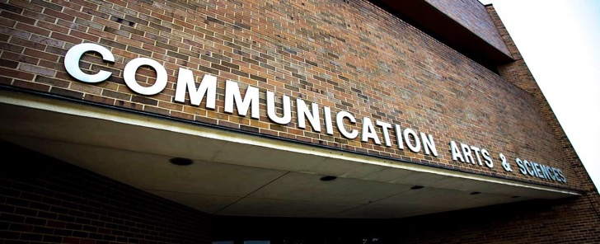

IN THIS ISSUE OF THE SPOTLIGHT
Mo's Megaphone
WhooHoo! Great Things from Alumni The Story of Gordon Freedman #COMRocks: Scholarship Winners Faculty Feature
Follow us on social media to stay up to date!

SPRING ISSUE 2021

Mo's Megaphone

WHAT. A. YEAR.
These 3 words hold a whole lotta meaning this academic year (can you hear my Up North accent?). They speak of exhaustion, frustration, and uncertainty. For parents, they speak of Google classrooms. For many working adults, they speak of countless Zoom meetings. And, for our COMM faculty, they speak of teaching students without, much of the time, actually being able to see them. I hope that all of our COM friends and family made it through the pandemic healthfully. And I hope that you are seeing a light at the end of this COVID-19 tunnel.

As for us, the pandemic certainly took its toll. From figuring out how to engage students to dealing with the budget shortfalls, we had our share of snags. But COM persevered. We mastered online learning. We videotaped countless lessons. We held meetings and happy hours on zoom.

Indeed, once it was clear that this pandemic was not “flattening” quickly, we carried on with our mission. Faculty and students alike stepped up and moved forward. We know that our students deserve a rigorous education no matter what the modality is. We know that we must keep innovating—even if we must do it online. And we know that we need to engage our most important stakeholders—our students and our alum. And we are looking forward to the Fall of 2021 and a return to some sense of normalcy.

Despite the chaos of 2020/2021, there were plenty of "wins". Here is some news you should know about:

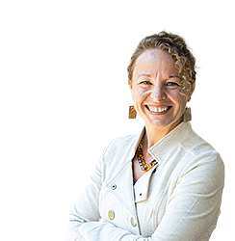
On May 15, 2021, Dr. Mary Bresnahan retired after 34 years of service to the Department of Communication. Many of our alum readers likely learned about intercultural communication, diversity, or intercultural psychology from Dr. Bresnahan. Though we are saddened by her departure, we stand in awe of the amazing career she had. Mary retires with well over 100 publications, an esteemed MSU Beal award and a legacy of dozens of graduate students who attribute their successes to her. Mary influenced the field on intercultural communication in ways that are not quantifiable.

Mary wrote:
“In Dreams from My Father which is an amazing read, Barack Obama writes (p. 285): ‘Legacy is a sense that you belong to something that will outlast your own life—and that when your time finally comes, a community will be there to remember you.”
That is how I feel about my time in our department...I wanted to be able to stand proudly with all of you—an amazing faculty of scholars and wonderful colleagues.”

SPRING ISSUE 2021

Mo's Megaphone

This Spring Dr. Maria Lapinski was awarded the prestigious MSU Beal Award. Lapinski, Professor and Director of the Health and Risk Communication Center, was recognized by the university for her excellence in research. Lapinski, who is also an alumna of our B.A. and Ph.D. programs, works in the areas of health and risk communication, persuasion, and most notably, social norms. Her model, Theory of Normative Social Behavior, has been cited and tested by numerous scholars across the globe. We are thrilled that Dr. Lapinski's work is being recognized in this way! Check out all the 2021 Beal Awardees.

Here are three examples of exciting initiatives we launched this year:
We launched a new major in the Fall of 2020! Communication, Leadership and Strategy offers students a series of practical and theory-based courses that teach principles of strategic communication, crisis communication, experiential learning, and more. This major leverages our existing expertise in organizational & interpersonal communication, media, and leadership and pairs courses in these areas with new CLaS courses. The CLaS major is directed by Professor Shawn Turner who came to MSU after a nearly 3-decades long career working in strategic communication for the federal government. In the Spring of 2021 Shawn took a prestigious leave of absence to assist the presidential administration with a critical role (check out this story about Shawn here). Still, Shawn will teach two CLaS courses each year until he returns full time!
Our department received a small grant from the MSU graduate school to kick-off a series of diversity, equity and inclusion initiatives. We want to ensure the voices of all COM majors are heard. Diversity comes in many forms, some visible and some not. All people are wanted in our major, on our research teams, at our speaker events, and “at the table”. We are increasing research fellowships, student representation on committees, and research that benefits diverse communities.
We started a new tradition: The Celebrating Excellence in Communication Scholarship panel.
This inaugural event, held online on June 4th 2021, featured two stellar scholars whose research is making a difference in underserved and vulnerable communities. Read more about Dr. Shardé Davis and Dr. Dana Mastro here.

Thank you for supporting the Department of Communication. In emotionally and financially difficult times, we think of the students and alum who trust us to train the best students with the most
up-to-date and relevant material.
You are our most important ally and we aim to make you proud. Go Green!
Mo

SPRING ISSUE 2021

WooHoo! Great things from Alumni!
Catherine Kingsley
Westerman won a Fulbright
Award to South Korea for
Fall 2020.
Allison Mazur completed
the first year of her PhD
program at UCSB, and
recently won the ICA
Interpersonal
Chelsea Fristoe led the
Diversity and Inclusion
initiative for the past year,
creating an LGBTQ
employee resource group in
Eastt Lansing from the
ground up, and drove
massive cultural change!
Lansing-based Martin
Waymire's Roger Martin,
APR, Andie Poole, APR, and
Angela Minicuci, APR,
received a Silver Anvil for
Public Service Campaign
from the Public Relations
Society of America.
Lauren Tamboer earned a
position with WA State
Department of Ecology
helping to implement the
nation’s most stringent law
related to reducing toxic
chemicals in consumer
products
Jennifer Shebib is
celebrating 35 years in
the Detroit area
Advertising industry

Do you have something to share with us?
Communication Division
Outstanding Master’s
Thesis Award for 2020.
from working from
agency to sales
positions!
Fill out this form to be featured next time!
SPRING ISSUE 2021

...and congrats to alumni starting
Dave Keating
Assistant Professor
University of New Mexico
Yi Zhu
Assistant Professor
Beijing Normal University
Assistant Professor
Sam Houston State
University
Xiaodi Yan
Assistant Professor
University of Politics and
Law in Beijing
University of Alabama
Birmingham
Melinda Aley
Lecturer
Montana State
University
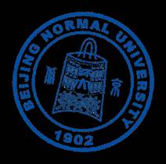
new careers!
Kevin Kryston
Samantha Shebib
Assistant Professor

SPRING ISSUE 2021

The Story of Gordon Freedman
MSU COMM alumni can be found across the globe running companies, creating strategy, consulting, developing campaigns, engaging in human resource management and other important and fascinating careers. And, sometimes, they have worked in various industries ranging from covering political scandals to creating documentary films to working in education. And, Gordon Freedman has done it all! Gordon is a Department of Communication alumnus who has had an interesting and winding career path. He worked on Capitol Hill as a staffer during the Watergate hearings, then moved into a career in news journalism, then television production and film. He is currently working on changing the structure of education to bring it up to date in the age of information technology, apps and the Internet. Linked student, Kaumudi Mahajan (KM), had the opportunity to interview Gordon and talk to him about how his degree in communication made an impact on his life.

KM: Could you tell us about your time at MSU? What was it like when you were a student there?
GF: I started off at the University of Denver and then, since I’m from Michigan and it was expensive to attend a private school in Colorado, I returned to Michigan to finish up. I started by looking at University of Michigan but, surprisingly Michigan State seemed more interesting to me. I was drawn to MSU’s interpersonal psychology program and a couple other areas. U of M, at the time, was very behaviorist, very quantitative, which really seemed very out of touch with where psychology was going in the early 1970s. I thought it would be the other way around between MSU and U of M!

However, the MSU Communication Department had become the most fascinating element of MSU to me because it was a way to take sociology and psychology and actual human activity and put them into a framework that allowed you to look at how society works on one level, and how things happen between people on another level. At the time, the war in Vietnam and the protests in the U.S. seemed to indicate that the country needed deeper understanding across the divides.

My interest was in the theoretical side of communication as a framework to examine human behavior, personal, social and political. I found this much more satisfying than psychology or sociology as subjects by themselves because it seemed to be an active form of social science, and something that was new and thoughtful and useful. Also, this was a time when the COM Department faculty were astounding, national and international leaders in communication theory and practice. I didn’t know until later how special some of them were or the department was.

One faculty member who made a deep impression on me was Donald Cushman. Cushman said something that stuck in my mind for all time and has been important to me in everything I’ve done. He said, “The job of the critic is to unmask false pieties.” So, if you think about that ... you look at the things that politicians or corporations say and wonder, “How can I get to the bottom of what that means?” what are they cloaking with their rhetoric? What lurks beneath the surface?”
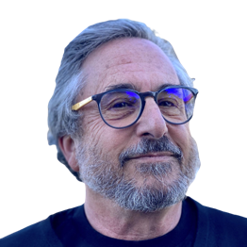
That little saying summed up a lot of what it meant to be in the COM Department, as opposed to Comm Arts. Ironically, I had no intention of going into the news, media or film, but eventually ended up in all of them using the theory I learned in MSU to better perform my reporting.
I’d sum up by saying that the communication department gave me a perspective that I could use to analyze a variety of social, political and business organizations.
– Gordon Freedman

SPRING ISSUE 2021

KM: Were there specific theories or experiences you had throughout your education that prepared you for your career path?
GF: I would say so. For one, I’ve had a great interest in organizational behavior and its effects on individuals and their well-being. This included the foundational readings and interpretations we were taught, especially of George Herbert Mead’s work examining meaning and how it arises in
language and relates to the self in society. I would say the framework of how meaning gets created, transmitted and where that breaks down is essential for interpersonal communication, or if you’re posting a blog or reporting for the New York Times. Also, the truth value of what people say, write and communicate is important as well, something that is severely challenged today. It is getting more difficult to “unmask false pieties.”

For anyone that’s considering going into broadcast, news journalism, film or social media, not having a broad understanding of human communication is a mistake. What is on the surface and why it is on the news, or film, and who it benefits, is often very deceiving though appearing quite legitimate.
We need to deconstruct to understand.

KM: So, are there strategies you’d tell people to employ when they’re trying to decipher the real meaning behind what someone is saying?
GF: I learned something equally lasting from outside the COM Department from an outstanding abnormal psychology faculty mentor, Dr. Marian Kinget, who had been associated with the European philosophy of phenomenology and the work of human-centered psychologist Carl Rogers. In phenomenology, it is the job of the philosopher, or observer, to get through as many layers of “suppositions” or assumptions being presented to finally understand what someone is saying, and why they are saying it in a given situation.
When you hear political talk, or corporate speak, the question is what the presuppositions are being made that are not spoken, and what are they based on. In this scenario, the job is to uncover those presuppositions, or the pre-positions, which are being stated or might be the rhetoric of a political movement or an economic theory.
There’s intention, attention and being able to peel back the layers to ask, “What is sitting in the background of the speaker and their associations and relationship to give them the validity to make that statement, and what should I make of it?”
When there's communication, it’s never a simple matter.

KM: Can you give us a quick summary of your career path?
GF: Across my career, I have worked as a political corruption investigator on Capitol Hill, an investigative reporter in the Washington, DC news corps, a network television news and news magazine show producer and feature film and television producer. In those jobs, I was bringing information not known to the public and processing it for public consumption — in Congressional hearings, in newsprint, broadcast news or actually in documentary film or entertainment based on fact.
All this including making a feature documentary on Stephen Hawking which won at the Sundance Film Festival. That film changed my perspective of being a processor of information not well-known or understood by the public to thinking how I could put my communication theory perspectives to use in reform — not processing others’ experiences — but taking a challenging area, like education transformation, and trying to construct better approaches.
So, in 1998 as the Internet emerged, I made a sharp turn away from media and commenting on society and digging around its edges to trying to deconstruct where the failure in education was coming from because so many young people and working adults will never have a good education like I had. Education to me is an entire communication and knowledge ecosystem that needs to be vastly improved and modernized. I use my Comm theory experience to look for points of failure and for points where leaners and their institutions can progress together.
SPRING ISSUE 2021

KM: How did you start off on this the multiple career path you have taken?
GF: When I was at MSU, during my spring semester of my sophomore year, I was taking a logic class that, for the life of me, I couldn’t figure out. At the same time, the country was embroiled in the Vietnam War, and we were beginning to go through an earlier version of what we had been through with the Russian investigations of President Trump. This was the beginning of the Watergate investigations of former President Richard Nixon. It is hard to understand now how surprised and polarized the country was when Nixon was accused of campaign violations, using secret teams to break into the Democratic National Committee headquarters or the office of major government dissident and lie about it. The American was naïve then. But for us, a new young generation, these things seemed wrong.
I was one of the students who attended rallies and to sleep-ins on the campus grounds, though I would sneak to class during the day. The news was full of Nixon’s alleged misdeeds, and hearings were beginning in Congress. I felt what had been happening in the streets in protest was now coming to Congress and I wanted to go see this. So I left my logic and other classes behind and drove to DC to watch the hearings in person, leaving in my beat-up, orange VW Bug.
There were long lines to get into the hearing, and someone I met in line asked me, “If you are so interested in this, maybe you could get a job here.” I didn’t think it was even possible to “get a job,” but somehow, I started to explore the possibilities, and eventually I found myself on the staff of the Senate Watergate Committee. Right after I landed the job, my parents, upset that I abandoned classes, wanted me to return to MSU. However, COM Department Chair Dr. David Ralph, saved me. He said, “What we do as academics is the same every year, it’s boring. You need to go get us the scoop and bring it back here,” adding, “You tell your parents that the Chair said you must stay in DC.” The COM Department came through for me!
As I started as a researcher on the Senate Committee looking for political corruption and illegal behavior of the Senate staff, my thinking was guided by what I was learning about how to analyze and put complex matters into a theoretical perspective that could guide understanding. To me, political corruption was when “practice becomes principle.” This saying and what it implies has stayed with me. In fact, to assuage my parents, I did two independent studies while in the Senate staff jobs and one of them was about how rhetoric and meaning degrade when people in power deviate for their own or their factions’ interests.
The Nixon Administration started to reinterpret the U.S. Constitution, replacing Constitutional principles with their own practice. In the hearings, this was severely rebuked. The chairman of the committee would shake a tiny copy of the U.S. Constitution at the president's aides in a way that one might shake a cross at a vampire to bring them back to our Constitutional foundations.
While I was finally finishing up at Michigan State after the Watergate investigation, I started commuting back and forth to DC while working on Capitol Hill in two
more Congressional investigations that followed Watergate. In my time on the “Hill” I got to know the

written press and the new
media quite well, sometimes giving backgrounders, or in a few cases, being a source.

KM: Do you think that the idea
of ‘practice becoming principle’ in

I learned a lot that is not taught in journalism school through the back and forth with the press and news media while
working as a Congressional staffer.

government and advertising has become more prevalent in how we’ve been operating?
GF: I think it’s very difficult today to get back to an agreement on what the principles are and to have a meaningful relationship or understanding the value of truth. Since the truth has become a variable, it’s hard to understand where the truth plays a roll. It’s much harder now to become a journalist or media person because it appears that politics of all kinds have become more of a sport than about actual governance.
Most good writers seem to be trying to come back to principles and truth, but since principles are being twisted and debated now, the journalist’s job is much more difficult, and this would apply to advertising as well.

SPRING ISSUE 2021

Truth telling is not just a good Samaritan quality, but rather a way to organize society to operate cooperatively, something that is severely challenged now, and communication analysis and action is more important than ever.

KM: How do you think your approach to communication has shifted over the years?
GF: Well, the world is a completely different place now then it was when I was at MSU in the sense of the Internet and mobile communications! Now we’re living in a world where there’s no shortage of information or access to it. Every sector in the economy (finance, manufacturing, medicine, etc.) has made great use of information technology. When you log into any traditional e-commerce system, you’re logging in as an individual, and hopefully it’s doing you some good. The only sector that hasn’t taken real advantage of the information technology revolution is education and higher-ed.
We’re in a time of virtual education where people have used tools that were designed for online learning. But these tools are just an extension of what the classroom looks like in person. We just took it and moved it online. The communication framework for education today is the same as it was many years ago: stuck in the separate organizational structures. But for students in the informational age who are trying to gather information and deduce what they’re doing to do with their life, career and general future, there are no tools for this in K12 or higher ed like there are on the web for everything else.

So to conclude, to come full circle from my personal educational experience, education is now in need of being transformed to leverage the information age to match education to jobs and to open the process to all people, not to exclude them because of poverty, race or other constrains. Education is what the future is based on — for all of us.

I don’t see schools of communication actually going in and analyzing this kind of problem. Yet, these are all communication issues. Michigan State has one of the best communication and education departments in the country. My hope, if I can contribute further, is to try to bring those two MSU departments together to build a more solid structure for learning in class and on the open Web so more learners can contribute personally, socially and economically to keep our country strong.

“I think the Communication Department training I had at Michigan State gave me the ability to hear any kind of discourse and peel back the layers to actually see what’s going on and not get pulled into it emotionally. I think this is really important; all communication in itself is not complete. Each person brings a history of other material to it. I use that training every day and with everything I do.” -- Gordon Freedman

I think the Communication Department training I had at Michigan State gave me the ability to hear any kind of discourse and peel back the layers to actually see what’s going on and not get pulled into it emotionally. I think this is really important; all communication in itself is not complete. Each person brings a history of other material to it. I use that training every day and with everything I do.

SPRING ISSUE 2021

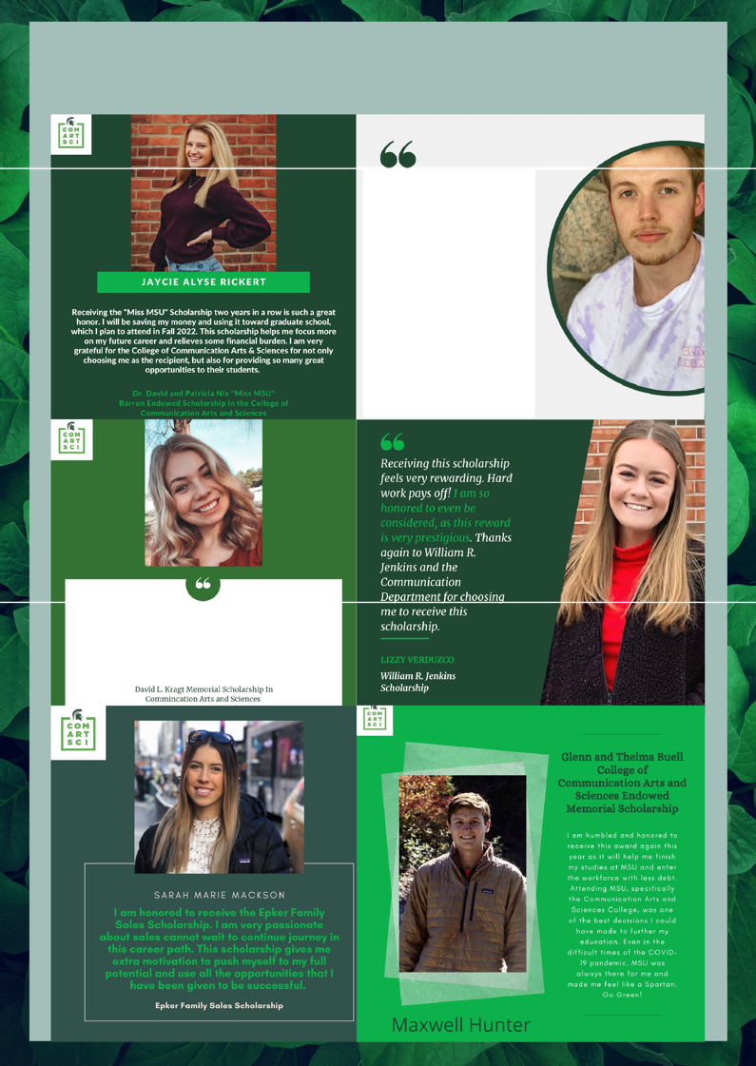
Super Student Scholarships

Gawronski Family Scholarship
This scholarship has given me confidence to keep growing as a person and to appreciate past experiences because they can and will play a role in the future decisions I make

--JACOB KIPP WINIGER

I want to make a difference and help people have a better quality of life. Everyone deserves the opportunity to communicate with their peers. Everyone deserves to be able to share their opinions and ideas. With a degree in Speech Pathology, I will be able to assist people in being able to better communicate. The David L. Kragt Memorial Scholarship will help me continue my education so that I am able to help people and make a difference in the world

KATIE WAHL

SPRING ISSUE 2021

Faculty Feature: Meet Brandon Van der Heide
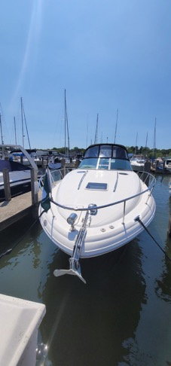
Once the snow melts, the air becomes warm, and final grades are turned in, many Michiganders head “up north”. But, for Brandon Van der Heide (Associate Professor and Coordinator of the Doctoral Program), the warm weather means heading west to his boat. During the summer months you can find Brandon, his wife Jen (Associate Professor in the College of Education) and their son Liam working and playing on their boat that is docked in Holland, Michigan.

When I asked Brandon why he wants his “summer cottage” to float—he said “I have always loved the great lakes, particularly Lake Michigan. I love having the freedom to make almost any harbor on Michigan's west coast our back yard for the night. I also really love being able to teach myself new skills that are unrelated to my job (e.g., engine maintenance, nautical navigation, boat handling, etc.) Finally, although we didn't necessarily expect this when we got into boating, but boaters have the capacity to be some of the most wonderful, caring people There is sort of an egalitarian "we're all in this together" spirit among boaters. It doesn't matter if you own a multimillion- dollar 75-footer, or you just snagged your first 40-
year-old boat from Craigslist, we all live together at the marina, want to make sure that we're all enjoying the water, want to protect Michigan's water resources, and want to help keep everyone safe and happy into and out of Michigan's waterways. It's both weird and awesome that people so different from one another could share such a tie that binds them all together.”

Brandon likes the saying “"The hardest knot to untie is the cleat hitch.’ “This quote requires a bit of explanation, probably. The cleat hitch is the knot that one uses to tie their boat to the dock. It's actually a very easy knot to untie, physically speaking. It's made to be easy to untie because if you ever need to get away from the dock in a hurry, you can easily take off without trouble, even if the line is tight. The reason the cleat hitch is "hard" to untie is because leaving the dock is terrifying. You're doing something new, something scary. You're putting a fairly big asset at risk. Weather can whip up, even on the great lakes, at just a moment's notice.

So leaving the dock is scary--even for seasoned boaters. Which leads me to my absolute favorite quote (of which I must remind myself each time we untie from the dock), commonly attributed to Mark Twain: "Twenty years from now, you will be more disappointed by the things you didn't do than those you did. So, throw off the bowlines. Sail away from the safe harbor. Catch the wind in your sails. Explore. Dream Discover."

SPRING ISSUE 2021

Stay in touch!

@CommDeptMSU @CommDeptMSU

@CommDeptMSU

Get your MSU COMM T-Shirt today!
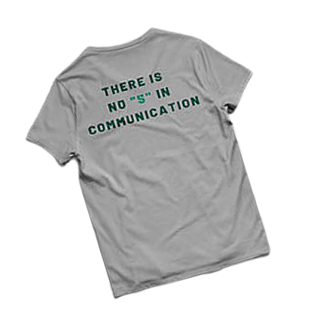
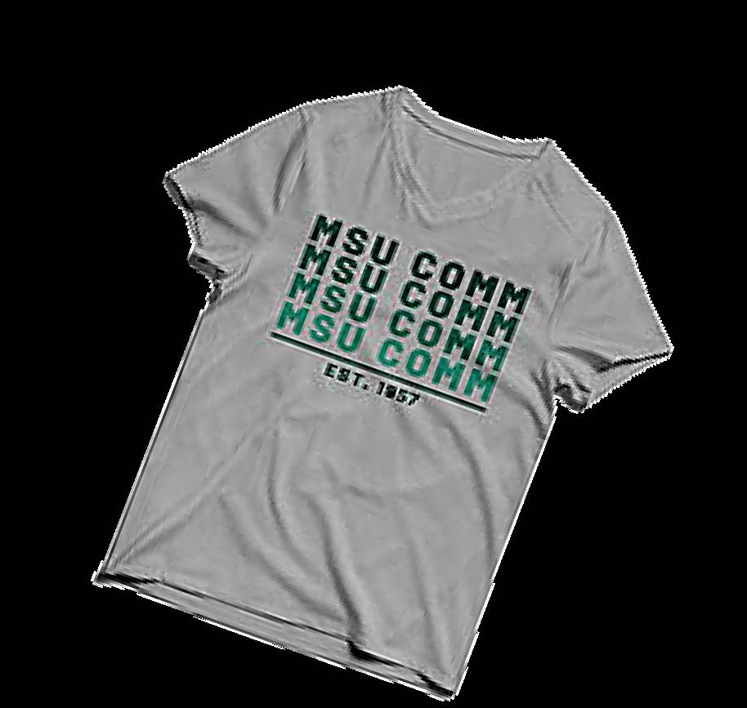
Due to COVID-19 we are now shipping all orders nationwide only. Please allow up to 30 days for delivery.
commerce.cashnet.com/msu_3827

SPRING ISSUE 2021

