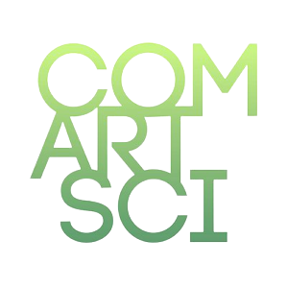
THE SPOTLIGHT
M S U D E P A R T M E N T O F C O M M U N I C A T I O N

• 2 0 2 1 - 2 0 2 2 •

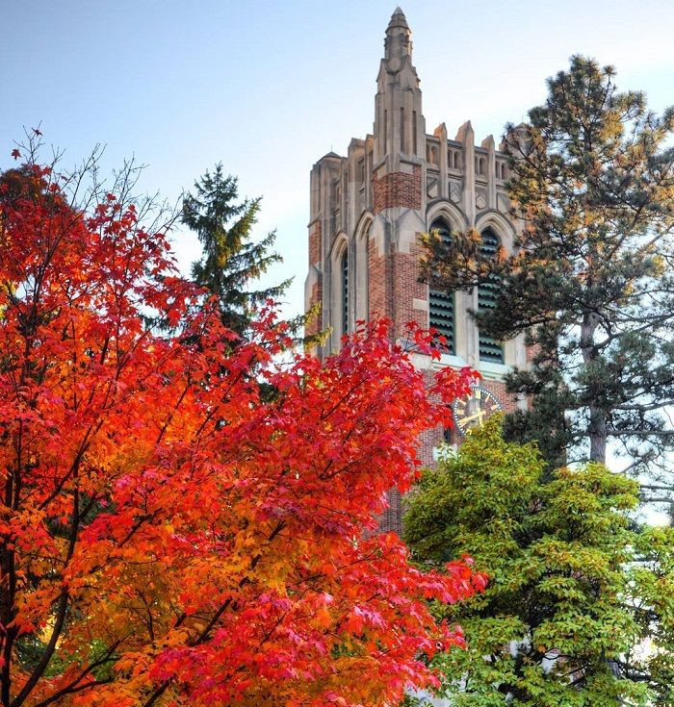

W H A T ' S I N S I D E

Communication Careers

The Origin of a New Major

Alumni Spotlight

M O ' S M E G A P H O N E
BY MONIQUE TURNER

I have been heard saying, more than once, “Now is the time to study and practice communication!”. My repeated beating of this communication drum is probably getting tired. But it is still an important and relevant message. Particularly in a global pandemic, ineffective communication, miscommunication, unclear communication, and/or sources who lack credibility can lead to the loss of human life.
Everything we know about credibility, crisis and risk messaging, non-verbal communication, interpersonal dynamics, organizational trust, media effects, and political polarization (I could go on and on) are affecting the various dramas we watch play out in our lives, and our communities, and on the news every day.

M O ' S M E G A P H O N E ( C O N T . )
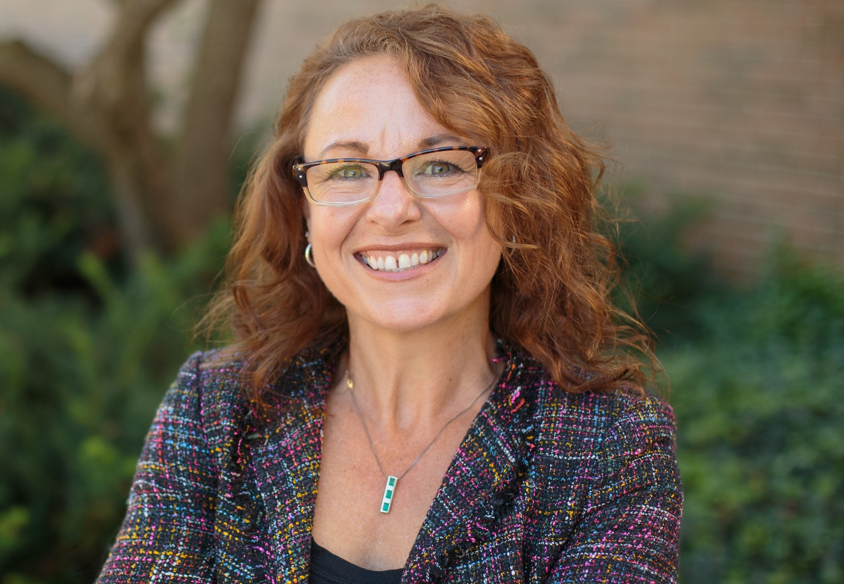

It is no secret that communication science has struggled to get the kind of respect STEM fields receive. For example, let’s consider federal funders of research. Most of the National Institutes of Health (NIH) funds go to medical clinical trials and “bench science”. Indeed, there are zero institutes dedicated to health communication. The National Science Foundation (NSF) has some focus on economics and behavioral sciences—but no specific focus on communication processes. And, yet, we know that bad communication is dangerous. Take COVID-19 as one salient example. When communication is unclear (quarantine or not?), too complex (Do vaccines prevent the virus or make it so people would have less severe consequences?), or seems contradictory to previous communication (Is this virus airborne or not?), message receivers become frustrated, and the message source loses credibility. This frustration can build into anger. In fact, Turner, Lapinski, and Peng’s (unpublished) NSF data showed us that when 10,000 US adults were asked about the primary emotion they felt when they thought about COVID-19, about 25% of them indicated anger. My own research indicates that anger has an important relationship with the ways in which we process health information. What am I trying to say here? Communication practitioners and experts, and a focus on communication science, would have been a great help over the last 2 years.
Francis Collins, former Director of the National Institutes of Health, came to this realization late in the game. Collins is a traditional STEM scholar, a biomedical researcher to be exact, who made his name by running the Human Genome Project. Read what he had to say about this when interviewed by The New York Times:

“I do think we need to understand better how — in the current climate — people make decisions. I don't think I anticipated the degree to which the tribalism of our current society would actually interfere with abilities to size up medical information and make the kinds of decisions that were going to help people. To have now 60 million people still holding off of taking advantage of lifesaving vaccines is pretty unexpected. It does make me, at least, realize, "Boy, there are things about human behavior that I don't think we had invested enough into understanding." We basically have seen the accurate medical information overtaken, all too often, by the inaccurate conspiracies and false information on social media. It's a whole other world out there. We used to think that if knowledge was made available from credible sources, it would win the day. That's not happening now… We're having serious conversations right now [at NIH] about whether this ought to be a special initiative at NIH to put more research into health communications and how best to frame those [messages] so that they reach people who may otherwise be influenced by information that's simply not based on evidence. Because I don't think you could look at the current circumstance now and say it's gone very well.”

See the entire piece here.

I’m proud to tell you that our faculty and graduate students are engaging in studies that Francis Collins needed; in fact, in this issue, Johnny McGraw (MA student) interviewed Dustin Carnahan about his work on misinformation.
Maria Lapinski and Sandi Smith’s research on health and risk communication would be a good read too. It’s our time, communicators! This is our time to take a seat at the table and make clear the importance of our work. We need to be out front sharing our knowledge and skills. It is time for people to see that financial outcomes, reputations, brands, worker’s’ quality of life, and yes, human lives, are dependent upon the understanding human communication processes and effects. Students, alum, and friends of the department: I will be preaching from the mountain tops about the worth of our work and scholarship—and I invite you to do so also. It is our time.

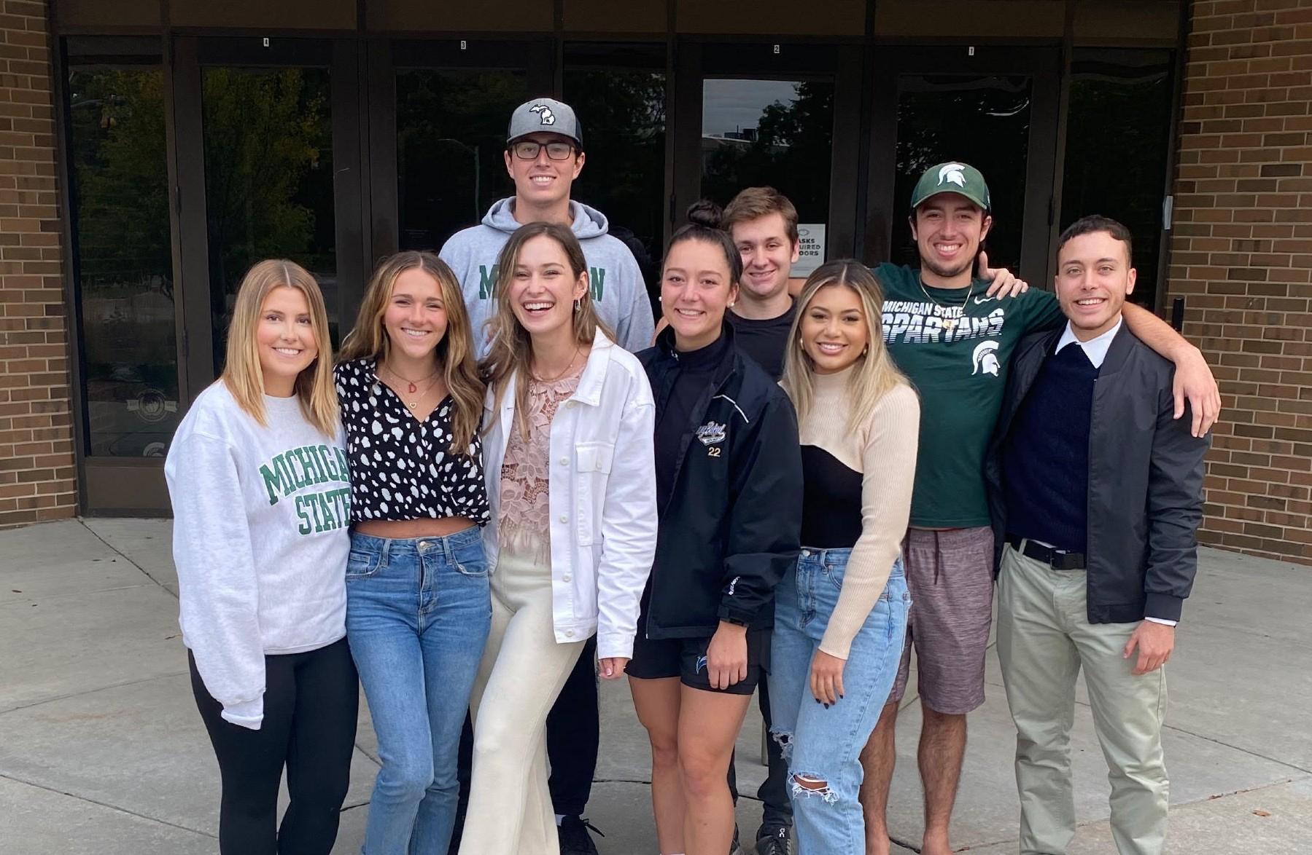
THE SPOTLIGHT • 2021-2022

C O M M U N I C A T I O N L E A D E R S H I P & S T R A T E G Y

The Communication Leadership and Strategy major has its first graduating cohort this year! The CLAS seniors wrapped up their program with a capstone course taught by the program's director, Shawn Turner. In the course, students in the major were able to apply the skills emphasized throughout the program to real-world communication problems. The students had the opportunity to work with Traverse Bay Children’s Advocacy Center, Ingham County 911, and PepsiCo! The graduating cohort also welcomed 17 experts in strategic communication to talk about the various complexities of working in the field. The speakers offered a wide variety of different perspectives and future career opportunities.
The speakers not only helped the students further their knowledge, but provided them an opportunity to network and discover the directions this major can take them on their career path post-graduation.

CLAS also launched a student association, the CLAS Society, which offers both social and professional support to students.
The inaugural board members were Gabrielle Winfrey-President, Samantha Tricarico-Vice President, Darby Walker- Secretary, and Calena Carabelli-Treasurer. The new major has shown to be an integral aspect of the Department of Communication and we expect continued growth for future semesters to come!

C O M M U N I C A T I O N L E A D E R S H I P & S T R A T E G Y S T U D E N T S

What assignment did you enjoy the most and why? Did it prepare you for future roles?
In COM 480, we developed a communication plan for two
organizations in crisis. I enjoyed this the most because these were real-world problems that two organizations were having and our teams worked to help them with their challenges. This project helped the most in preparing us for future roles, because this experience is exactly what I envision working in future roles would look like.
What course in CLAS was your favorite and why?
COM 480, we learned about how to write and present a strategic communication plan for real organizations. we ended up helping the organizations in solving complex challenges, It's a great feeling to know that we were able to imake a diffence for them both.
What is your favorite takeaway from your time in CLAS?
My favorite takeaway from my time in CLAS is the connections that were built during class. Professor Shawn Turner helped every member of CLAS network to many important people throughout the semester by bringing them in to talk about what they do. This gave me a much better understanding of what I want to do after I graduate.
What skills did you develop throughout your time in the major?
How will you utilize these post-grad?
How to work and handle a crisis, which I feel is one of the most important skills you can have. This skill can be the difference between saving a company or ruining a company. I will utilize this post-grad by helping the company I work for in their time of need to ensure they come out of their crisis without any fallbacks.
I N T E R V I E W E R : G A B R I E L L E W I N F R E Y
What assignment did you enjoy the most and why? Working with real clients in the capstone, COM 480. We had our professor to lean on and ask questions to, but we did most of the work. I enjoyed working with my classmates to come up with two unique communication plans.
What speaker impacted you and how so?
Mark Riley impacted me the most. He gave us his top 6 key reminders to remember when working in the communications industry. Those 6 reminders resonated with me the most because I could use them in my life right now in school, track, and in my relationships with people.
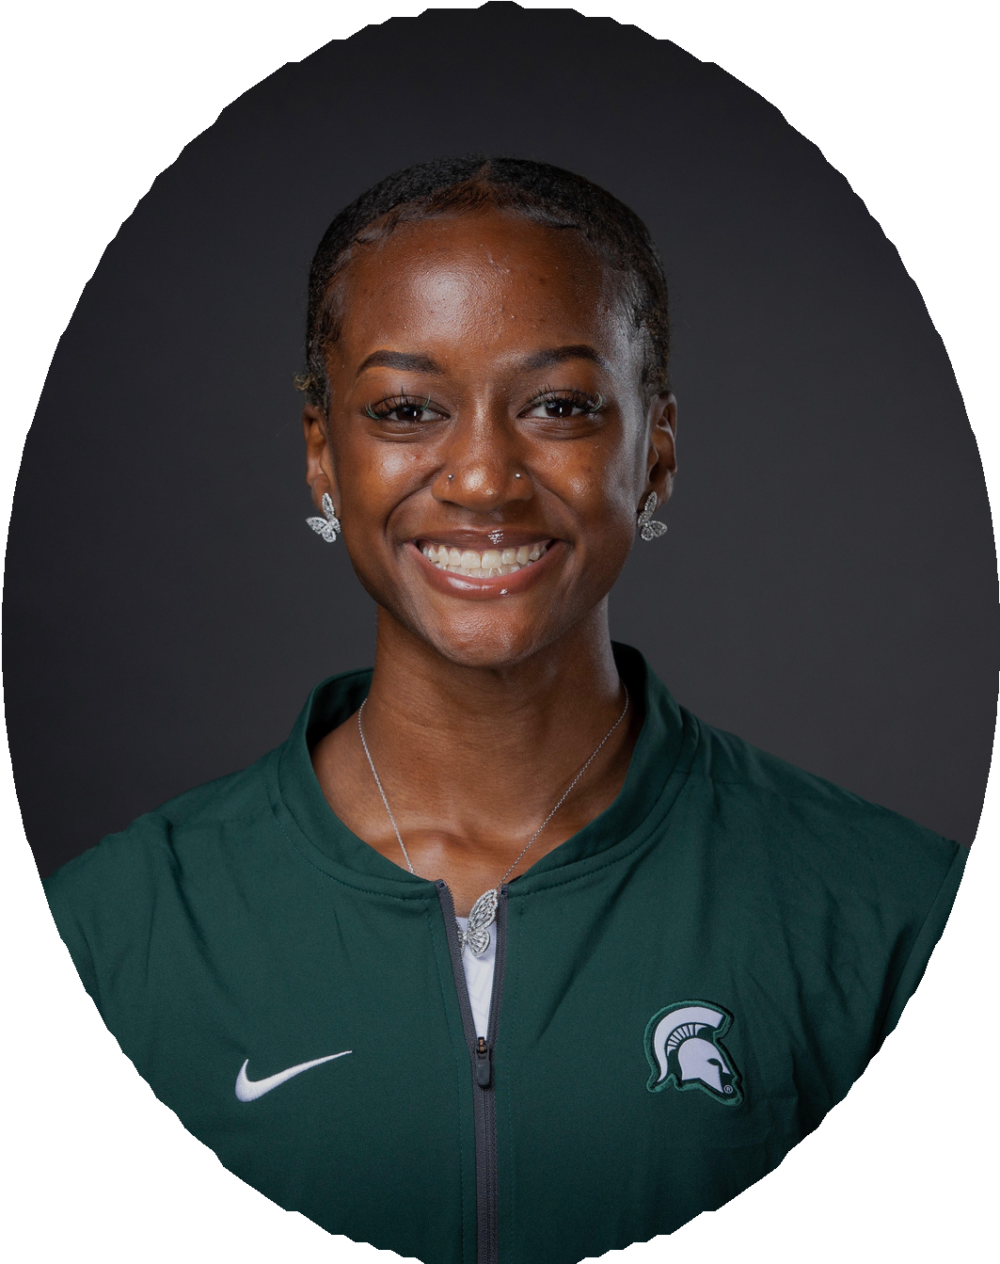
Shakira Dancy
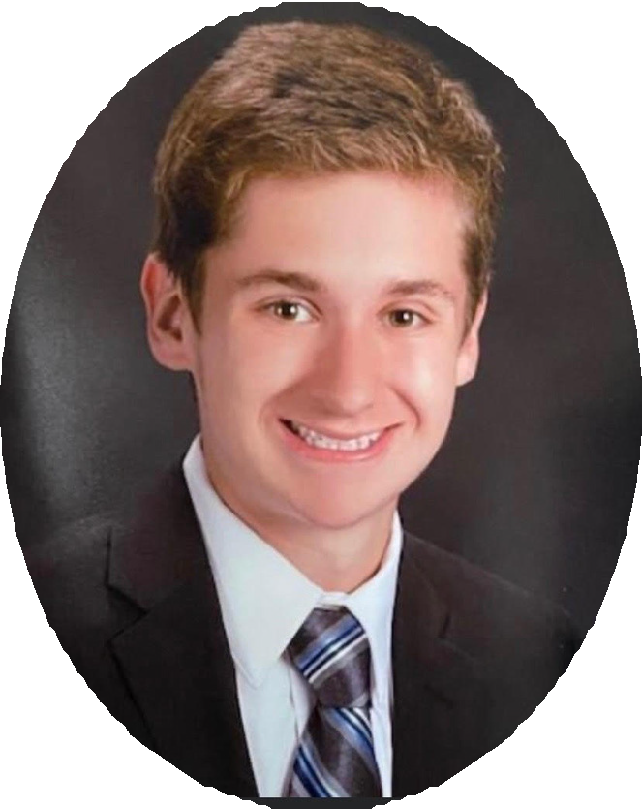
Ryan Simmons
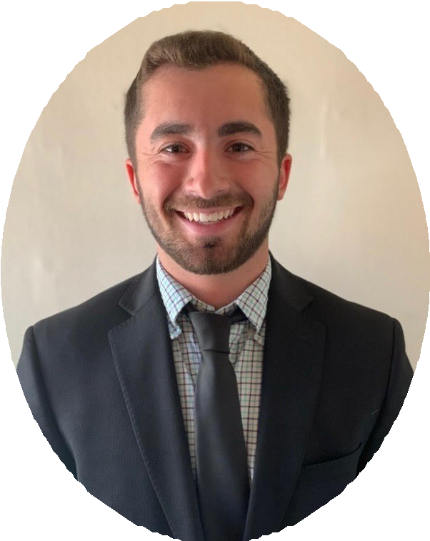
Colton O'Doherty

S T U D E N T S I N R E S E A R C H
MSU UNDERGRADUATE STUDENTS GET THE OPPORTUNITY TO BE A PART OF RENOWNED RESEARCH TEAMS DOING GROUNDBREAKING WORK
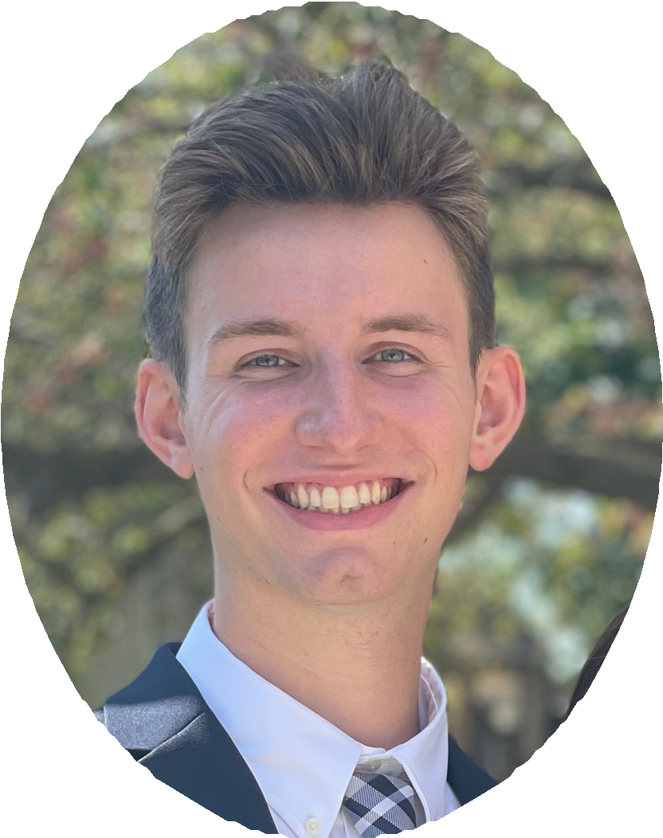

As an undergraduate research assistant, I was able to work with people who are professionals in my field. I had never thought that I could be on a team with master's and Ph.D. students, but they showed me what a graduate degree in communication looked like. Meanwhile, as a Communication Leadership and Strategy student, working with Professor Monique Turner who is the chair of the Communication Department is a real honor. I learned that being an undergraduate student is not just about going to class, doing the assignments, and finishing the exams. It can involve exploring more new areas in your field rather than only taking doing something that is already familar.
- YUYING PENG
As a research assistant, I was able to have the ultimate hands-on experience by independently analyzing and collecting data-using critical thinking, problem-solving, and communication skills that will help my career excel in any industry.
- KATRICE LARKINS-SANDERS

Learning about the research process as an undergrad at MSU was the jumpstart I needed to set me on the right track to excel in my post-grad goals. As a master's student at MSU now, I couldn't be more appreciative looking back on the research I got to be a part of as an undergrad.
From establishing great relationships with professors to learning about theory and the process-driven approach that one must take when doing research, the journey has been beneficial across the board from start to finish. I would recommend it to any undergrad who has even the slightest interest in doing research.
- JOHNNY MCGRAW

C O M M U N I C A T I O N C A R E E R S
SEE WHAT OUR RECENT ALUMNI ARE UP TO
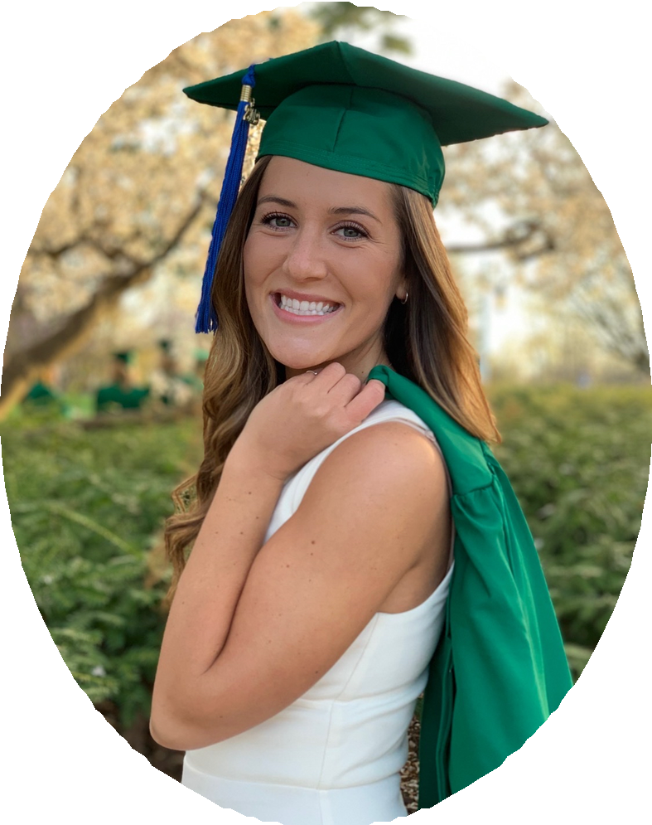
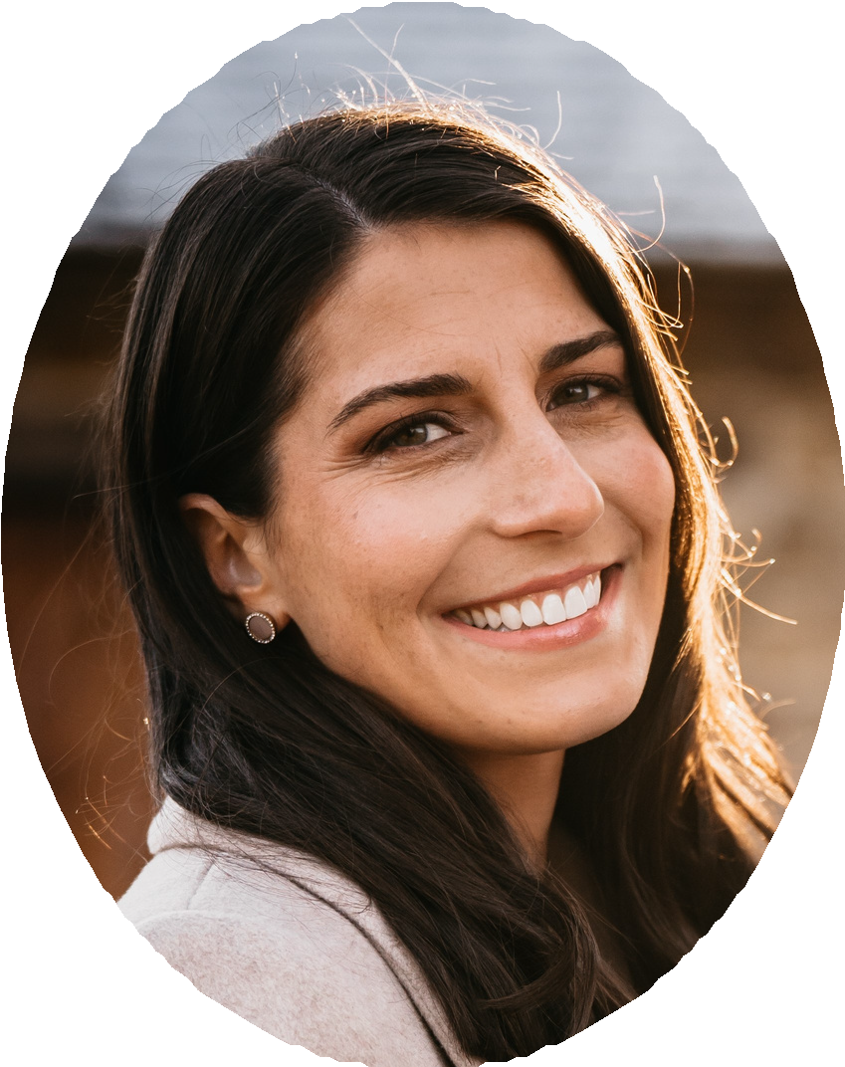
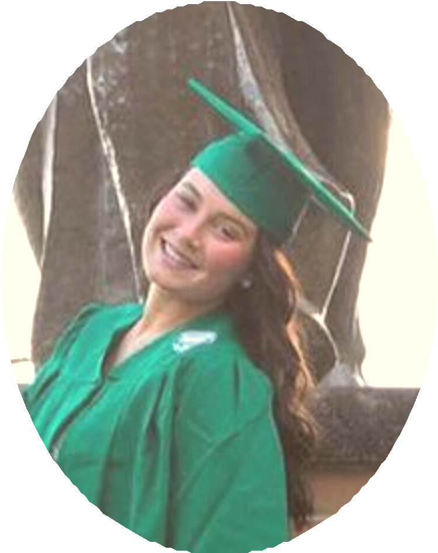

I am a Social Media Strategist on the Corporate Marketing team at Auto-Owners Insurance. In my current role, I am responsible for content creation, monitoring corporate social platforms, reviewing analytics, and helping build targeted ad campaigns. All the fun things that go along with social media! My communication degree fully prepared me for this position since I was well-rounded in interpersonal and mass communication. Learning how to effectively communicate on multiple different levels in college
made my career successful. I really enjoyed getting my degree from MSU because I was pushed outside my comfort zone, I learned many new skills, and I was able to improve the way I communicate with others. A communication degree prepares you for any job you apply for outside of college. Go Comm, Go Green!
- COURTNEY MUNFORD
I am a Director / Innovation Business Partner with NielsenIQ BASEs. I develop relationships with our retail clients (convenience, drug, grocery, pet, and mass retailers). I listen to the clients' quantitative market research needs and business questions and then recommend the appropriate research method to answer their questions. I'm responsible for selling, scoping, and managing the delivery of our innovative research projects. I'm also responsible for consulting with clients' cross- functional teams on strategic, financial, and executive decisions for both short and long-term innovation. Working with a wide range of clients every day, I still find myself drawing on the communication theories and research we discussed during my time at MSU to help grow these relationships. The research grants I was able to work on during those years also sparked my interest in continuing on with a research-focused career. I'm so grateful to help our clients using quantitative, data-driven insights every day.
- REBECCA KOZERSKI

I graduated in December 2021 with a bachelor's degree in communication and an additional major in human resource and labor relations. I minored in leadership of organizations and had a concentration in organizational communication.
When I was first a communication major, I was not sure what I wanted to do with my degree, but after taking the
core classes I realized that the human resource route was for me. I have accepted a full-time role as an Associate Team Relations Specialist at Rock Family of Companies. This role is in their Human Resource department and is a role that
helps support and develop team members within the company.
- HAILEY RITCHIE

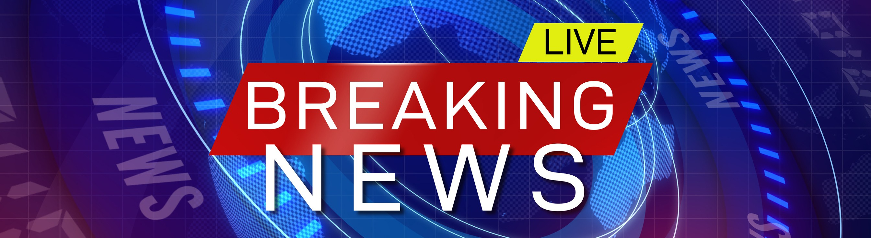

M I S I N F O R M A T I O N R E S E A R C H A T M S U
BY DR. DUSTIN CARNAHAN

Concerns around misinformation – defined as false, misleading, or unsubstantiated claims about the current state of the world – have risen dramatically in recent years given its implications for political discourse, scientific understanding, and public health. Dr. Dustin Carnahan discusses his research on misinformation and what can be done about it.

Why do people believe misinformation?
Most explanations center on motivated reasoning, or our tendency to accept statements that support our way of thinking and reject statements that don’t. For this reason, people will often find a falsehood that supports their worldview more believable than a truth that challenges it. Additionally, frequent exposure to misinformation can influence how easily we understand a falsehood and subsequently make the claim seem more believable – known as the illusory truth effect.

Exposure to misinformation is relatively uncommon.
While social media platforms and disreputable "news” websites have amplified the spread of misinformation, research has suggested that misinformation and fake news makes up only a fraction of what we see online. One recent study estimated that adults in the U.S. on average likely encountered only one or a few fake news stories during the 2016 election online, while other work suggests that high levels of engagement with misinformation occurs primarily amongst a small segment of the population.

Even so, misinformation remains a cause for concern.
While misinformation might not feature heavily in our information diets, it can still be problematic. During the 2016 U.S. presidential election, fake news stories – such as those proclaiming that Donald Trump was endorsed by Pope Francis – generated more engagements than news stories from reputable sources.

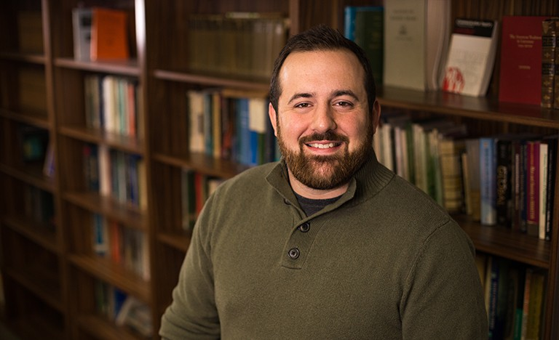

And other work suggests that misinformation spreads faster, farther, and deeper into our social networks than real news content. This suggests that even a small amount of misinformation has the potential to be highly disruptive.

What can we do about misinformation? Research has shown that the most effective strategies to combat misinformation take place before most of us even see it. Technological interventions, media literacy efforts, and pre- bunking messages that aim to prepare people to identify, avoid, and resist low-quality information
have been shown to successfully reduce both belief in and spread of misinformation.

But even after people believe misinformation, communication interventions such as fact-checking messages can improve belief accuracy – even on highly controversial topics. Our research suggests that corrective messages can successfully change the beliefs of even the most steadfast believers, and these effects are evident even several weeks later.
Further, our work suggests that these strategies are even more effective when measures are taken to reduce the threat that people might feel in response to a fact-checking message.

However, people often respond defensively to messages that tell them they are wrong, which limits the effectiveness of fact-checking messages. Additionally, misinformation can affect our attitudes and decisions even after it has been debunked, known as the continued influence effect. This highlights the need for early interventions aimed at addressing false and misleading claims before they reach a wide audience.

A L U M N I S P O T L I G H T
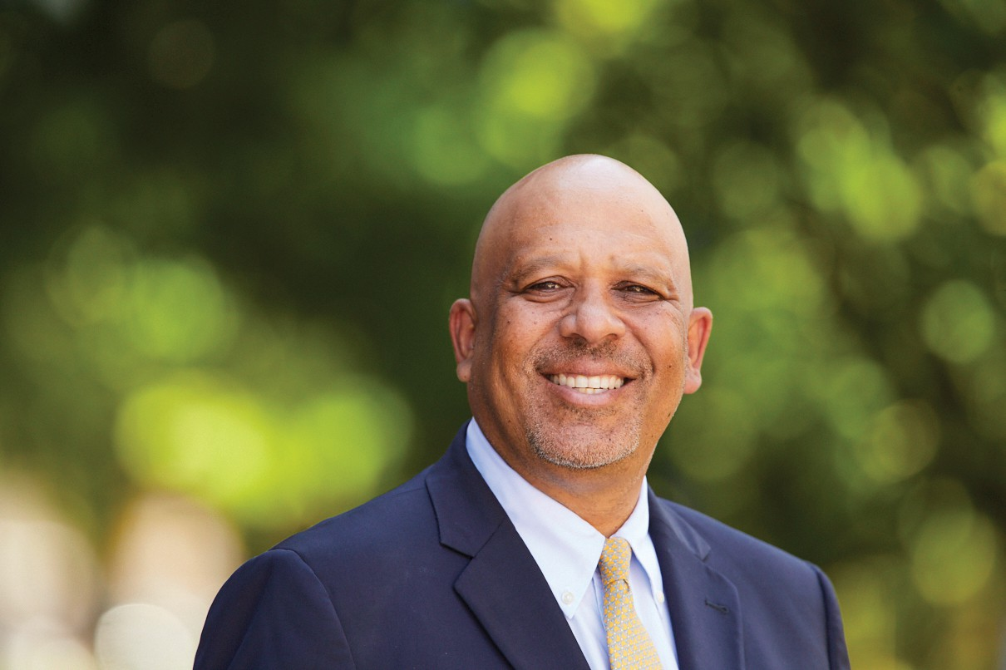
D R . K IM O A H Y U N
Provost and Executive Vice President for Academic Affairs, Marquette University

How has your degree in Communication served you in your specific career path?

As a Provost I have the opportunity to engage with many area leaders, including deans, vice presidents, and vice provosts. As a leader, it is important to have strong interpersonal skills, in addition to an understanding of human dynamics and the importance of focusing on the person as well as the objective. In this way, you must be flexible. Each person requires different types of engagement and this interpersonal flexibility allows for success. In addition to having strong interpersonal skills, my job also requires having strong persuasion skills. To get change in leadership, it begins with changing attitudes and behaviors, which are often complex and do not follow a linear path.

How did your degree in Communication from MSU build up the skills you use
every day in your area of work?

The approach from the Communication program at MSU is data driven.
I am asked to make recommendations at a university that has a budget that exceeds 400 million dollars. Strong skills in understanding data and presenting it in a way that is easily understood by all has become a key part of being successful in my position. It is important to make the right decisions for the university and stress that the data informs my decision.

What are some benefits of the degree
that you find yourself using more often than you may have thought you would?

Understanding and engaging in conflict management is something that I am asked to do regularly. With competing goals among different units, it is common for conflict to emerge. Understanding how to effectively understand the source of the conflict, frame it within the context of the university mission, and prioritize actions has helped to move the matter away from a specific individual and towards the greater good of the university. I have found this approach to be effective in deescalating conflict and in finding the most acceptable solutions for all.

A L U M N I S P O T L I G H T

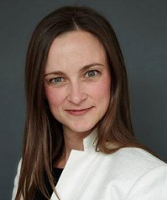
How has your degree in Communication served you in your specific career path?

MSU CAS Communication curriculum provided me real world experience that prepared me for full-time work post graduation. Between catered internships, guest lecturers, and CAS faculty who had come from the communication industry, this program was the triple-win. These experiences from both inside and outside of the lecture hall gave me the cutting edge on how to perform and react in the professional world as an entry-level associate. In addition, the impressive scale of the MSU student body and campus prepared me for how to live and work in metropolitan cities such as Washington D.C., Chicago, New York, and Los Angeles. MSU is a fully operating city within a city. You had to adapt quickly to get from point A to B on a vast campus, juggling a schedule and deadlines while building strong relationships with faculty, students, and staff at the same time. I have high hopes my two children will be Spartans, because I know it will prepare them for the real world.
V A N E S S A S H A Y
Chief Revenue Officer, San Diego National Women's Soccer League

S T A Y I N T O U C H !
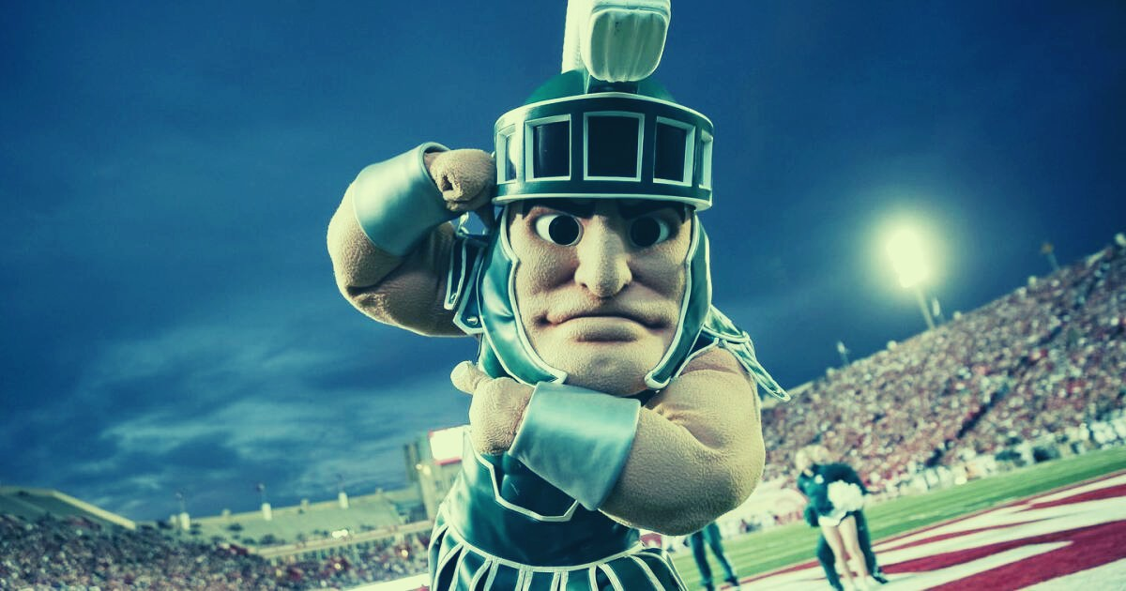

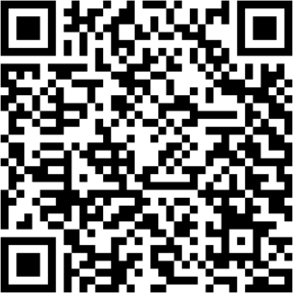
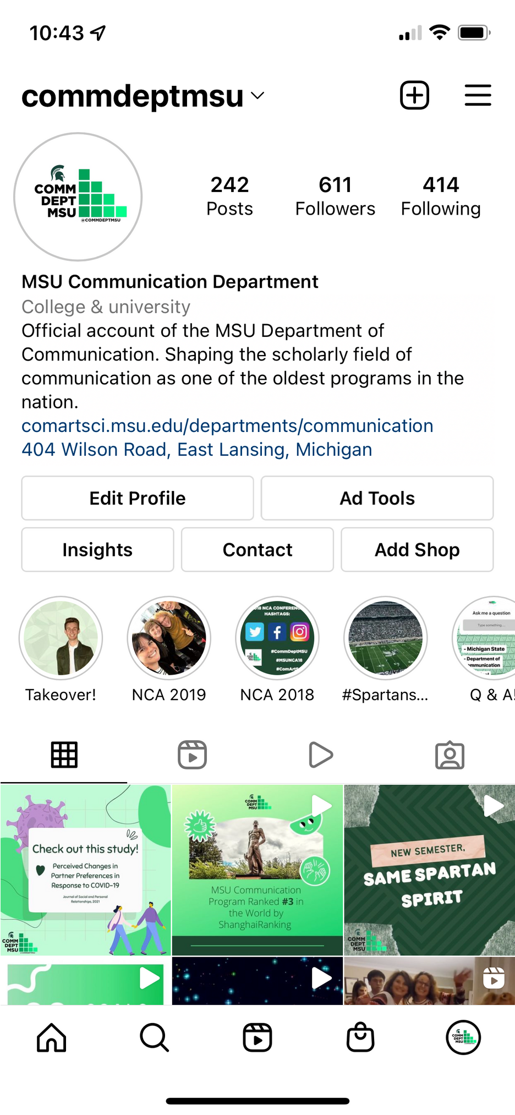
Got some great stuff going on? Whether it be a new job, an award you've won, or just an accomplishment you're proud of, let us know! It could get shared in our next newsletter!
Follow us on our social media! @commdeptmsu
Fill out our form here!

