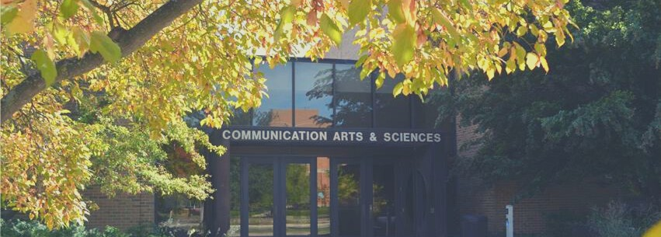

I N T H I S I S S U E

Mo's Megaphone

Whoo Hoo! Great Things from Alumni #COMMRocks... Literally
Colloquium Series Department T-Shirts
Professor Donohue Receives an Award

Stay up to date with the Department of Communication by following us on social media
@CommDeptMSU

@CommDeptMSU

@Michigan State University Communication Department OR @CommDeptMSU

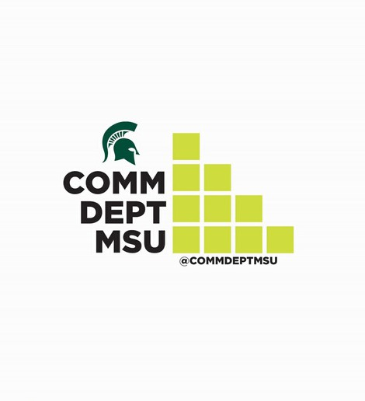
Undergraduate Communication Association 2019 NCA Conference
T H E S P O T L I G H T .
F A L L I S S U E 2 0 1 9

Mo's Megaphone: A Letter from the Editor

Of the many reasons for why I love the holiday season, one is because it reminds me to focus on what is truly important. Through all the grant deadlines, meetings, grading, revisions on papers, band concerts and soccer games—it feels good to stop and remember that it’s really about relationships. For me that means being more in the moment with my awesome spouse and our wonderful daughters (and our new puppy, Maggie!). It also means looking around the #MSUCOMM community and feeling incredibly fortunate to work with such interesting, productive, and decent people every day.

So, welcome to the first edition of the Department of Communication’s new newsletter, The Spotlight! I am delighted to launch this newsletter because of what it represents: A firm commitment to communicating with our community—faculty, students, parents, alum, and friends. The Department of Communication was established in 1957—making it one of the oldest and historically important Departments of Communication in the country. We have thousands of alums who have accomplished incredible things. I believe in the importance of staying in touch with these valued community members and bragging about the exciting happenings back here in East Lansing. And, I do not only want to talk to you—I want to talk with you.

One of the great parts of serving as your chair is being the head cheerleader. I love sharing what the faculty and students—present and past—are doing. Our top goal for this newsletter is keeping friends updated with the goings-on of the faculty and students here at #MSUCOMM.

This newsletter will also give you a bird’s eye view of the dynamic personalities of our faculty— starting with Dan Bergan and John Sherry’s band activities in their hip group, Beirut 66. We also cover the prestigious honor Bill Donohue recently earned. Of course, none of us would be employed without the awesome undergraduates—so, in this edition, we introduce the 2019/20 executive board of the Undergraduate Communication Association.

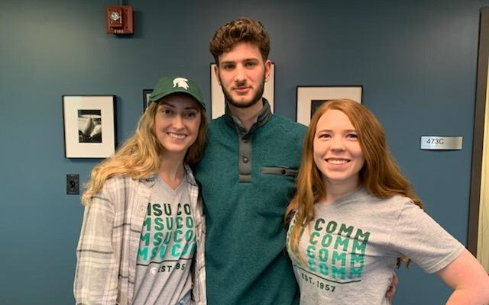
Before I sign off, I must thank the students that helped me put this together: Josie Boumis (MA program), Jason Savoca, and Hannah Burleson (BA program). Hannah and Jason put on their green graduation gowns this December and became alum of our program and Josie is deep in the throes of completing her master’s thesis in interpersonal communication. Thank you for working with me to create this first edition!

Happy New Year and Go Green!

Monique Turner Professor & Chair Spartan for Life

W H O O H O O !
G R E A T T H I N G S
F R O M O U R A L U M N I :
PhD alum Kimo Yun was recently named the new provost of Marquette University

Nick Bowman, PhD alum, was awarded a Fulbright and named Wu Jing-Jyi Arts and Culture Fellow at the National Chengchi University in Taiwan. He will be continuing his research into the social demands of video games and virtual reality

BA alum Vanessa Shay took time to chat with Mo at MSU about her work in CA as Vice President of Global Partnerships for AEG

Lauren Tamboer, linked BA-MA alum, landed a great job as a Communications Consultant (yes, industry uses the "s") for the Department of Ecology in the Washington State government

BA alum, Dr. John Banas won a top paper (along with his colleagues) in the Health Communication Division of NCA and was elected Chair of the Communication and Social Cognition Division of NCA
THIS IS A SAMPLING OF ALUMS'
AMAZING ACCOMPLISHMENTS AND IS
CERTAINLY NOT EXHAUSTIVE! FILL
OUT THIS FORM TO TELL US WHAT
YOU HAVE GOING ON FOR THE
SPRING EDITION.
https://forms.gle/swkZWLBXBHZS3L8t6

#COMMRocks!…literally
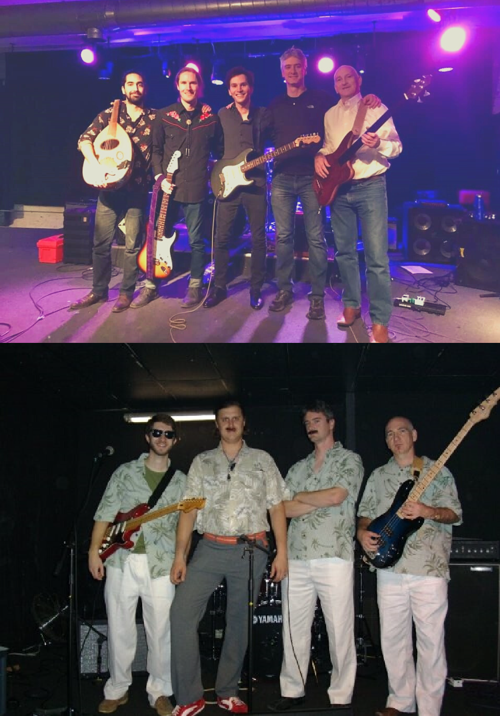
What does “Trash Talk”, “The Script”, “Skizoo” and the Department of Communication have in common? The answer may be surprising: They all established a musical band in 2005! When our faculty and students are not knee deep in data, grading, and writing manuscripts, some of them are rocking out, namely Drs. John Sherry and Dan Bergan. In fact, the Department of Communication has had three different department bands with a mix of faculty and students. These include a punk rock band, Stooge City Liberation Front, a funkabilly band, The Sophisticates and the current group Beirut 66.

Beirut 66, which was formed in 2017, offers a unique blend of American rock and jazz blended with traditional Arabic music. The band consists of three PhD students and two faculty members from the Department of Communication.
"We started as a trio of only students, but then I heard there had been faculty bands in the past and looked into it," said Reed Reynolds, who is studying misinformation persistence. Reynolds is currently a Communication PhD student, lead guitarist, and singer. "We ended up recruiting Professor Sherry and Professor Bergan, and the rest is history."

Sari Sa’diya plays cello and oud (Arabic version of a lout) and is currently a joint PhD student in Computer Science and Psychology. Alex Burgoyne is a PhD student in Cognitive Psychology who studies expertise and plays rhythm guitar. Dr. John Sherry plays the bass while Dr. Dan Bergan plays the drums and percussion for the band.

"The music is really demanding because it is so different from the Western style that most of us learned. It is like trying to think in a different culture," Reynolds said. "But Sari is patient with all of us! It’s a great bunch of guys and a lot of fun to play together."

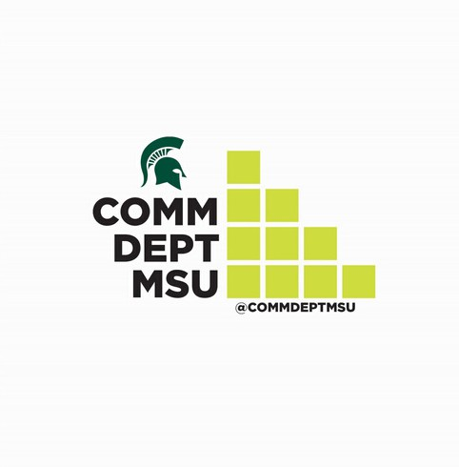
Colloquium Series
T H E S P O T L I G H T .
F A L L I S S U E 2 0 1 9
DEPARTMENT HIGHLIGHTS SPECTACULAR SCHOLARSHIP FROM AROUND THE NATION.

WHAT AN AMAZING L INE UP OF SPEAKERS WE HAD THIS FALL FOR OUR DEPARTMENTAL COLLOQUIUM
SERIES! CHECK OUT THE L IST OF SPEAKERS

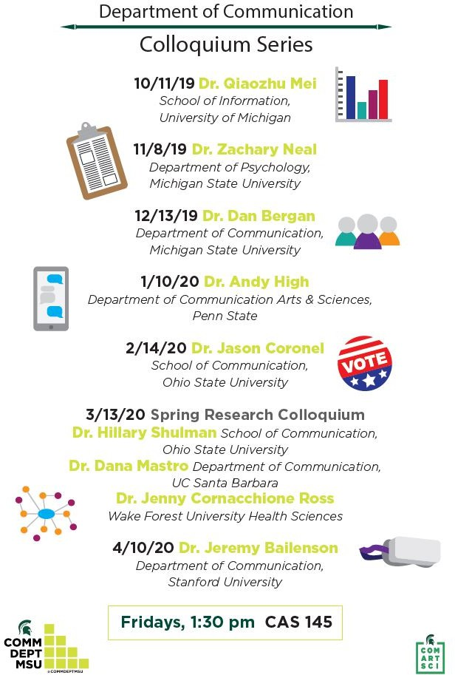
Show your pride in your alma mater!
CHECK OUT OUR BRAND- NEW T- SHIRT
DESIGN. ONCE THIS INITIAL ORDER IS SOLD, WE WILL ORDER SWEATSHIRTS, ROUND COLLAR T— SHIRTS AND MORE! FOLLOW US ON SOCIAL MEDIA TO F IND OUT WHEN THE
ONLINE
STORE WILL OPEN TO PURCHASE
THESE ITEMS!

Professor Dr. Bill Donohue receives distinguished award for conflict management research
Dr. Bill Donohue, University Distinguished Professor, was named a fellow of the International Association for Conflict Management (IACM) this Fall.

Top scholars in the association are honored with this award to signify the accumulation of the contributions and efforts made in the field of communication and conflict. Donohue, who has spent 44 years at MSU, has certainly made such an impact with his research. Dr. Donohue, or Bill’s, research has focused on the structure of language in conflict settings. Across most of his research he has discovered that the more frame synchrony disputants share, and the more systematically they work through their issues, the more likely they are to resolve their differences.

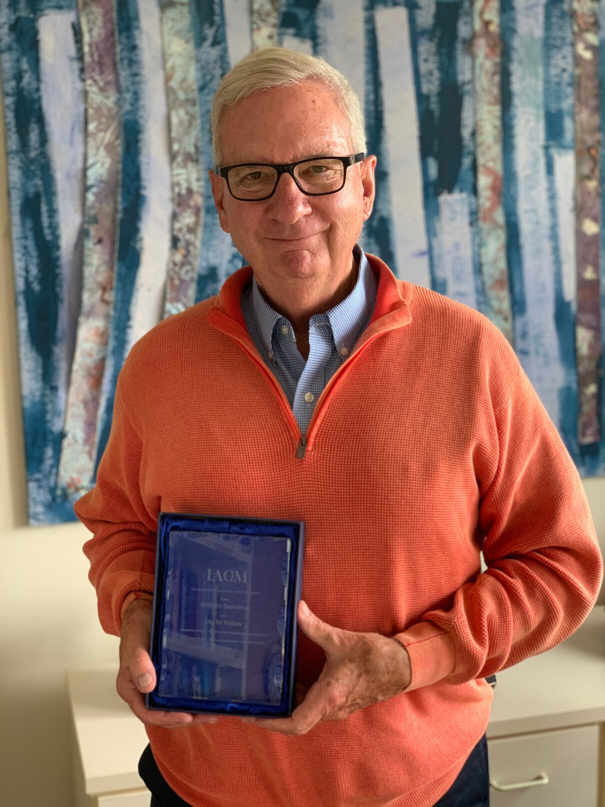
" I t ’ s n i c e t o b e r e c o g n i z e d f o r m y c o n t r i b u t i o n s t o
t h e f i e l d a n d i s a g r e a t
t r i b u t e t o t h e w o r k I h a v e d o n e , ” s a i d D o n o h u e .

H o w e v e r , w h a t i m p r e s s e d h i m m o s t a b o u t r e c e i v i n g t h e a w a r d w a s t h e a m o u n t o f p e o p l e w h o h a d v i e w e d h i s w o r k .

Donohue has researched some “hot topics” in the past including divorce mediation, hostage negotiations and even Somalian pirate negotiations. More recently, he has been doing research in the area of supply chain management looking at value chain competencies and exploring role identity conflict in conflict resolution situations.

“I love working at MSU because the quality of the colleagues and the environment,” Donohue said. “MSU has so many opportunities on campus and there are strong relationships between faculty members in different departments.”

For more information on Donohue and his research, visit “https://comartsci.msu.edu/our-people/william-donohue.”

Undergraduate Communication Association
For several decades a defining mark of the Department of Communication has been the leadership provided by the Undergraduate Communication Association (UCA). The UCA has long been the voice of students pursuing communication studies within the College of Communication Arts and Sciences. UCA’s goal is to provide education, leadership, assistance, and unique opportunities to students as they prepare for careers within the communication field. UCA does this by providing resources, seminars, and advice on issues such as graduate school, career preparation, job searches, internships. UCA organizes opportunities for communication students to further their crucial networking skills by getting to know the faculty and their peers. UCA leadership also attends monthly faculty meetings and represents the undergraduate student body interests.

MEET THE 2019 UCA EXECUTIVE BOARD!
It consists of President - Hailey Ritchie; Vice President - Kristina Wylin;
Social Media Director - Mary-Catherine Canavan; and Treasurer - Ashraf Mohamed.

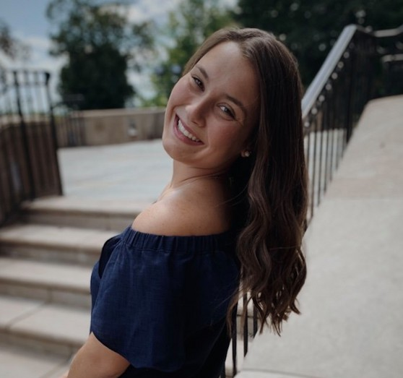
Hailey Ritchie is a sophomore majoring in
. Communication and Human Resources. Her desired career is to be in Human Resources.
Her favorite thing to do to pass time is hangout with friends and family.

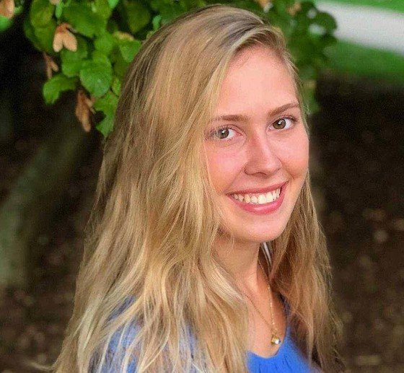
Kristina Wylin is a senior, majoring in Communication and minoring in Sales Leadership. She enjoys being outdoors and traveling. Kristina is planning to graduate by Summer 2020.

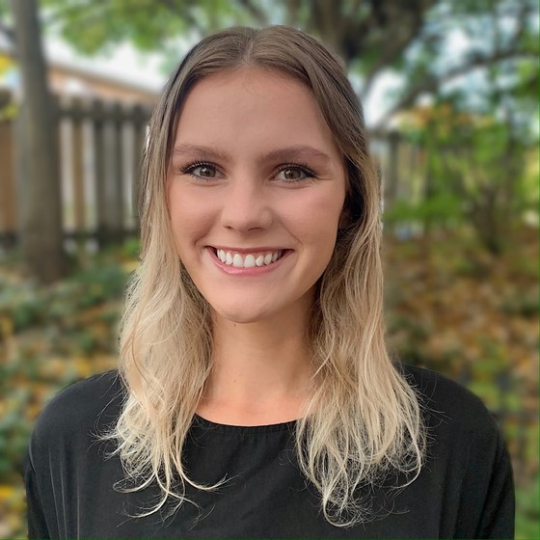
Mary-Catherine Canavan is a senior majoring in Communication with minors in Public Relations and Sociology. She hopes to find a job within the marketing and communication field post- graduation this upcoming May.

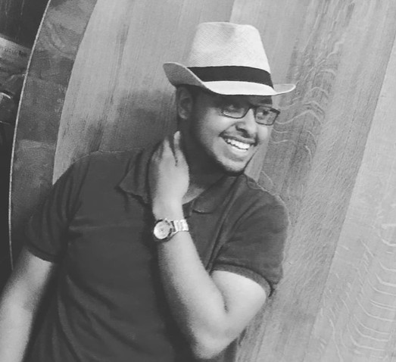
Ash Mohamed is a senior, majoring in Advertising, and hopes to find a job in sales after graduation.

MSU Storms the 2019 National Communication Association Annual Conference
In November, the City of Baltimore, MD was swept with green and white as the MSU Department of Communication rushed in to present research at the National Communication Association Annual Conference. NCA presents an opportunity for our community to show the field the state-of-the-art we have been conducting.

MSU faculty and graduate students presented 40 papers and panel presentations throughout the four-day conference. #MSUCOMM work was spread across divisions including family communication, social cognition, mass communication, game studies, health and interpersonal communication and others.

Congratulations to the following faculty and graduate students, who were awarded TOP PAPER awards at the national conference:
Mary Bresnahan, Xiaodi Yan, Yi Zhu, & Syed Hussain (International and Intercultural Communication Division); Vernon Miller, Ken Levine, Emma Kinney, & Matthew St. Germain (Applied Communication Division); Shannon Cruz & Frank Boster (Communication and Social Cognition Division).

For more information on the presentations, the Department’s Facebook page posted all of the presentation titles at the time of the conference.
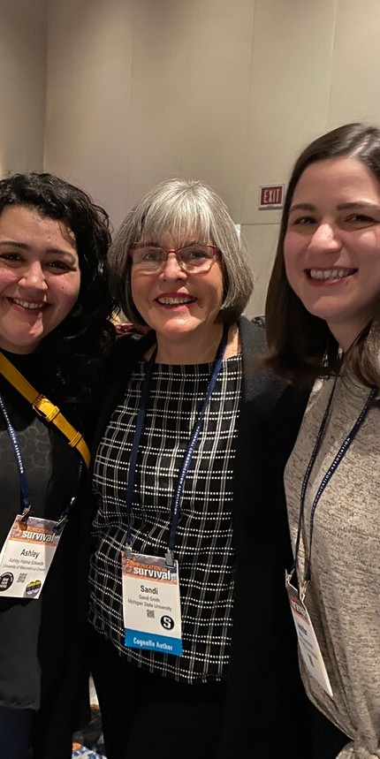
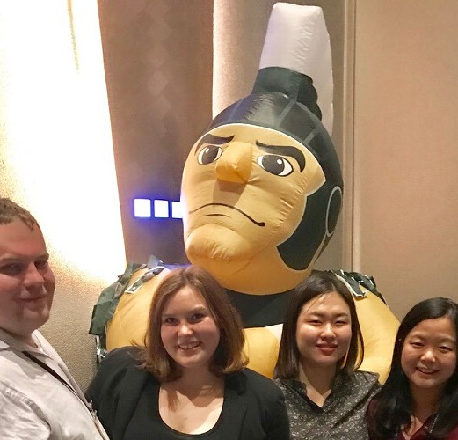
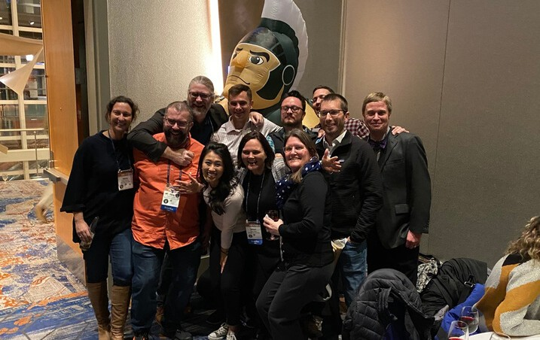
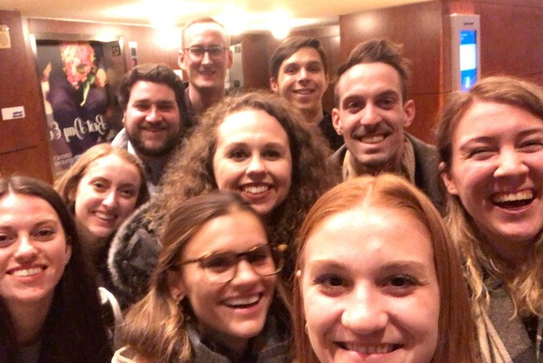
Visit "https://www.facebook.com/CommDeptMSU/" to see the posts.

SEND IDEAS, LETTERS TO THE EDITOR, COMMENTS, ETC. TO MMTURNER@ MSU.EDU

