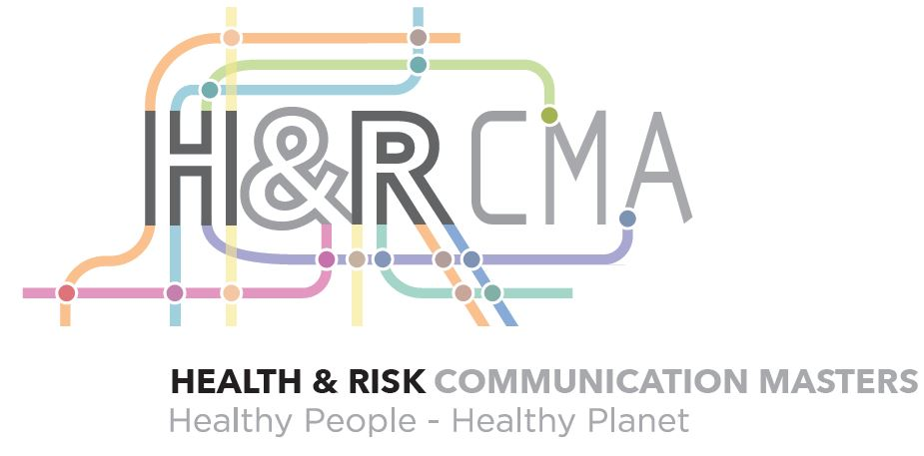

Career Paths of Alumni of the
Master’s in Health & Risk Communication

Since the establishment of the Master’s in Health & Risk Communication in 1998 Michigan State’s program has had a strong showing of alumni serving in the field. Our HRCMA 2017-18 annual report states 82.5% placement rate for our graduates.

Alumni have found employment in a variety of organizations across the country and world, including jobs in prestigious organizations, such as the U.S. Center for Disease Control (CDC). Common job titles include manager, coordinator, communication associate/specialist, and program/project director. The most common job responsibilities include research activities, the development of health communication materials, project/program management, communication management, and social media/website management.

Many of our alumni have gone on to pursue their doctorate. The universities include, Michigan State University, Ohio State, University of Georgia, Rutgers University, University of Texas-Austin, and the University of Kentucky. These same alumni now hold faculty tenure track positions at the University of Alabama, Texas Christian College, Arizona State University, University of West Virginia, Berry College, and Purdue University.

Examples of career positions include:
- Marketing Team, Health Solutions Division, Fluke Corporation, Everett, WA
- Communications Specialist at Evive, Chicago, IL
- Researcher, Center for Healthy Communities at Michigan Public Health Institute, Okemos, MI
- Public Health Consultant, Ohio State Department of Health, Columbus, OH
- Community Coordinator for Blood Drives, American Red Cross, Minneapolis, MN
- Medical Cases Manager at CARES, Kalamazoo, MI
- Communication Coordinator, Scripps Research Translational Institute, San Diego, CA
- Research Analyst, Altarum, Ann Arbor, MI
- Senior Project Coordinator, Klein Buendel Inc, Lakewood, CO
- Director, Populations Health at Sparrow Health Systems, Lansing, MI
- State-wide Workforce Development Coordinator, Michigan Public Health Institute, Lansing, MI
- Associate, Center for Disease Control & Prevention, Wilmington, NC
- Public Health Consultant, Michigan Dept. of Health & Human Services, Lansing, MI
- Research Analyst, Colorado Health Institute, Denver, CO
- Epidemiologist/Coordinator, Michigan Dept. of Health & Shuman Services, Lansing, MI
- Research Specialist, Community Mental Health, Lansing, MI
- Diabetes Partners in Action Coalition/Michigan Dept. of Health & Human Services, Lansing, MI
- Coalition Coordinator at CDC Foundation, Atlanta, GA
- Community Health Promotion Specialist, Barry-Eaton District Health, Charlotte, MI
- Director of Communication at MSU Center for Regional Food Systems, East Lansing, MI
- Manager, Patient Safety & Quality at Michigan Health & Hospital Association, Lansing, MI
- Marketing Strategy and Analysist, Sapient Consulting Public Sector , Washington DC
- Senior Program Coordinator, National Kidney Foundation of Michigan, Detroit, MI
- Government Affairs Manager, Nurse-Family Partnership, Lansing, MI
- Senior Health Care Analyst at Blue Cross Blue Shield of Michigan, Grand Rapids, MI
- Marketing Communication Manager at University of Michigan Health Systems, Ann Arbor, MI
- Health Communications Fellow, National Cancer Institute, Washington, DC
- Global Health and International Development Digital Communications Specialist, Washington, DC
- Health Science Policy Analyst, National Institutes of Health, Office of Science Policy, Bethesda, MD
- Health Analyst, Emergent Technologies, Atlanta, GA
- Researcher, Health Policy Research Division, Korea Institute for Health & Social Affairs, Seoul Korea
- Communications Specialist, Bioversity International, Rome, Italy
- Health Education Coordinator for Peace Corp in Peru
- Assistant Administrator to the Environmental Public Health Director, Michigan Dept of Health & Services, Lansing, MI
- Research Asst, Behavioral & Field Research Core, Karmanos Cancer Institute, Detroit, MI
- Assistant Project Officer Nutrition, UNICEF INDONESIA
- Communications Team Leader (Remote) Health Alliance Plan, Denver, CO
- Public Relations Specialist at Health Alliance Plan (HAP), non-profit health plan and a subsidiary of the Henry Ford Health System, Detroit, MI.
- Communications Coordinator, Office of the Surgeon General, Michigan Dept of Community Health.

