Dr. Rachel Mourao
Director of Journalism Graduate Studies mourao@msu.edu

Nicole Bond
Academic Program Coordinator bondnic@msu.edu

School of Journalism Michigan State University 404 Wilson Road, Room 304 East Lansing, MI 48824
(517) 432-1256

Ta b le o f Co nt e nt s

Welcome & Introduction 5
School of Journalism Program Overview 5
Program Goals 5
Role of Graduate Studies Director and Committee 5
Role of Graduate Studies Adviser 6
Course Core Requirements 6
Overall Degree Requirements 6
Concentrations 7
Course Waiver 8
Minimum/Maximum Credit Load 8
Course Levels & Consideration 8
400-level Undergraduate Courses 8
Independent Study 8
Program Timetable 9
Typical Semester Schedules 9
Annual Evaluation 10
MAven Hour 10
Options for Completing the Program 11
Thesis/Professional Project Options 11
Thesis/Professional Project Process 11
Thesis/Project Standards 12
Thesis 13
Professional Project 13
School of Journalism Unique Programs 14
Linked or Dual Master’s Program in Journalism 14
Master’s to Ph.D. Program 14
Journalism Graduate Certificate 14
Policies on Academic Performance and Implications on Financial Aid 15
File Access and Privacy 16
Grief Absence Policy for Students 16
Responsible Conduct of Research and Scholarship (RCR) 16
Standards of Integrity 16
Student Conduct and Conflict Resolution 17
Work-Related Policies 17
Appointments 17
Work Rules 18
Grief Absence Policy for RAs, TEs and TAs 18
Mandatory Training 19
Terms of Appointment and Leave 19
Tuition and Funding 19
Appendices 21
- Plan A Thesis Option 21
- Plan B Project Option 22
- Academic Grievance Procedures 23
- Office of the University Ombudsperson 28
- J-School Student Code of Ethics & Standards 29
- Best Practices in Journalism 30
- Code Violations 32
- 10 Tips to Guide Social Media Use 33
- Policy Regarding Training in the Responsible & Ethical Conduct of Research 35
- University Resources 36

Lin k s t o S c h oo l o f J o u rn a lis m MA Gu id e lin e s a n d Do c u m e nt s

- Centers and Labs

- Course Details

- Degree Requirements

- Program Forms

- Master of Arts in Journalism

- Responsible Conduct of Research (RCR)

Lin k s t o S e le c t Un iv e rs it y P o lic ie s

- Academic Governance
- Academic Programs Catalog

- Anti-Discrimination Policy (ADP)

- Code of Teaching Responsibility

- Disability and Reasonable Accommodation Policy

- General Student Regulations
- Graduate Students Rights and Responsibilities (GSRR)

- Guidelines for Integrity in Research and Creative Activities

- Integrity of Scholarship & Grades

- Law Student Rights and Responsibilities (LSRR)
- Medical Student Rights and Responsibilities (MSRR)

- MSU Guidelines for Graduate Student Mentoring and Advising

- MSU-GEU Contract
- Policy on Relationship Violence and Sexual Misconduct

W e lc om e a n d Int ro d uc t io n

The faculty of the School of Journalism welcomes you to our Master of Arts degree program. We are among the top graduate programs in the nation. Our faculty of outstanding professionals and scholars has made important contributions in both the academic and media worlds. We are committed to making your graduate program successful.

A successful graduate program requires students who are both committed to excellence in their work and knowledgeable about the requirements for the degree. This handbook is meant to help graduate students in the School of Journalism to know, understand and complete the requirements of their master’s degree program.

The information below complements university regulations. Students must meet all university as well as School of Journalism requirements. Students should also consult the following publications for guidance:
- Academic Programs Catalog
- Graduate Students Rights and Responsibilities
- MSU/Graduate Employees Union Contract
- Guidelines for Graduate Student Advising and Mentoring Relationships
- Research Integrity

Students are also encouraged to consult their assigned academic adviser and committee faculty members for advice and interpretation of the requirements and information in this handbook.

Our graduate students come from all over the world and walks of life and enter the program, for different reasons as they envision different career objectives. Some are fresh from a bachelor’s degree in journalism while others have degrees outside of journalism. Still others are returning journalism professionals who want to update and advance their skills, while others desire a transition into the journalism industry or to use their journalism skills in other industries. And some are looking to enter the academy as researchers and teachers.

P ro g ra m O v e rv ie w
  - Program Goals
The master’s degree program is designed to serve students who want scholarly training for an academic career and those students who want applied professional training for communications-related employment. The program, therefore, provides academic courses that stress both scholarly research and professional journalistic- related competency skills courses.
  - Role of Graduate Studies Director and Master’s Graduate Committee
The School of Journalism Graduate Studies Director and Graduate Studies Committee administer the master’s degree program of the School of Journalism; together they recommend graduate program policy and curriculum to the faculty. The Director of the School of Journalism designates the Graduate Director who oversees the day-to-day operation of the program. The Graduate Studies Director and Committee select students for admission into the program and select faculty advisers for students based on their interests.

Each academic year in April or early May, students must meet with their adviser to discuss their progress in the program.

After both student and adviser complete the Annual Progress Report, both will sign the form and give it to Nicole Bond.
  - Role of Graduate Studies Adviser
Please meet each semester with your adviser to discuss your career objectives, determine courses and review your progress in the program. Please don’t hesitate to ask your adviser or any faculty member for advice or apprise them of any challenges you encounter.

Your program plan should be discussed with and approved by your adviser and the Director of the Grad Program within the first semester. Please design your entire program plan by determining when you will take which courses. Planning helps students take advantage of courses that are not offered every semester. Search for MSU graduate courses here. College courses are available in Journalism (JRN), Advertising+PR (ADPR), Media & Information (MI), Communication (COM) and College of Communication of Arts and Sciences (CAS). You are also welcomed to take electives outside of Journalism and the College if they make sense to your program.

BA-MA Dual/Linked students should submit their dual form when they accept their admission letter. This notes the courses you want to transfer, which also determines the formal start of your status as a graduate student.

The Graduate Committee matches each accepted student with a temporary adviser who consults with students as they work toward their degree. Students may, at any time in their program, request to change their academic adviser. If you want a change, but do not have a specific adviser in mind, then you are welcome to ask the Director for help. Please update your GradPlan and apprise Nicole Bond of the change.
  - Course Core Requirements
Four core courses (JRN 802, JRN 804, JRN 805, and JRN 806) are required for ALL students, with additional courses required for either the Plan A (thesis) and Plan B (professional project). The core courses are meant to help students develop a broad and theoretical understanding of the process and effects of mass media in local to global communities.
  - Overall Degree Requirements
The program requires students earn 31 credits in 400-, 800- and 900-level courses. Eighteen of the 31 credits must be at the 800 or 900 level in courses offered in the School of Journalism. Students are limited to 12 credits of 400- level courses. (This includes transfer courses.) The requirements are outlined in Table 1, below.

Table 1

Requirements for the Master of Arts Degree in Journalism

A minimum of 31 credits is required for the master’s degree in journalism in Plan A (thesis) or Plan B (professional project).

Plan A Required Courses
1 credit JRN 802 Journalism ProSeminar
3 credits JRN 803 Introduction to Quantitative Research Methods 3 credits JRN 804 Journalism Studies Seminar
3 credits JRN 805 Disruptions in Journalism Seminar
3 credits JRN 806 Current Issues in Journalism Seminar 3 credits JRN 816 Applied Research Methods in JRN*
6 credits JRN 899 (thesis)-2 semesters
9 credits Electives
31 total credits

Plan B Required Courses
3 credits JRN 800 Multiple Media Reporting I* 3 credits JRN 801 Multiple Media Reporting II*
1 credit JRN 802 Journalism ProSeminar
3 credits JRN 804 Journalism Studies Seminar
3 credits JRN 805 Disruptions in Journalism Seminar
3 credits JRN 806 Current Issues in Journalism Seminar 6 credits JRN 896 (project)-2 semesters
9 credits Electives
31 total credits
Optional Transcriptable Concentrations
The elective credits for both Plan A and Plan B students may include a 9-credit transcriptable concentration in Environmental, Science and Health Journalism or International Journalism. Please notify Nicole Bond to add the concentration to your transcript.

International Journalism – 9 credits
3 credits JRN 465, Comparative Issues in International Journalism 3 credits JRN 892, Global Affairs Reporting skills
3 credits Choose from the following:
JRN 872, Environment, Science & Health Reporting Topics JRN 873, Environment., Science & Health Reporting Seminar JRN 887, JRN Edu Abroad
Any adviser-approved credits (skill, seminar or education abroad)
Environment, Science & Health Journalism – 9 credits
3 credits JRN 872, Environment, Science & Health Reporting Topics
– can retake with a different topic for another
3 credits JRN 873, Environment, Science & Health Seminars
3 credits Any adviser-approved credits (skill, seminar or education abroad)

*JRN 816 is no longer offered. Find an advisor-approved 800-900 level research course as a substitute.
*Students with commensurate professional experience or coursework may request a waive.

  - Course Waiver
Students are required to take both JRN 800 and JRN 801. If a student is a pursuing the master’s program to learn journalism skills or want a general skills refresher course, then these courses will help with practice and feeling well grounded in knowledge.

If a student thinks that they are already well inculcated on the principles of journalism, and don’t need the general reporting practice, whether because of a similar course or professional experience, then they may request a waiver from JRN 800. For linked- and dual-degree students, JRN 200 experience can suffice but students should consider the extra practice and review.

If a student is interested in a course waiver, they must write a letter to the JRN Graduate Committee requesting the waiver and justifying how they’ve met commensurate academic and/or professional experience. To support their letter, students must submit a cover letter or email, their resume, the syllabus
of their similar course and their grade and/or links to their multimedia work. Please send to Academic Program Coordinator Nicole Bond (bondnic@msu.edu), ideally before the semester begins.

A caveat is that a waiver is for the course itself and not the credits. Students would find an elective course to achieve the 31 program credits.

  - Minimum/Maximum Credit Load
A full load is considered 6 credits. Most students take 9 credits per semester.
Graduate students may carry up to 16 credits each semester, but it is NOT recommended. A course load of more than 16 credits requires Dean’s approval.

All students using University services for graduate work must be registered each semester. Minimum registration consists of 1 credit.

To be considered full-time for academic purposes, financial aid and assistantships, etc., master’s students must carry a minimum of 6 credits per semester.

  - Course Levels & Considerations
Courses at the 400 level are considered advanced undergraduate, 800 level are master’s courses and 900 level are doctoral courses.
Twelve credits at the 400 level may count toward the program.
    - Enroll in the 800-level equivalent of cross-listed 400-and 800-level courses (e.g., JRN 830 is cross listed with JRN 430).
    - No double-dipping in JRN course content (e.g., a student could not receive credit for both JRN 430 and JRN 830).
    - Courses from other units that duplicate the content of any of the core courses will not be counted.

  - Independent Study
Independent Study (variable 1 to 6 credits) is an option for students who wish to research
a specific topic in more depth than a particular course allows or to research a topic not available in an established course. Six credits total are allowed and approved by the adviser.

Students seeking an independent study usually approach faculty members the second semester or later in the program.
Students wishing to enroll for Independent Study credits must complete
an Independent Study form in collaboration with the instructor with whom they will be working.

Once the form is completed with signatures of both the instructor and the student, the student must also get the signature of his/her academic adviser. Once the adviser signs the form it should be turned into Nicole Bond (bondnic@msu.edu).

  - Courses & Program Timetable
The required core courses are offered annually and usually completed in the student’s first two semesters.
Each fall: JRN 800, JRN 802 and JRN 804.
Each spring: JRN 801, JRN 803, JRN 805 and JRN 806
Students can normally complete the program in four semesters (dual enrollment students can complete the program in one calendar year). This will depend, however, on the number of courses transferred or taken each semester. Program duration also depends on whether students take courses during summers.

For example, a student who takes three 3-credit courses each semester in the academic year would complete the last three credits in the fourth semester. A student who takes four 3-credit courses each semester in the academic year would complete the last six credits in the third semester.
  - Typical Semester Schedules
Move your elective credits to other semesters to determine a workable schedule.

For example, you might want a lighter course load in the semester that you determine committee members and write a formal proposal, which needs committee approval before enrolling in JRN 896 or JRN 899.

Your course schedule may vary, depending on when you entered the program full-time, work and other things going on in your life.

New Student Entering in Fall Example
Fall: JRN 800 (3 credits) (Plan B) or JRN 816* (3 credits) (Plan A), JRN 802 (1 credit), JRN 804 (3 credits) = 7 credits
Spring: JRN 801 (3 credits) (Plan B) or JRN 803 (Plan A), JRN 805 (3 credits),
JRN 806 (3 credits) = 9 credits and determine committee chair and 2 members (3 total)
Summer: internship or work full time = 0 credits
or internship or elective or independent study (all variable credits) = variable credits and write proposal for committee approval before enrolling in JRN 896 or JRN 899
Fall: JRN 896 or JRN 899 (3 credits), two electives (3 credits each) = 9 credits
Spring: JRN 896 or JRN 899 (3 credits), elective (3 credits) = 6 credits

New Student Entering in Spring Example
Spring: JRN 805 (3 credits), JRN 806 (3 credits), elective (3 credits) = 9 credits Summer: internship or work full time = 0 credits
or internship or elective or independent study (all variable credits) = variable credits
Fall: JRN 800 (3 credits) (Plan B) or JRN 816* (3 credits) (Plan A), JRN 802 (1 credit),
JRN 804 (3 credits), elective (3 credits) = 10 credits
and determine committee chair and 2 members (3 total), if not sooner
and write proposal for committee approval before enrolling in JRN 896 or JRN 899, if not sooner

Spring: JRN 801 (3 credits) (Plan B) or JRN 803 (3 credits) (Plan A), JRN 896 or JRN 899 (3 credits) = 6 credits

Linked Journalism or Dual Degree Student Entering in Fall Example
If student transfers three 400-level courses = 9 credits

Fall: JRN 800 (3 credits) (Plan B) or JRN 816* (3 credits) (Plan A), JRN 802 (1 credit), JRN 804 (3 credits) = 7 credits

Spring: JRN 801 (3 credits) (Plan B) or JRN 803 (3 credits) (Plan A), JRN 805 (3 credits),
JRN 806 (3 credits), JRN 896 or JRN 899 = 9 credits
and determine committee chair and 2 members (3 total), if not sooner
and write proposal for committee approval before enrolling in JRN 896 or JRN 899, if not sooner

Summer: 1st session: JRN 896 or JRN 899 (3 credits), 2nd session: JRN 896 or JRN 899 (3 credits) = 6 credits

Linked Journalism Student Entering Full-Time in Fall Example
Transfers three 400-level courses (9 credits), and took 800-level course(s) while an undergrad = 12+ credits Graduate with BA in spring. Then immediately:
Summer: elective (3 credits) = 3 credits
and determine committee chair and 2 members (3 total)
and write proposal for committee approval before enrolling in JRN 896 or JRN 899
Fall: JRN 802 (1 credit), JRN 804 (3 credits), JRN 896 or JRN 899 (3 credits) = 7 credits
Spring: JRN 805 (3 credits), JRN 806 (3 credits), JRN 896 or JRN 899 (3 credits) = 9 credits
*JRN 816 is no longer offered. Find an advisor-approved 800-900 level research course as a substitute.

  - Annual Evaluation
You are required to meet with your adviser in April or early May to discuss your academic progress and how to move forward. You and your adviser are required to fill out the progress report and submit it to Nicole Bond.

Official university transcripts and other information such as the Annual Progress Report are used as the basis for the evaluation. The evaluation addresses the number of credits completed toward the degree, the satisfaction of core course requirements, and the documentation needed for thesis or project options. In addition, the evaluation cautions the student in the event of substandard course performance or failure to make timely progress in the program. The evaluation also notes outstanding performance and progress in the program and calls to the student’s attention options available to complete the degree.

  - MAven Hour
A maven is “a person who knows a lot about a particular subject,” as described by Merriam-Webster. Students present their projects and theses at MAven Hour. MAven Hour is an event hosted at the end of fall and spring semesters by the School of Journalism. Graduating students showcase their work to all MA students and faculty so they can learn about the student’s thesis or project. (Friends and family are welcomed.) Students who graduate in the summer give a progress report in the prior spring MAven Hour.
Participation as a presenter is a requirement for the degree. All MA students must attend.

O p t io n s fo r Co m p le t in g t h e P ro g ra m
  - Thesis/Professional Project Options
Students should begin their final project during the first semester of their second year or earlier. Beyond specific course requirements, students choose the courses and degree-completion option that best fit their career goals. Master’s degree students who seek teaching and/or research careers following their programs, or whose eventual goal is to earn a doctorate in preparation for university employment, ordinarily take a greater number of 800-level courses both within and outside the school that help them develop a specialization.

Students who conclude the program with “Plan A” thesis or “Plan B” professional project options must follow school procedures for obtaining approval and successfully completing their work. Students select a committee of faculty members for their professional project or thesis and have their written proposal approved by their committee before registering for thesis (JRN 899) or professional project (JRN 896) credits, in the last two semesters of their program. Dual enrolled students should select a committee and start work on their thesis of professional projects proposals by the fourth week of the second semester. Students in the regular program should select a committee and start work on their thesis or professional projects proposals by the beginning of the second year.

Plan A. Future Ph.D. applicants or research career students are advised to conclude their program with a “Plan A” master’s degree thesis demonstrating the capability to conduct research that contributes to our knowledge of the media-society relationship. A thesis helps to prepare students for actual scholarly research and provides them with a credential that will distinguish them when applying for doctoral programs. Students in “Plan A” are encouraged to produce scholarly research and participate on research teams during their program.

Plan B. Master’s degree students who seek professional careers following their programs or who seek to enhance the professional skills they already possess ordinarily take a greater number of competency courses that develop their capabilities to work in a range of media careers. These students may be advised to conclude their program with a “Plan B” professional project that advances their journalism skills. Students in the “Plan B” option are urged to demonstrate professional commitment and achievement by publishing their work during their program.

  - Thesis/Professional Project Process—schedules vary depending on the student Topic
Students should decide by the end of their first semester of enrollment if they will pursue Plan A or B, and they need to decide by the beginning of their second academic year the topic of their thesis or project.
Chair selection
Faculty members must supervise the work of students who select the “Plan A” thesis or “Plan B” project options. Dual enrolled students must select their chair during the beginning of their second semester. Regular program students must select their chair during the beginning of their second academic year or earlier. They must be a tenure-stream faculty from the School of Journalism.
Students may want to discuss with the Journalism Graduate Director or their adviser about finding a chair for the committee. Students should schedule a meeting with their chair to discuss the selection of two additional committee members.

Committee Selection
Students will then share their proposal idea with two potential committee members as students request faculty participation on their committee. Ideally, a student’s committee includes people with a diversity of backgrounds who can advise them on the final project. Committees are made up of a minimum of three full-time School of Journalism faculty members. One faculty member from outside the School of Journalism may serve on a student’s thesis or professional project committee. The committee members must be reviewed and approved by the Graduate Affairs Committee.
Oral Proposal Meeting
A formal, written proposal should be approved by the committee chair before it is sent to committee members. A proposal meeting should include an oral defense of their proposal in which students detail their project with an introduction, justification, literature review, method, timeline and description of the final product to their committee. (Please refer to the attached checklist for more information.)

The student’s thesis or project committee must meet at least twice with the student (for the proposal and final defense). Students may meet with their committees and/or individual members as frequently as necessary or desirable to review a student’s progress toward thesis or project completion.
Oral Final Defense
The graduate student will present the results of the thesis or project at a meeting open to the community. While members of the public may attend the meeting, they may not participate in the discussion or remain for the committee’s decision about the work.

Students should schedule their oral defense date and send their thesis or professional project to committee members two weeks prior to their defense date. Oral defenses are about an hour long in which the student presents and discusses their work to the committee. Within the same meeting, the committee will meet privately to decide whether to accept the work, accept the work conditionally or reject the work. Work that is considered to be acceptable has met the stated goals set out in the thesis or project proposal.

Work considered acceptable conditionally has failed to meet all the proposal goals but adheres enough to proposal specifications so that the student can revise it successfully by following committee guidance.

Unacceptable work has failed to adhere to stated proposal goals and cannot be successfully revised absent major undertakings by the student to bring the work into line with the approved proposal.

The decision will be made by majority vote, with each committee member’s decision recorded. In the event that a majority cannot be obtained for one of the three options, the committee will meet again no later than two weeks later to continue its deliberations.

Should the committee pass the student’s thesis or project, the committee may designate the committee chair to oversee any minor or stylistic revisions before the work is finalized. If the committee gives the student’s work a conditional pass, the entire committee may review the revisions before a final decision is made on approval. If the committee rejects the work, the committee chair will provide reasons in writing within one week, along with options the student has to complete the program and/or challenge the decision.
  - Thesis/Project Standards
A master’s thesis and a professional project must demonstrate excellence that both draws on the courses comprising the program and displays the student’s original work. Each thesis or project will be unique, and the standards for evaluation of its merit will be specific to the goals

set out in the approved proposal and the degree to which those goals have been met. In general, a thesis and project will also differ importantly in both focus of that goal and the audience for which they are relevant.

  - Thesis
Students taking the thesis option (Plan A) must allocate six credits to the thesis. Students must be registered for at least one credit at the time of their thesis completion.

A thesis is ordinarily a more traditional, scholarly work that draws on previous research to define a problem that the thesis can address with new knowledge or insights. Most theses will focus on some aspect of the media-society relationship, attempting to describe that relationship and define influences on it. Consequently, a thesis is aimed at a scholarly audience attentive to research in the field for which the thesis is relevant. The purpose of research is to benefit society in some way. Thus, the thesis should end with not merely criticisms or descriptions, but suggestions as to how to improve the situation, for example.

Therefore, the standards of evaluation applied to the thesis are those used to assess a work for a peer-reviewed, scholarly convention or publication.

Students who plan to write a thesis are strongly encouraged to review the Graduate School’s formatting guidelines prior to beginning the research project.

    - Request for hold/embargo on publications of documents submitted to ProQuest Students submitting a thesis/dissertation to ProQuest now can request a hold/embargo of publication by ProQuest by contacting the Graduate School at or calling 517 353 3220. In response to the request, the Graduate School will send directly to the student a form that needs to be completed and turned to the Graduate School prior to the document submission to ProQuest. The form needs to be signed by the student’s major professor
and by the Associate Dean of the student’s college. The request for the hold/embargo may be for six months, one year or two years. Requests for a period longer than six months must include a brief justification for the length of the requested hold/embargo.

    - Creating an Open Researcher and Contributor ID (ORCID) at the time of submission of electronic documents to ProQuest At the time of submission to ProQuest, authors now have the opportunity to create an ORCID that provides researchers with a unique identifier for linking their research outputs and activities. An ORCID:
      - Improves recognition of research contributions
      - Reduces form-filling (enter data once, re-use it often)
      - Works with many institutions, funders, and publishers
      - Is a requirement of many journal manuscript submission systems and grant application forms.

  - Professional Project
Students selecting the professional project option (Plan B) must allocate six credits to a professional project. Students must be registered for at least one credit at the time of their professional project completion.

A professional project similarly defines a problem, but one relating to social issues or developments that can be explored journalistically through the use of more advanced methods of newsgathering and dissemination. Students are expected to create a journalistic project that meets professional standards. A few examples include: a series of podcasts, a website based on historical research, and a website presenting photographic portraits and an oral history report. These methods may include research, the use of online databases and document searches, with the goal of interpretation and

investigation. Dissemination may be through print, visual, digital or other means that demonstrate a student’s mastery of the chosen medium. Consequently, professional projects are aimed at a wide public audience.

Sc h o o l o f J o urna lis m Un iq u e M.A.- Re la t e d P ro g ra m s

In addition to the regular master’s degree, the School of Journalism offers three special programs related to master’s-level work – the Dual Bachelor’s-Master’s program, the Master’s-Ph.D. program and the Journalism Graduate Certificate.
  - Linked or Dual Bachelor’s-Master’s Program in Journalism
The linked or dual bachelor’s-master’s program allows undergraduates at MSU to use 9 credits of qualifying (journalism courses preferred) 400-level courses toward the 31 credits required for a master’s degree. The undergraduate courses should be completed after admission to the master’s program. The start of the linked or dual master’s program begins the earliest semester in
which they have transferred their courses from their undergraduate program. No 400-level courses with a grade lower than 3.0 will count toward the master’s degree. Credit obtained from 400-level pass/fail courses and internships will not count toward the degree.

Undergraduate students who apply to the linked or dual program must have at least 86 credits and can apply up to their final semester at MSU. Credits applied to the linked or dual Bachelor’s-Master’s Program are not eligible to be applied to any other graduate degree program. Accepted students must get their plan of study approved during their first semester.
- Linked: undergraduate students pursuing their bachelor’s and master’s in Journalism
- Dual: undergraduate students pursuing their bachelor’s outside of the School of Journalism, while pursuing their master’s in journalism.
Admissions:
    - A minimum overall undergraduate GPA of 3.0
    - A completed online application that includes academic goals and personal statement such as applicant’s background. Note: the Graduate Record exam is NOT required.
    - Resume
    - At least 3 letters of recommendation: two must be MSU faculty who fill out a one-page reference form.
    - Shared credit form that lists your 9 credits you plan to use toward your master’s degree.
  - Master’s to Ph.D. Program
Master’s students can apply to the Information & Media doctoral program at MSU during their second year in the program. Information about the application process is available here. Students admitted to the doctoral program can transfer up to nine credits from their Master’s program. Only 800- and 900- level courses with a grade of 3.0 or higher can be transferred. For more information about this special program, contact the Director of the Master’s program or the Director of the Information & Media doctoral program.
  - Journalism Graduate and Professional Certificate
The Graduate and Professional Certificate in Journalism is designed to help students understand the role of journalists and the news media in democratic societies. The certificate allows students
to explore and understand the skills, historical developments and current issues that have and continue to shape the journalistic profession. Students learn how to apply critical perspectives in understanding the influence and effects of media in society.

Admissions:
To be considered for admission into the Graduate and Professional Certificate in Journalism, applicants must have completed a bachelor’s degree and submit a short essay simply explaining why they are interested in pursuing the Certificate. (No grade minimum or entrance exams are needed.) The Certificate can be earned by students who are enrolled in a graduate program at MSU or by professionals and others who take the credits through Life-Long Education. Students may earn the Certificate in one semester or longer. For information about applying, please contact Nicole Bond.
Students are required to complete the following:
1 credit JRN 802 Journalism Proseminar
3 credits JRN 804 Journalism Studies Seminar 3 credits JRN 805 Disruptions in Journalism
3 credits JRN 806 Contemporary Issues in Journalism
10 total credits

P o lic ie s o n Ac ad e m ic P e rfo rm a n c e an d Im p lic a t io n s o n F in a n c ia l Aid

To receive financial aid and graduate, students in the master’s degree program in the School of Journalism need to maintain a minimum 3.0 grade point average (GPA). If a GPA dips below 3.0, the student will need to either re-take a course or courses that resulted in a 2.5 or lower or enroll in a new course or courses to improve the GPA. Graduate students who receive financial aid will have one semester to improve their GPA to a 3.0 or higher to continue to receive the aid. Students who fail to improve their GPA may appeal for continued financial aid by going through the Satisfactory Academic Process in the Office of Financial Aid.

In addition, consistent with college policies, a student who obtains a 2.5 or lower in three or more courses will be dismissed. A student withdrawn under this regulation is required to wait a minimum of one calendar year from the date of the withdrawal before becoming eligible to apply for readmission to a graduate program in the College of Communication Arts and Sciences.

The student may be readmitted, contingent upon repeating one of the three courses in which a grade of
2.5 or lower was received and earning a 3.0 or better grade in the course. The School may specify the course. While permission may be granted by the student's academic unit chair and the associate dean of the College to repeat a course in which a grade of less than 3.0 was earned, subsequently earning a grade of 3.0 or higher does not eliminate the first earned grade in the course as one of the two allowed under this regulation. Both grades are included in the GPA. A short letter requesting readmission, why improvement is assumed, and a timeline for completing the program is sent to Graduate Programs Coordinator Nicole Bond and the Director of the Master’s program. Following readmission, any additional grade 2.5 or below in any course will result in permanent dismissal.

Students are also expected to complete their degree programs within the five-year limit set by the Graduate School. A student who exceeds that time limit must apply for a program extension. A short letter requesting an extension, explaining the length of study and any circumstances that have changed for now completing the program and a timeline for finishing is sent to Graduate Programs Coordinator Nicole Bond and the Director of the Master’s program. Examples of valid reasons for extending the program beyond five years include family or medical emergencies and extraordinary work or study opportunities that relate to the graduate program. The Graduate Studies Director provides a recommendation on program extension to the associate dean for graduate education in the college, who makes the final decision.

- File Access and Privacy
Students may be granted access to their files. The student may bring to the attention of the committee any errors in the file or information not in the file at the time the evaluation was made. Letters documenting the error may be addressed to the Graduate Affairs Committee and will be placed in the student’s file. Recommendation letters that have explicitly mandated confidentiality will be removed from the file before it is examined by the student. In addition, any correspondence in the file concerning the student must be explicitly released to the student by the author(s) of those correspondences.

- Grief Absence Policy for Students
For master’s (Plan A or Plan B) with research responsibilities, it is the responsibility of the students to: a) notify their adviser/major professor and faculty of the courses in which they
are enrolled of the need for a grief absence in a timely manner, but no later than one week from the student’s initial knowledge of the situation, b) provide appropriate verification of the grief absence as specified by the adviser/major professor and faculty, and c) complete all missed work as determined in consultation with the adviser/major professor and faculty. It is the responsibility of the adviser/major professor to: a) determine with the student the expected period of absence— it is expected that some bereavement processes may be more extensive than others depending on individual circumstances, b) receive verification of the authenticity of a grief absence request upon the student’s return, and c) make reasonable accommodations so that the student is not penalized due to a verified grief absence. If employed as a RA or TA, the graduate student must also notify
their employer. Both employer and student will swiftly communicate to determine how the student’s responsibilities will be covered during their absence. Graduate teaching assistants (TAs) should refer to the bereavement policy in the MSU GEU CBU Article 18. Students who believe their rights under this policy have been violated should contact the University Ombudsperson.

Re s p o n s ib le Co n d u c t o f Re s e arc h a n d S c h o la rs h ip ( RCR)

The School of Journalism and the College of Communication Arts and Sciences support the federal requirements for training set forth in the Competes Act and by the Graduate School which teaches the responsible conduct in research, scholarship, and creative activities which is fundamental to the integrity of every graduate program. As a graduate student you will be required to complete the appropriate training. You can find resources to help fulfill these requirements at here.

S t an d ard s fo r In te g rit y

All university and college standards for ethical conduct are implemented by the School of Journalism. University standards are detailed in Article 2 of the Graduate Student Rights and Responsibilities document. In addition, the School of Journalism has adopted its Students Code of Ethics and Standards that governs the conduct of our students. (Please read it.)

These policies encompass cheating and plagiarism, as well as the expectation and demand that graduate students conduct themselves with respect and consideration for faculty and students in the program.
Cheating, plagiarism, and conduct that is dangerous to the health and safety of others are all grounds for dismissal from the program.

In addition, students must conform to all college and university policies relevant to privacy, confidentiality, and concern for harm in any work in the program involving animals, adult human subjects,

or children. Failure to follow these policies will result in immediate suspension of the work, the rectification of any harm done, and the review and appropriate revision of the student’s program. Such errors made in ignorance or good faith are not considered criteria for the student’s removal from the program. However, willful neglect or violation of such policies or repeated violations of such policies are considered criteria for removal from the program. Students should familiarize themselves with the Graduate School’s guidelines for Research and Scholarly Integrity. In addition, MSU has provided access to “iThenticate,” the anti-plagiarism software that is available on Desire 2 Learn as part of the “Turn-It-In” package. iThenticate is set up so that faculty, postdocs, and graduate students can check their manuscripts for unintentional plagiarism before submitting them.
Read more here.

S t ud e n t Co nd uc t a n d Co n flic t Res o lu t io n

All university and college policies on resolving conflicts with students are followed by the School of Journalism. The university policy is detailed in Article 5, Adjudication of Cases Involving Graduate Student Rights and Responsibilities. The School of Journalism policy on graduate student grievance procedures was passed in 2015. The procedures can be found in the Appendix. In general, the School seeks to resolve disputes as quickly and directly as possible. However, formal mechanisms can be created if a graduate student believes the informal resolution is impossible or undesirable.

Informal ways to correct grievances consist of conversations with faculty and/or academic staff over the nature and source of the grievance. In addition, the graduate student may talk with the director of the School of Journalism, with the director of the graduate affairs committee and the committee as a whole (if desirable). The student may also talk with the university ombudsman in an attempt to resolve grievances.
The functions and services of the Office of the Ombudsman is in Appendix 6.

If the student wishes a more formal hearing on grievances within the School of Journalism, please consult the procedures in Academic Grievance Procedures for Master of Arts Students in the School of Journalism. (Please see the Appendix 7.)

W o rk- Re la t e d P o lic ie s

Graduate students employed in teaching, research or other capacities in the School of Journalism are expected to perform their duties in accord with acceptable standards. This includes meeting all classes or attending all work hours required, handling the work professionally and competently, and providing adequate notice if illness or emergency makes performance of duties impossible.

Teaching assistants are referred to the Graduate Employees Union website and the current GEU contract and to GSRR Article 4 for work-related policies and details of their health care plan.
  - Appointments
Any half-time and quarter-time assistantships appointment offers are normally made in spring or at the time that admission to the program is offered. Research and teaching assistantships are awarded based on merit and school research and teaching needs. They are renewable on a semester-by- semester basis depending upon performance, School needs and the availability of funds.

The J-School director will obtain a written evaluation of the student’s assistantship each semester. When a student has the principal responsibility for teaching a course or section of a course, the

director shall appoint a faculty member to supervise the teaching assistant each semester of the appointment. The faculty supervisor should visit the classroom at least once during the first semester the student teaches the course. Following the visit, the faculty member should meet with the assistant to discuss strengths and weaknesses in teaching. Whenever a student teaches a course, student evaluation forms are presented to the school director at the end of the term. When a student assists a faculty member in teaching a course, separate written term-end reports by the faculty member should be prepared and discussed by the two.
If an assistantship involves research responsibilities, the supervising faculty member should evaluate the student’s work. Unacceptable performance can result in loss of a student’s assistantship. Students and departments should consult university guidelines for further information.

The University requires that departments notify their graduate assistants that their appointments either are or are not being renewed for the following semester. The student’s faculty supervisor provides a written evaluation each semester. Assistantships may be terminated at any time and pay reduced for gross negligence, such as failure to perform assigned duties or, for teaching assistants, any serious dereliction of the Code of Teaching Responsibility. Faculty supervisors may require students to keep timecards and/or maintain regular office hours, at their option.

Graduate students may be appointed to assistantships on a quarter-time, half-time, or three-quarter- time basis. Graduate assistants must be registered each semester in which they hold an assistantship. Graduate assistantships are available only to students who are actively pursuing graduate degree programs and who are making satisfactory progress toward their degrees. The determination of what constitutes satisfactory progress is made by the Graduate Affairs Committee or by a student's guidance committee as appropriate.
Failure to maintain minimum academic standing requires no committee action to determine if work is unsatisfactory.

  - Work Rules
    - Minimum Work Hours
Normally during a semester, the weekly hours of graduate assistant duties will average: Quarter- time 10 hours/weeks
Half-time 20 hours/weeks
Three-quarter-time 30 hours/weeks

    - Minimum Credit Registration
Quarter-time 6 credits
Half-time 6 credits
Three-quarter-time 3 credits
    - Maximum Credit Registration
Quarter-time 16 credits
Half-time 12 credits
Three-quarter-time 8 credits

Registration Standards
No deviation from minimum registration is allowed except in summer sessions, when students must register for a minimum of three credits. Graduate assistants must be enrolled in graduate level courses unless the Graduate Affairs Committee has granted written permission otherwise. Visitor credits do not count toward the minimum. Any deviation from the maximum credit load rule must have the approval of the graduate affairs committee, the director of the school and dean of the college prior to registration for the semester in which additional hours are to be taken.

  - Grief Absence Policy for RAs, TEs and TAs
If employed as an RA or TE, the graduate student must also notify their employer.

Both employer and student will swiftly communicate to determine how the student’s responsibilities will be covered during his or her absence. Graduate teaching assistants (TAs) should refer to the bereavement policy in the MSU GEU CBU Article 18. Students who believe their rights under this policy have been violated should contact the University Ombudsperson.

  - Mandatory Training
All TAs and RAs must complete the on-line training about the Relationship Violence and Sexual Misconduct Policy. To Access the training, login to the ORA training website and click “Register,” “Complete Registration” and then “Launch” to begin the Relationship Violence and Sexual Misconduct (RVSM) Policy—Faculty, Staff Training. (If it indicates that you have already registered, use “In Progress Training”, then “Launch.”). You will want to reserve approximately 30 minutes to complete all assignments. If you need assistance, contact the Helpdesk at 517-884-4600 or train@ora.msu.edu.

  - Terms of Appointment and Leave
Teaching and research assistants are expected to report for duty one week prior to the beginning of classes and to remain on duty until the day after final grades are submitted each semester. Sick leave requires documentation from a licensed physician and assistants are responsible for arranging, in advance, with their faculty supervisors for the completion of their duties while on sick leave.
Permission for late arrival or early departure or for temporary leave must be obtained in writing, in advance, from the student’s faculty supervisor who will forward the request to the director for approval.

Tu it io n a n d Fund in g

  - Tuition Calculator
  - In-state tuition eligibility
  - Office of Financial Aid
  - Emergency Funds
  - Council of Graduate Students Travel
  - Graduate Office Fellowship (GOF): GOF funds may be available to graduate programs. Student must be enrolled in a degree-granting program in the semester they receive the funds and be in good academic standing. The Director of Graduate Studies decides how these funds are dispersed. Different models are used. For acceptable practices used in your department, please contact your Director of Graduate Studies. Examples of how these funds have been used by departments in the past include, but are not limited to conference travel to support paper presentations, research support, merit, emergency funding and recruitment. Students who are requesting funding for travel to conferences should complete the Graduate School Travel Funding Request form.
The Graduate School website also has a form for students requesting emergency funding.

The forms and all supporting documentation should be turned into the Grad Office (304 Com Arts). Students who are requesting funding for items other than travel should email the Director of Graduate Studies with their specific request. Students should cc: the Grad Office at ondnic@msu.edu.

  - Graduate Assistantships: MA students interested in obtaining a Teaching Assistantship should send their resume and a cover letter to the Director of the School of Journalism.

MA students interested in obtaining a Research Assistantship should be directed to send their resume/vita and cover letter to faculty members actively participating in areas of research related to the student’s interest and to the Director of the School of Journalism.

Appe n d ic e s

Appendix 1
Michigan State University School of Journalism

Instructions Plan A Thesis Option

To fulfill the thesis requirements under Plan A, you must:

- Meet with your academic adviser not later than the second semester of study to review possible thesis topics and thesis committee members.

- File Designation of Thesis Committee form with graduate secretary after receiving approval from three faculty members to serve on thesis committee. Designate committee chair.

- File Approval of Thesis Proposal and Thesis Defense Report with the graduate secretary upon receiving written approval of the thesis proposal from the thesis committee and final approval of the thesis from the thesis committee. Students may enroll in JRN 899 Thesis credits only after the Graduate Affairs Committee has approved the proposal. Note: The proposal should conform to the style outlined by the Graduate School. Allow two weeks for the committee to review the proposal. The School of Journalism subscribes to the university, college and school guidelines on academic honesty as explained in this Handbook. Violation of these guidelines could result in dismissal from the program.

Write a thesis proposal that includes:
- A title page and a statement explaining the proposed study, its significance to the literature of journalism and/or mass media, the availability of primary and secondary research material and sources, and the proposed methods of the study.
- An outline of the proposed study.
- A brief explanation of your educational and/or professional background, showing how this background establishes competency for undertaking the proposed research.
- A preliminary bibliography of research materials and sources dealing with the specific subject matter.

Upon approval of thesis proposal (see Approval of Thesis Proposal):
- Conduct thesis research and write thesis under the super vision of your thesis director and Committee.
- Submit copies of a draft of the thesis and an abstract to the committee members at least two weeks before the oral examination for comments and direction. The draft shall conform to the style outlined by the Graduate School.
- Select a date, time and place for an oral examination acceptable to thesis committee members. Contact the graduate secretary to schedule a room for the oral defense. Note: Public notice shall be given of the defense.
- Undergo an oral defense of your thesis. The thesis committee may approve or reject the thesis or approve the thesis on condition that revision be made under the direction of the thesis director. (See Thesis Defense Report)
- Meet the due dates and deadlines for the semester in which the degree is to be conferred.
- Register during the semester in which thesis is defended. (You must minimally register for 1-credit of JRN 899.)

File an Application for Graduation Form with the Registrar’s Office at any time during the semester you intend to graduate. However, in order for your name to appear in the commencement program you must do so before the end of the first week of the semester.

Appendix 2
Michigan State University School of Journalism
Instructions
Plan B Project Option

To fulfill the thesis requirements under Plan B, you must:

- Schedule an appointment with your academic adviser no later than the second semester, to review possible project topics and committee members.
- File Designation of Project Committee with the graduate secretary after receiving acceptance from three faculty members to serve on your project committee. Designate a committee chair.
- File Approval of Project Proposal and Project Defense Report with the graduate secretary upon receiving signed approval of the project proposal by your committee and final approval of the project from the Project Committee. Students may enroll in JRN 896 project credits, only after the committee has approved the proposal.
Write a project proposal that includes:
- A title page and a statement explaining the proposed project, its significance to a definable public, the method that will be used and the media through which the work would be disseminated.
- An outline of the proposed project.
- A brief explanation of your educational and/or professional background, showing how this background establishes competency for undertaking the proposed project.
- A preliminary bibliography of research materials and sources dealing with the specific subject matter.
Upon approval of project proposal:
- Conduct project research and create project under the supervision of your project director and committee.
- Submit copies of a draft of the projects and an abstract to the committee members at least two weeks before the oral examination for comments and direction. The draft shall conform to the style outlined by the Graduate School.
- Select a date and time acceptable to the project committee members, for an oral examination. Contact the graduate secretary to schedule a room for the oral defense. Note: the oral examination deadline is prior to the last class week of the semester in which you expect to graduate. Public notice shall also be given of the defense.
- Undergo an oral defense of your project. The project committee may approve or reject the project or approve the project on condition that revision be made under the direction of the project director. (See Project Defense Report).
- Meet the due dates and deadlines for the semester in which the degree is to be conferred.
- Register during the semester in which project is defended. (You must minimally register for one credit of JRN 896).

File an Application for Graduation Form with the Registrar’s Office at any time during the semester you intend to graduate. However, in order for your name to appear in the commencement program you must do so before the end of the first week of the semester.

Appendix 3
Academic Grievance
Procedures for Master of Arts Students in the School of Journalism College of Communication Arts & Sciences
Michigan State University

Each right of an individual places a reciprocal duty upon others: the duty to permit the individual to exercise the right. The student, as a member of the academic community, has both rights and duties.
Within that community, the student’s most essential right is the right to learn. The University has a duty to provide for the student those privileges, opportunities, and protections which best promote the learning process in all its aspects. The student also has duties to other members of the academic community, the most important of which is to refrain from interference with those rights of others which are equally essential to the purposes and processes of the University (GSRR Article 1.2)

The Michigan State University Student Rights and Responsibilities (SRR) and the Graduate Student Rights and Responsibilities (GSRR) documents establish the rights and responsibilities of MSU students and prescribe procedures to resolve allegations of violations of those rights through formal grievance hearings. In accordance with the SRR and the GSRR, the School of Journalism’s M.A. program has established the following Hearing Board procedures for adjudicating graduate student academic grievances and complaints. (See GSRR 5.4.)
- JURISDICTION OF THE School of Journalism M.A. PROGRAM HEARING BOARD
  - The Hearing Board serves as the initial Hearing Board for academic grievance hearings involving graduate students who allege violations of academic rights or seek to contest an allegation of academic misconduct (academic dishonesty, violations of professional standards or falsifying admission and academic records). (See GSRR 2.3 and 5.1.1.)

  - Students may not request an academic grievance hearing based on an allegation of incompetent instruction. (See GSRR 2.2.2)

- COMPOSITION OF THE HEARING BOARD
  - The Program shall constitute a Hearing Board pool no later than the end of the tenth week of the spring semester according to established Program procedures. Hearing Board members serve a one- year terms with reappointment possible. The Hearing Board pool should include both faculty and graduate students. (See GSRR 5.1.2 and 5.1.6.)

  - The Chair of the Hearing Board shall be the faculty member with rank who shall vote only in the event of a tie. In addition to the Chair, the Hearing Board shall include an equal number of voting graduate students and faculty. (See GSRR 5.1.2, and 5.1.5.)

  - The Program will train hearing board members about these procedures and the applicable sections of the GSRR. (See GSRR5.1.3.)
- REFERRAL TO THE HEARING BOARD
  - After consulting with the instructor and appropriate unit administrator, graduate students who remain dissatisfied with their attempt to resolve an allegation of a violation of student academic rights or an allegation of academic misconduct (academic dishonesty, violations of professional standards or falsifying admission and academic records) may request an academic grievance hearing. When appropriate, the Department Chair, in consultation with the Dean, may waive juris- diction and refer the request for an initial hearing to the College Hearing Board. (See GSRR 5.3.6.2.)

  - At any time in the grievance process, either party may consult with the University Ombudsperson. (See GSRR 5.3.2.)

  - In cases of ambiguous jurisdiction, the Dean of The Graduate School will select the appropriate Hearing Board for cases involving graduate students. (See GSRR 5.3.5.)

  - Generally, the deadline for submitting the written request for a hearing is the middle of the next semester in which the student is enrolled (including Summer). In cases in which a student seeks to contest an allegation of academic misconduct and the student’s dean has called for an academic disciplinary hearing, the student has 10 class days to request an academic grievance to contest the allegation. (See GSRR 5.3.6.1 and 5.5.2.2.)

  - If either the student (the complainant) or the respondent (usually, the instructor or an administrator) is absent from the university during that semester, or if other appropriate reasons emerge, the Hearing Board may grant an extension of this deadline. If the university no longer employs the respondent before the grievance hearing commences, the hearing may proceed. (See GSRR5.4.9.)

  - A written request for an academic grievance hearing must (1) specify the specific bases for the grievance, including the alleged violation(s), (2) identify the individual against whom the grievance is filed (the respondent) and (3) state the desired redress. Anonymous grievances will not be accepted. (See GSRR 5.1 and 5.3.6.)
- PRE-HEARING PROCEDURES
  - After receiving a graduate student's written request for a hearing, the Chair of the Department will promptly refer the grievance to the Chair of the Hearing Board. (See GSRR 5.3.2, 5.4.3.).
  - Within 5 class days, the Chair of the Hearing Board will:
    - forward the request for a hearing to the respondent.
    - send the names of the Hearing Board members to both parties and, to avoid conflicts of interest between the two parties and the Hearing Board members, request written challenges, if any, within 3 class days of this notification.
    - rule promptly on any challenges, impanel a Hearing Board and send each party the names of the Hearing Board members. If the Chair of the Hearing Board is the subject of a challenge, the challenge shall be filed with the Dean of the College, or designee. (See GSRR 5.1.7.)
    - send the Hearing Board members a copy of the request for a hearing and the written response and send all parties a copy of these procedures.

  - Within 5 class days of being established, the Hearing Board shall review the re- quest, and, after considering all requested and submitted information:
    - accept the request, in full or in part, and promptly schedule a hearing.
    - reject the request and provide a written explanation to appropriate parties, e.g., lack of jurisdiction. (The student may appeal this decision.)
    - the GSRR allows the hearing board to invite the two parties to meet with the Hearing Board in an informal session to try to resolve the matter. Such a meeting does not preclude a later hearing. However, by the time a grievance is requested all informal methods of conflict resolution should have been exhausted so this option is rarely used. (See GSRR5.4.6.)

  - If the Hearing Board calls for a hearing, the Chair of the Hearing Board shall promptly negotiate a hearing date, schedule an additional meeting only for the Hearing Board should additional deliberations on the findings become necessary, and request a written response to the grievance from the respondent

  - At least 5 class days before the scheduled hearing, the Chair of the Hearing Board shall notify the respondent and the complainant in writing of the (1) time, date, and place of the hearing; (2) the names of the parties to the grievance; (3) a copy of the hearing request and the respondent's reply; and (4) the names of the Hearing Board members after any challenges. (See GSRR5.4.7.)

  - At least 3 class days before the scheduled hearing, the parties must notify the Chair of the Hearing Board the names of their witnesses and adviser, if any, and request permission for the adviser to have voice at the hearing. The chair may grant or deny this request. The Chair will promptly forward the names given by the complainant to the respondent and vice versa. (See GSRR5.4.7.1.)

  - The Chair of the Hearing Board may accept written statements from either party's witnesses at least 3 class days before the hearing. (See GSRR5.4.9.)

  - In unusual circumstances and in lieu of a personal appearance, either party may request permission to submit a written statement to the Hearing Board or request permission to participate in the hearing through an electronic communication channel. Written statements must be submitted to the Hearing Board at least 3 class days before the scheduled hearing. (See GSRR5.4.9c.)

  - Either party to the grievance hearing may request a postponement of the hearing. The Hearing Board may either grant or deny the request. (See GSRR 5.4.8.)

  - At its discretion, the Hearing Board may set a reasonable time limit for each party to present its case, and the Chair of the Hearing Board must inform the parties of such a time limit in the written notification of the hearing.

  - Hearings are closed unless the student requests an open hearing, which would be open to all members of the MSU community. The Hearing Board may close an open hearing to protect the confidentiality of information or to maintain order. (See GSRR 5.4.10.4.)

  - Members of the Hearing Board are expected to respect the confidentiality of the hearing process. (See GSRR 5.4.10.4.and 5.4.11.)
- HEARING PROCEDURES:
  - The Hearing will proceed as follows:
    - Introductory remarks by the Chair of the Hearing Board: The Chair of the Hearing Board introduces hearing panel members, the complainant, the respondent and advisers, if any. The Chair reviews the hearing procedures, including announced time restraints for presentations by each party and the witnesses, and informs the parties if their advisers may have a voice in the hearings and if the proceedings are being recorded. Witnesses shall be excluded from the proceedings except when testifying. The Chair also explains:
      - In academic grievance hearings in which a graduate student alleges a violation of academic rights, the student bears the burden of proof.
      - In hearings in which a graduate student seeks to contest allegations of academic misconduct, the instructor bears the burden of proof.
      - All Hearing Board decisions must be reached by a majority of the Hearing Board, based on a "clear and convincing evidence."(See GSRR 8.1.18.) (See GSRR 5.4.10.1 and 8.1.18.) For various other definitions, see GSRR Article 8.
    - If the complainant fails to appear in person or via an electronic channel at a scheduled hearing, the Hearing Board may either postpone the hearing or dismiss the case for demonstrated cause. (See GSRR5.4.9a.)

    - If the respondent fails to appear in person or via an electronic channel at a scheduled hearing, the Hearing Board may postpone the hearing or hear the case in the respondent's absence. (See GSRR5.4.9-b.)
    - If the respondent is absent from the University during the semester of the grievance hearing or no longer employed by the University before the grievance procedure concludes, the hearing process may still proceed. (See GSRR 5.3.6.1)
    - To assure orderly questioning, the Chair of the Hearing Board will recognize individuals before they speak. All parties have a right to speak with- out interruption. Each party has a right to question the other party and to rebut any oral or written statements submitted to the Hearing Board. (See GSRR 5.4.10.2.)
    - Presentation by the Complainant: The Chair recognizes the complainant to present without interruption any statements relevant to the complainant's case, including the redress sought. The Chair then recognizes questions directed at the complainant by the Hearing Board, the respondent and the respondent's adviser, if any.
    - Presentation by the Complainant's Witnesses: The Chair recognizes the complainant's witnesses, if any, to present, without interruption, any statement directly relevant to the complainant's case. The Chair then recognizes questions directed at the witnesses by the Hearing Board, the respondent, and the respondent's adviser, if any.
    - Presentation by the Respondent: The Chair recognizes the respondent to present without interruption any statements relevant to the respondent's case. The Chair then recognizes questions directed at the respondent by the Hearing Board, the complainant, and the complainant's adviser, if any.
    - Presentation by the Respondent's Witnesses: The Chair recognizes the respondent's witnesses, if any, to present, without interruption, and statement directly relevant to the respondent's case. The Chair then recognizes questions directed at the witnesses by the Hearing Board, the complainant, and the complainant's adviser, if any.
    - Rebuttal and Closing Statement by Complainant: The complainant refutes statements by the respondent, the respondent's witnesses and adviser, if any, and presents a final summary statement.
    - Rebuttal and Closing Statement by Respondent: The respondent refutes statements by the complainant, the complainant's witnesses and adviser, if any, and presents a final summary statement.
    - Final questions by the Hearing Board: The Hearing Board asks questions of any of the participants in the hearing.
- POST-HEARING PROCEDURES
  - Deliberation:
After all evidence has been presented, with full opportunity for explanations, questions and rebuttal, the Chair of the Hearing Board shall excuse all parties to the grievance and convene the Hearing Board to determine its findings in executive session. When possible, deliberations should take place directly following the hearing and/or at the previously scheduled follow-up meeting. (See Section IV.D above.)
  - Decision:
    - In grievance (non-disciplinary) hearings involving graduate students in which a majority of the Hearing Board finds, based on a "clear and convincing evidence," that a violation of the student's academic rights has occurred, and that redress is possible, it shall recommend an appropriate remedy to the Department Chair or School Director. Upon receiving the Hearing Board’s recommendation, the Department Chair or School Director shall implement an appropriate remedy, in consultation with the Hearing Board, within 3 class days. If the Hearing Board finds that no violation of academic rights has occurred, it shall so inform the Chair or Director. The Chair of the Hearing Board shall promptly forward copies of the final decision to parties and the University Ombudsperson. (See GSRR 5.4.11.)

    - In grievance (non-disciplinary) hearings involving graduate students in which the Hearing Board serves as the initial hearing body to adjudicate an allegation of academic dishonesty and, based on a "clear and convincing evidence," the Hearing Board finds for the student, the Hearing Board shall recommend to the Department Chair or School Director that the penalty grade be removed, the Academic Dishonesty Report be removed from the student's records and a "good faith judgment" of the student's academic performance in the course take place. If the Hearing Board finds for the instructor, the penalty grade shall stand and the Academic Dishonesty Report regarding the allegation will remain on file, pending an appeal, if any to the College Hearing Board within 5 class days of the Hearing Board's decision. If an academic disciplinary hearing is pending, and the Hearing Board decides for the instructor, the graduate student's disciplinary hearing before either the College Hearing Board or the Dean of The Graduate School would promptly follow, pending an appeal, if any, within 5 class days. (See GSRR 5.5.2.2, 5.4.12.3, and 5.5.2.2)
  - Written Report:
The Chair of the Hearing Board shall prepare a written report of the Hearing Board’s findings, including recommended redress or sanctions for the complainant, if applicable, and forward a copy of the decision to the appropriate unit administrator within 3 class days of the hearing. The report shall indicate the rationale for the decision and the major elements of evidence, or lack thereof, that support the Hearing Board's decision. The administrator, in consultation with the Hearing Board, shall then implement an appropriate remedy. The report also should in- form the parties of the right to appeal within 5 class days following notice of the decision, or 5 class days if an academic disciplinary hearing is pending. The Chair shall forward copies of the Hearing Board’s report and the administrator’s redress, if applicable, to the parties involved, the responsible administrators, the University Ombudsperson and the Dean of The Graduate School. All recipients must respect the confidentiality of the report and of the hearing board's deliberations resulting in a decision. (See GSRR 5.4.12 and 5.5.2.2)
- APPEAL OF THE HEARING BOARD DECISION:
  - Either party may appeal a decision by the Hearing Board to the College Hearing Board for cases involving (1) academic grievances alleging violations of student rights and (2) alleged violations of regulations involving academic misconduct (academic dishonesty, professional standards or falsification of admission and academic records.) (See GSRR 5.4.12.)
  - All appeals must be in writing, signed and submitted to the Chair of the College Hearing Board within 5 class days following notification of the Hearing Board's decision. While under appeal, the original decision of the Hearing Board will be held in abeyance. (See GSRR 5.4.12, 5.4.12.2 and 5.4.12.3.)
  - A request for an appeal of a Hearing Board decision to the College Hearing Board must allege, in sufficient particularity to justify a hearing, that the initial Hearing Board failed to follow applicable procedures for adjudicating the hearing or that findings of the Hearing Board were not supported by the "clear and convincing evidence." The request also must include the redress sought. Presentation of new evidence normally will be inappropriate. (See GSRR 5.4.12.1, 5.4.12.2 and 5.4.12.4.)
- RECONSIDERATION:
If new evidence should arise, either party to a hearing may request the appropriate Hearing Board to reconsider the case within 30 days upon receipt of the hearing out- come. The written request for reconsideration is to be sent to the Chair of the Hearing Board, who shall promptly convene the Hearing Board to review the new material and render a decision on a new hearing. (See GSRR 5.4.13.)

- FILE COPY:
The Chair of the Department shall file a copy of these procedures with the Office of the Ombudsperson and with the Dean of The Graduate School. (See GSRR 5.4.1.) Approved by Faculty (Jan. 23, 2015)

Appendix 4
Office of the University Ombudsperson
Conflicts, disagreements, and issues sometimes arise during the course of a graduate program. If you find yourself in this situation and have exhausted the internal resources for resolving the issue, you may contact the Office of the University Ombudsperson.

The Office of the University Ombudsperson provides assistance to students, faculty, and staff in resolving University-related concerns. Such concerns include student-faculty conflicts; communication problems; concerns about the university climate; and questions about what options are available for handling a problem according to Michigan State University policy.
The University Ombudsperson also provides information about available resources and student/faculty rights and responsibilities. The office operates as a confidential, independent, and neutral re- source. It does not provide notice to the University - that is, it does not speak or hear for the University.

Contact the Ombudsperson at any point during an issue when a confidential conversation or source of information may be needed. The Ombudsperson will listen to your concerns, give you information about university policies, help you evaluate the situation, and assist you in making plans to resolve the conflict.
Contact information:

Office of the University Ombudsperson 354 Farm Lane, room 129
(517) 353-8830
ombud@msu.edu

Appendix 5

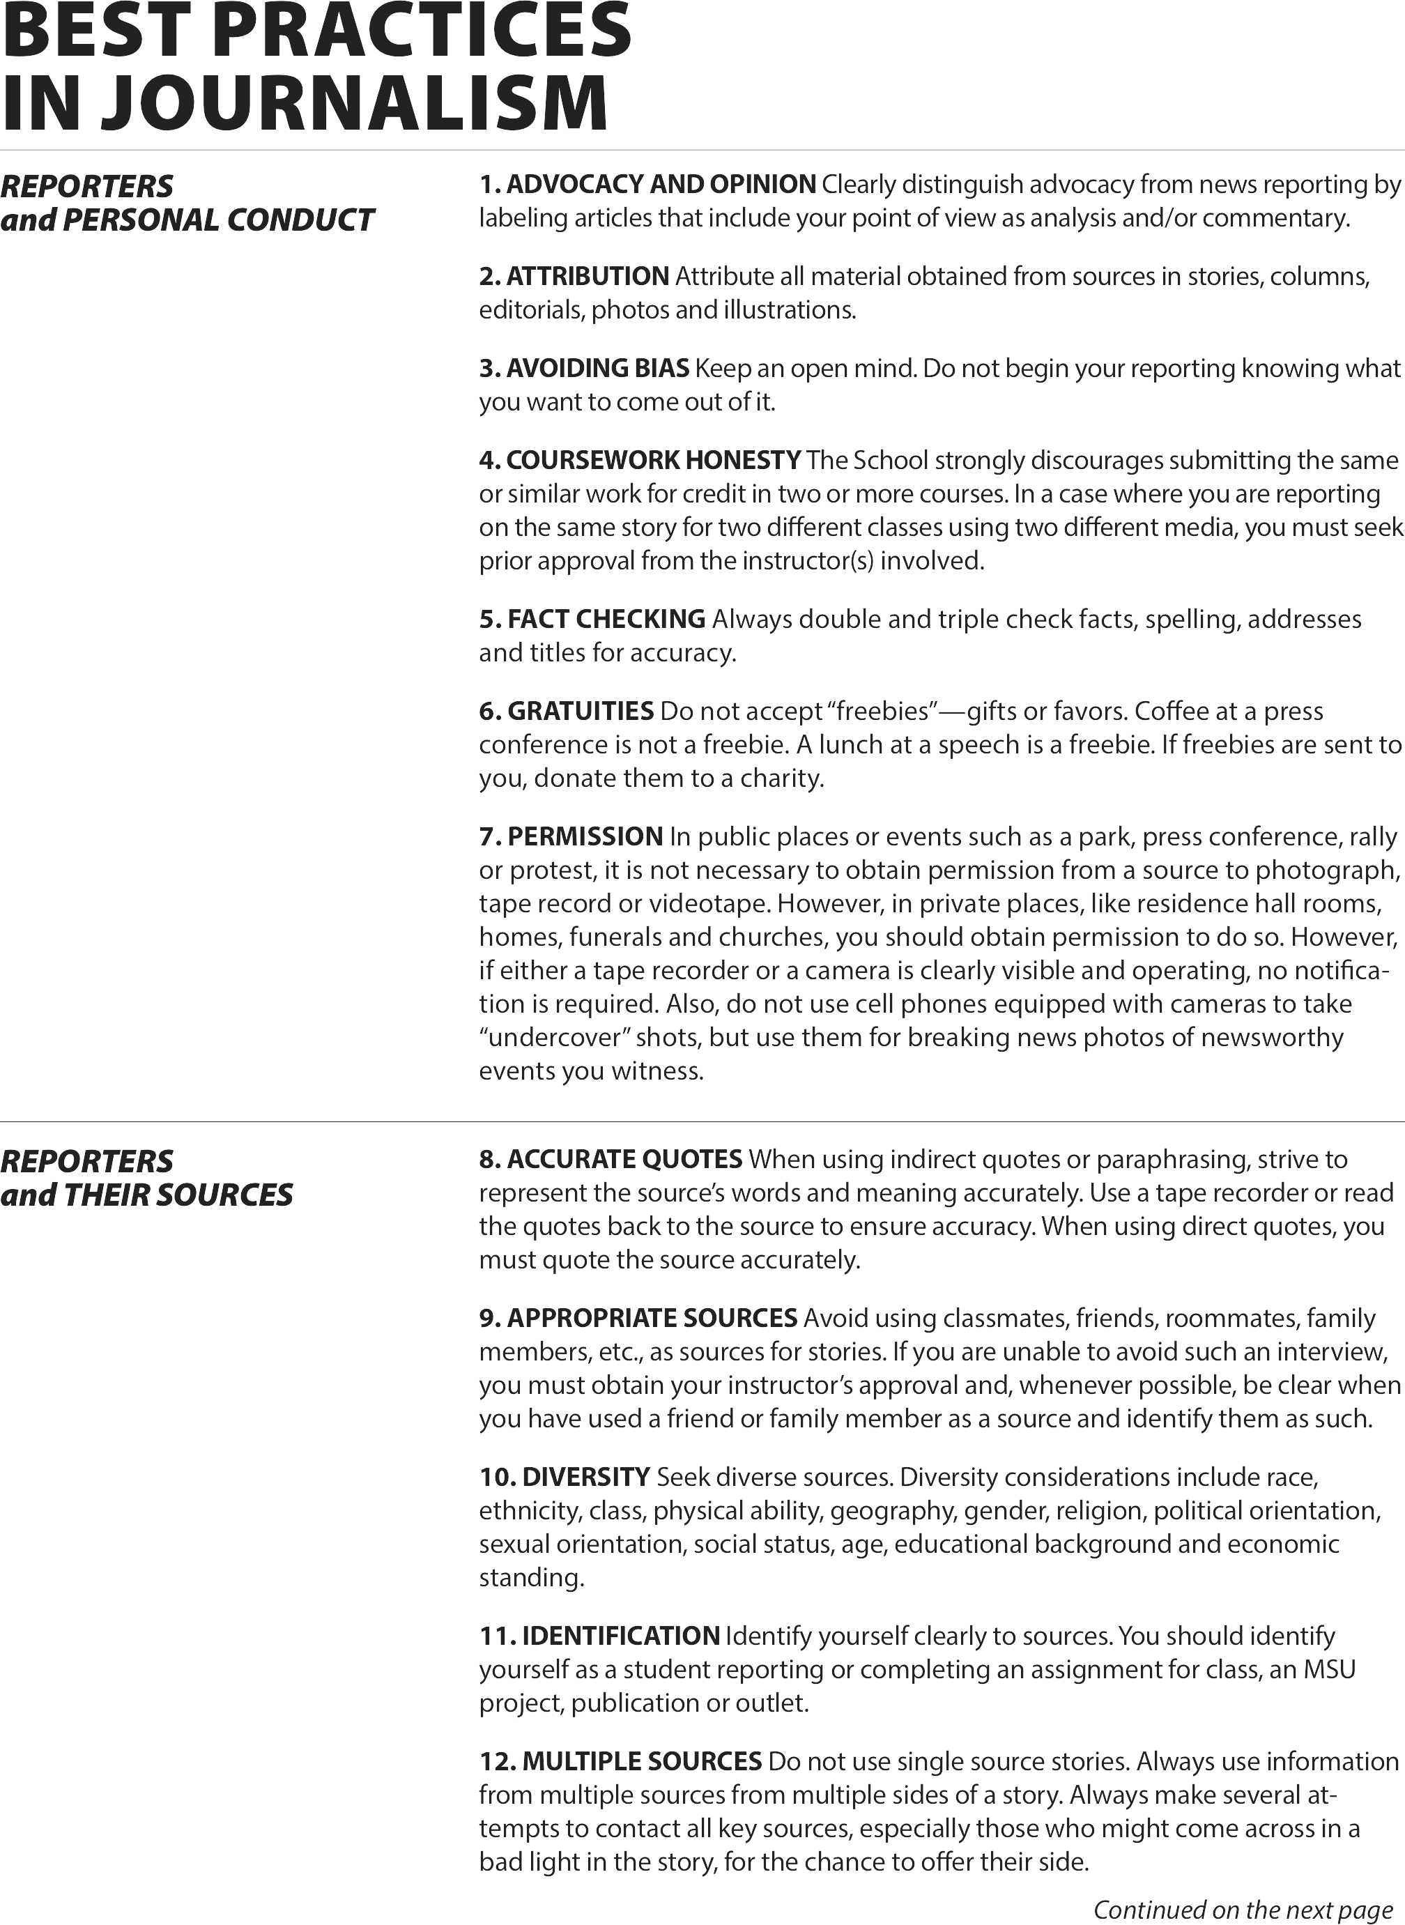

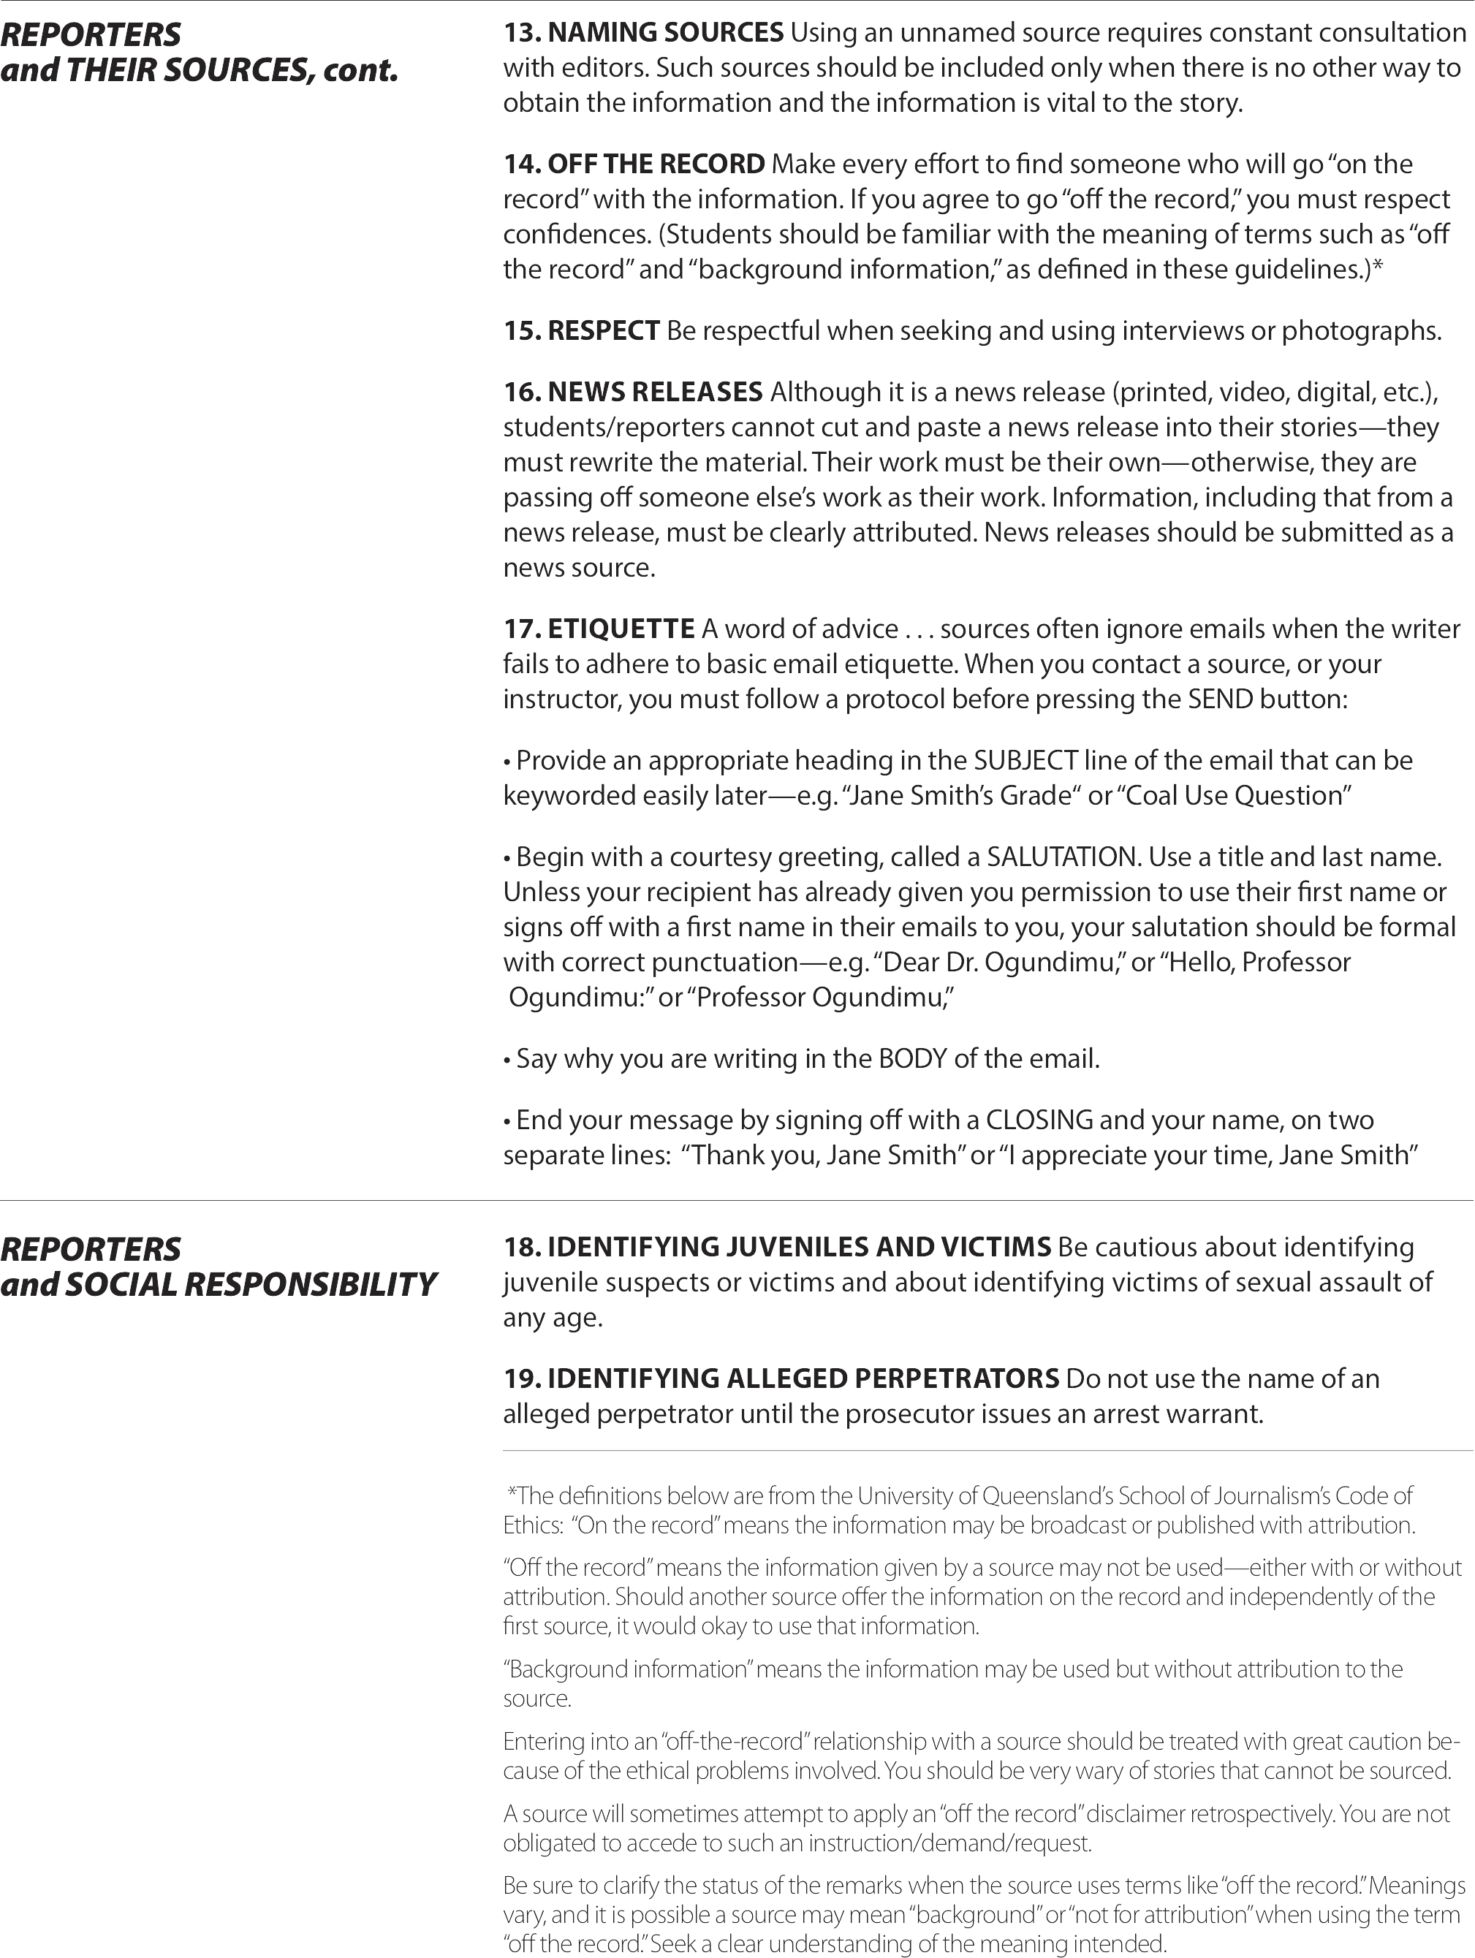

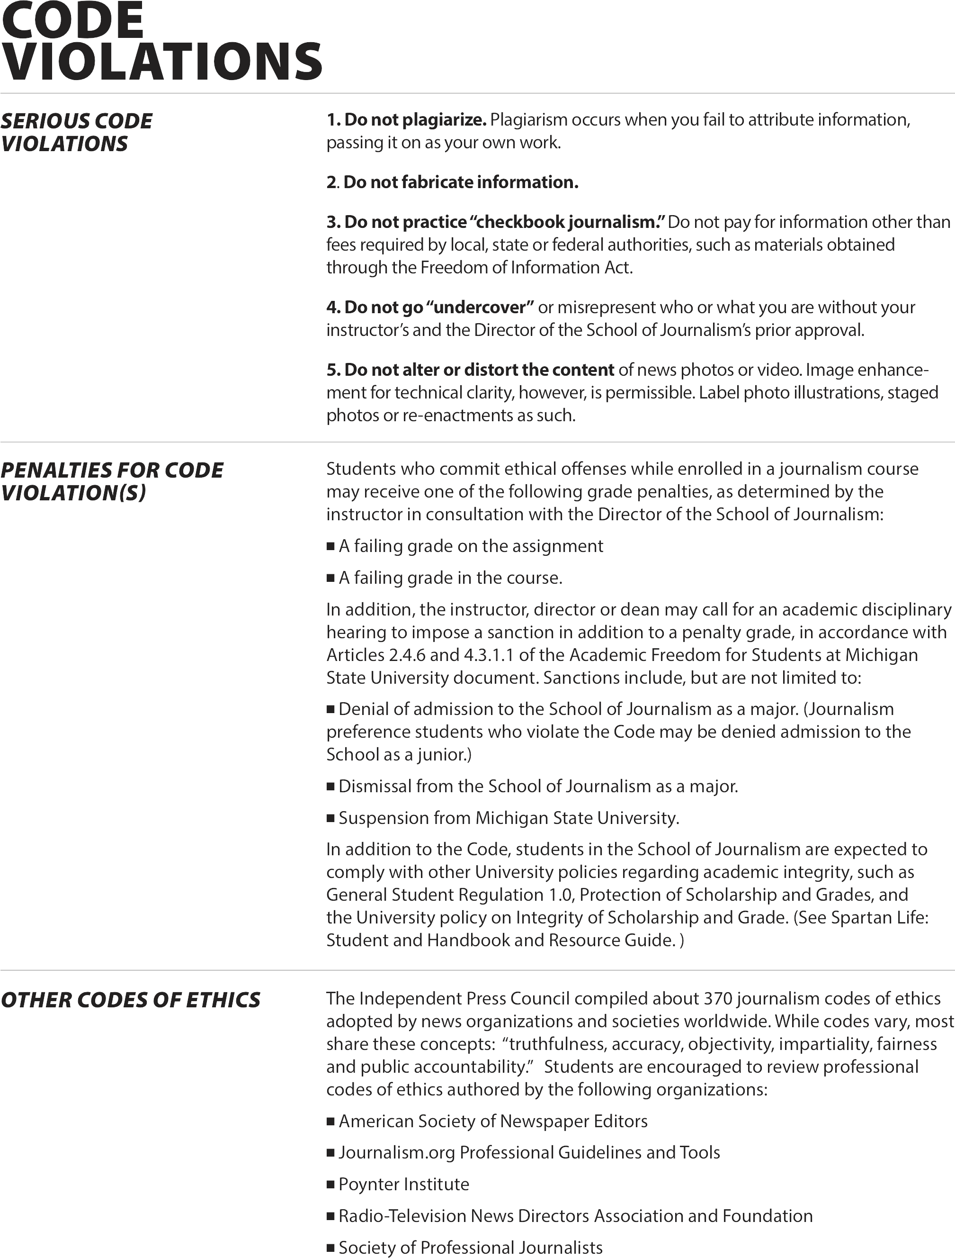

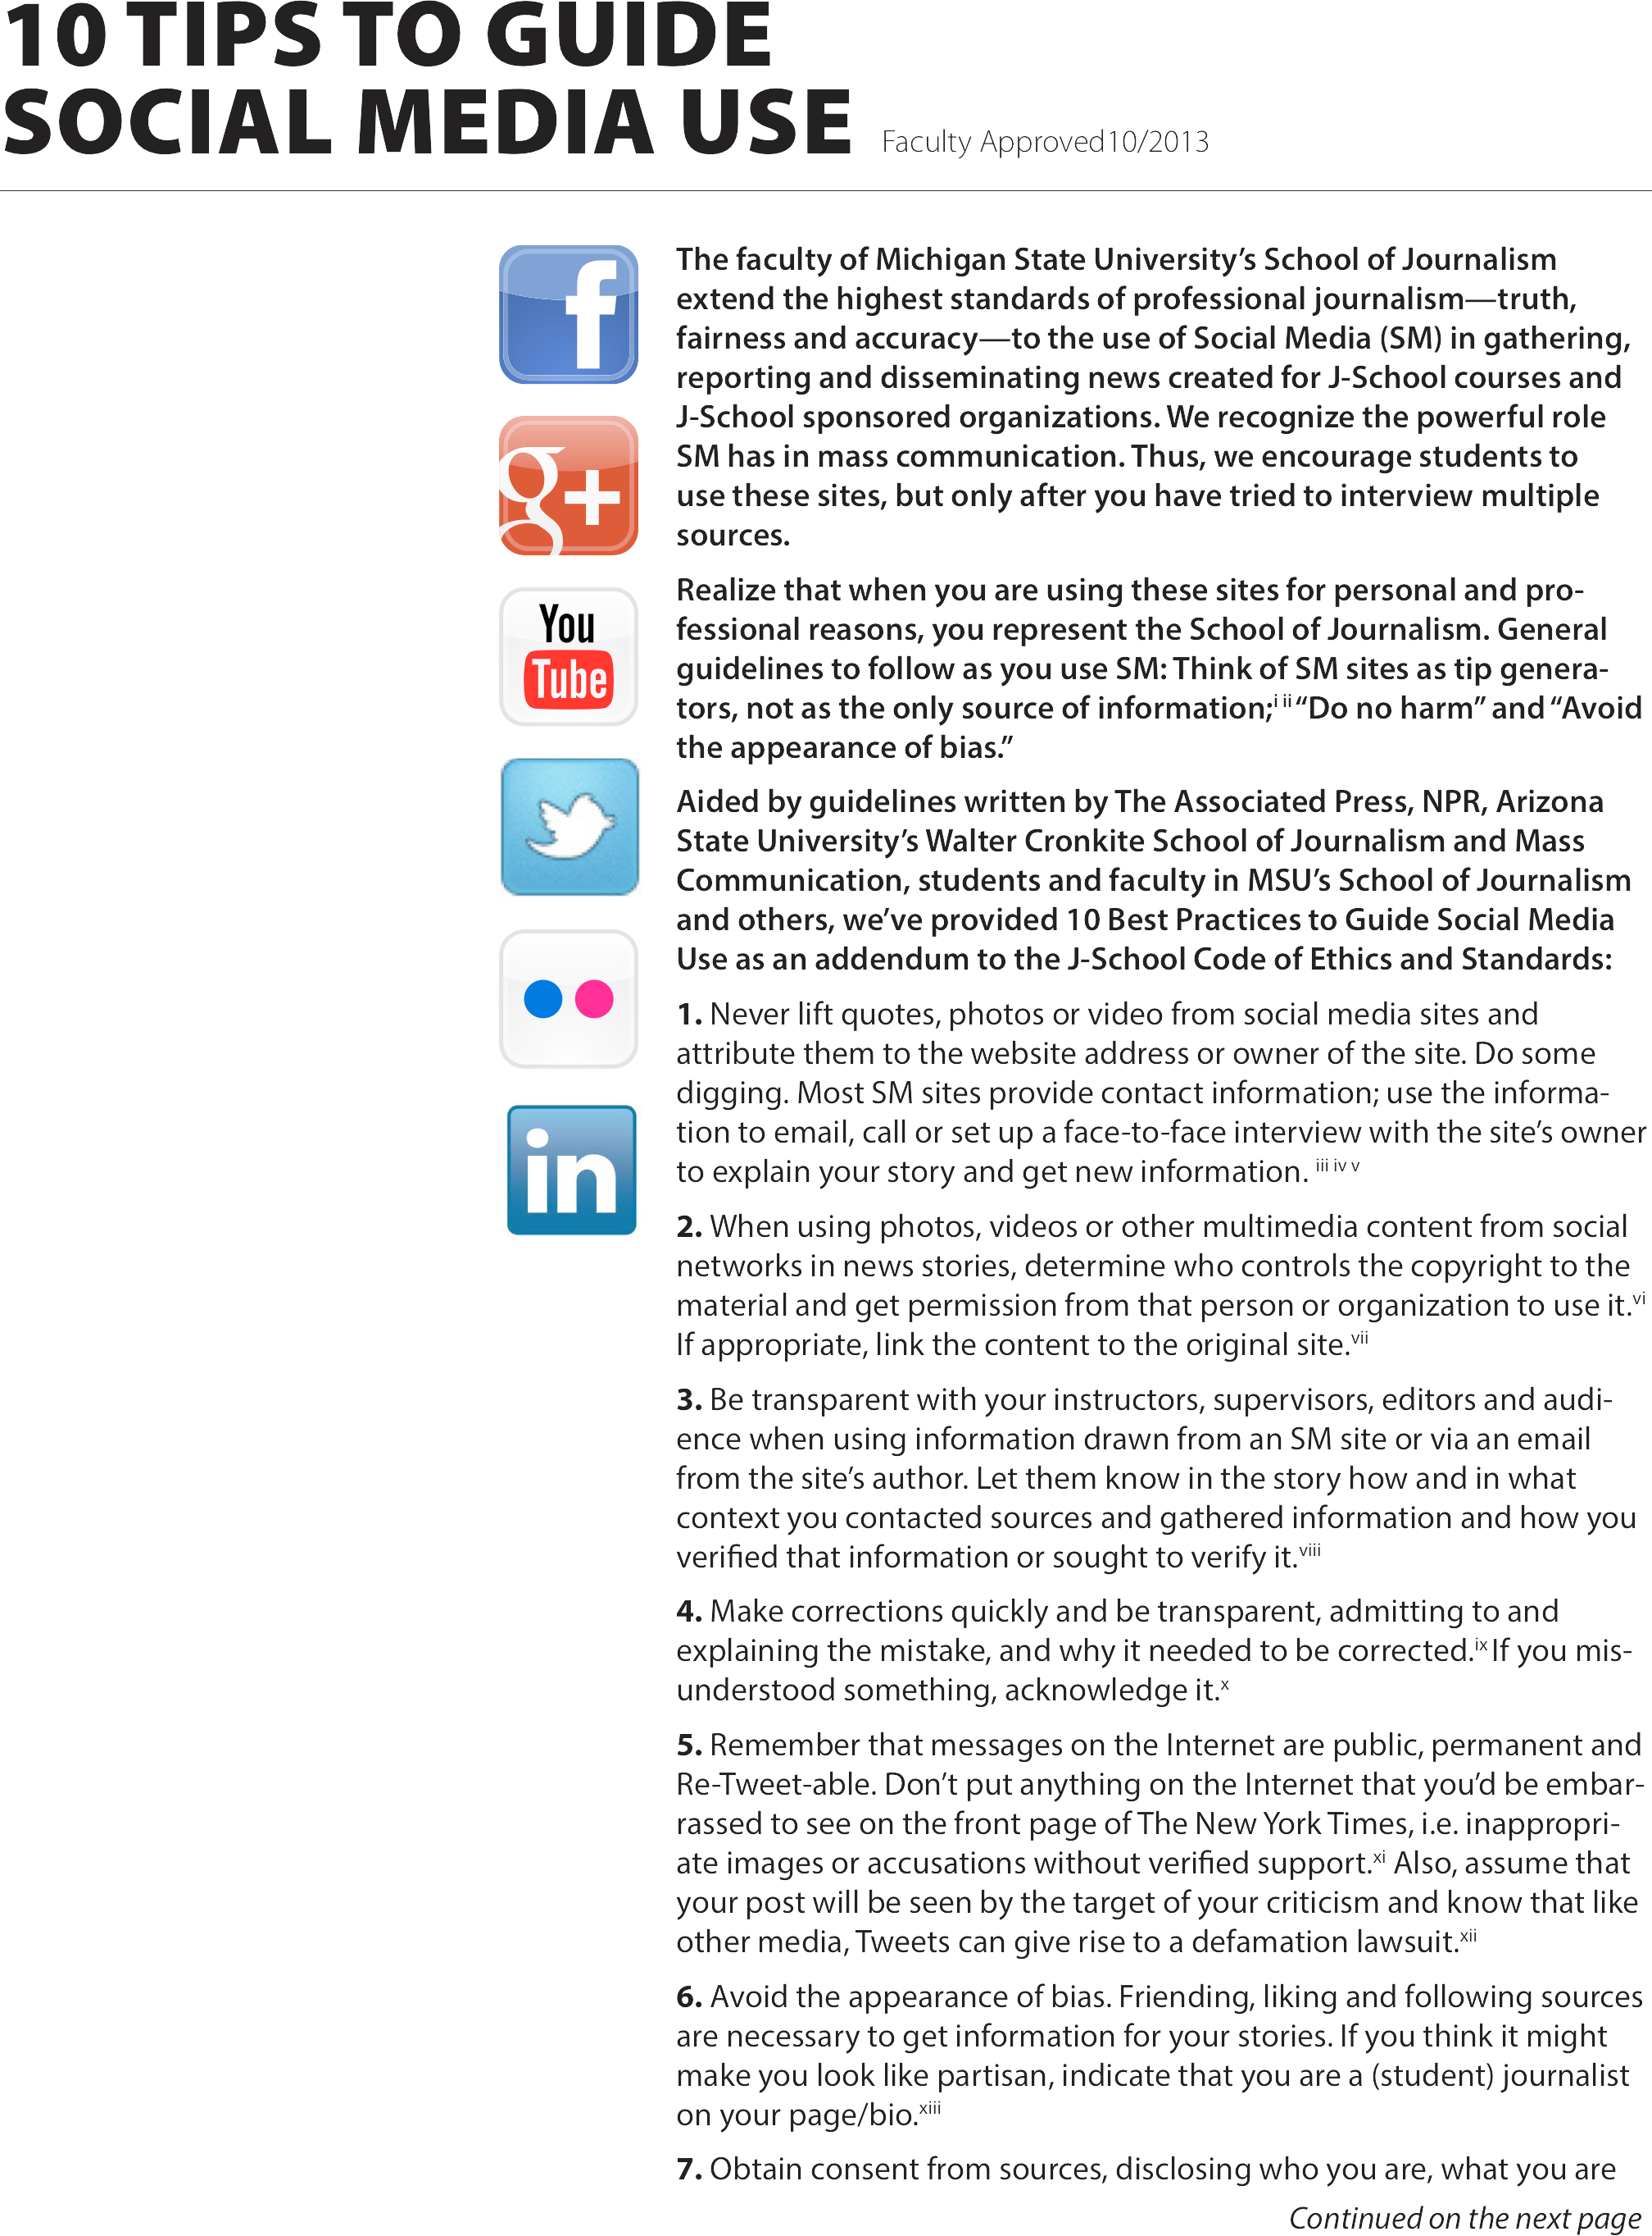

Appendix 6

College of Communication Arts and Sciences Michigan State University
Policy Regarding Training in the Responsible and Ethical Conduct of Research¹

Background:

Michigan State University (MSU) College Communication Arts and Sciences (CAS) strives to foster a research environment of ethical and responsible research conduct. CAS discourages research misconduct, and responds promptly to allegations or evidence of possible research misconduct. This document outlines the CAS policy on training and regulation of integrity in research and publication.

The Federal and Michigan State University Offices of Research Integrity outline procedures to help ensure the quality and integrity in research. These bodies recommend a combination of self-regulation, adherence to individual and professional standards, and reference to research traditions and best practices that characterize academic research institutions.

Purpose:

This policy is to establish a plan for complying with Section 7009 of the America Creating Opportunities to Meaningfully Promote Excellence in Technology, Education, and Science (COMPETES) as implemented by the National Science Foundation (NSF) and the NIH Responsible Conduct of Research Notice (NOT- OD-10-019), to provide training and oversight in the responsible and ethical conduct of research to undergraduate, graduate, and postdoctoral researchers supported by NSF and NIH funding to conduct research and research-related activities. Adherence to this policy is also strongly recommended for individuals from CAS who engage in any type of research activity.

Responsible Conduct of Research is defined as conducting research in ways that fulfill the professional responsibilities of researchers, as those responsibilities are defined by their professional organizations, Michigan State University (MSU) and, when relevant, governmental and other entities that support and regulate research. Research integrity is defined as the quality of possessing and steadfastly adhering to high professional principles, standards, and obligations, as prescribed by professional organizations, MSU, and, when relevant, governmental and other entities that support and regulate research. Research Ethics is defined as the critical study of the moral problems associated with, or that arise in the course of, pursuing research.

Applicability:

This policy applies to the following individuals, henceforth referred to as "Researchers":

- Undergraduates, graduate students, and postdoctoral researchers supported by NSF funding to
conduct research and research-related activities² .
- Scholars receiving NIH Institutional Research Training Grants, Individual Fellowship Awards, Career Development Awards (Institutional and Individual), Research Education Grants, Dissertation Research Grants, or other grant programs with a training component.
- Graduate and postdoctoral students working on research activities in CAS. ³

Un iv e rs it y Res ou rc e s

Graduate School Resources
- Diversity, equity, & inclusion programs
- Events
- Forms
- Funding
- GradPlan
- Graduate life & wellness
- Mentoring
- Policy information

University Resources

- Burgess Institute for Entrepreneurship & Innovation
- DEI Training
- Facilities and Housing
- Inclusion & Intercultural Initiatives
- MSU Center for Statistical Training and Consulting
- MSU Culinary Services
- MSU Libraries
- MSU Writing Center
- OISS
- Olin Health Center
- RCPD
- RVSM, SARV, Bystander
- Student Affairs
- Support Services
- University Outreach & Engagement

