- Go to the website, https://admissions.msu.edu

- In the header, click “apply”

- Scroll down and click on “Graduate Applicants”

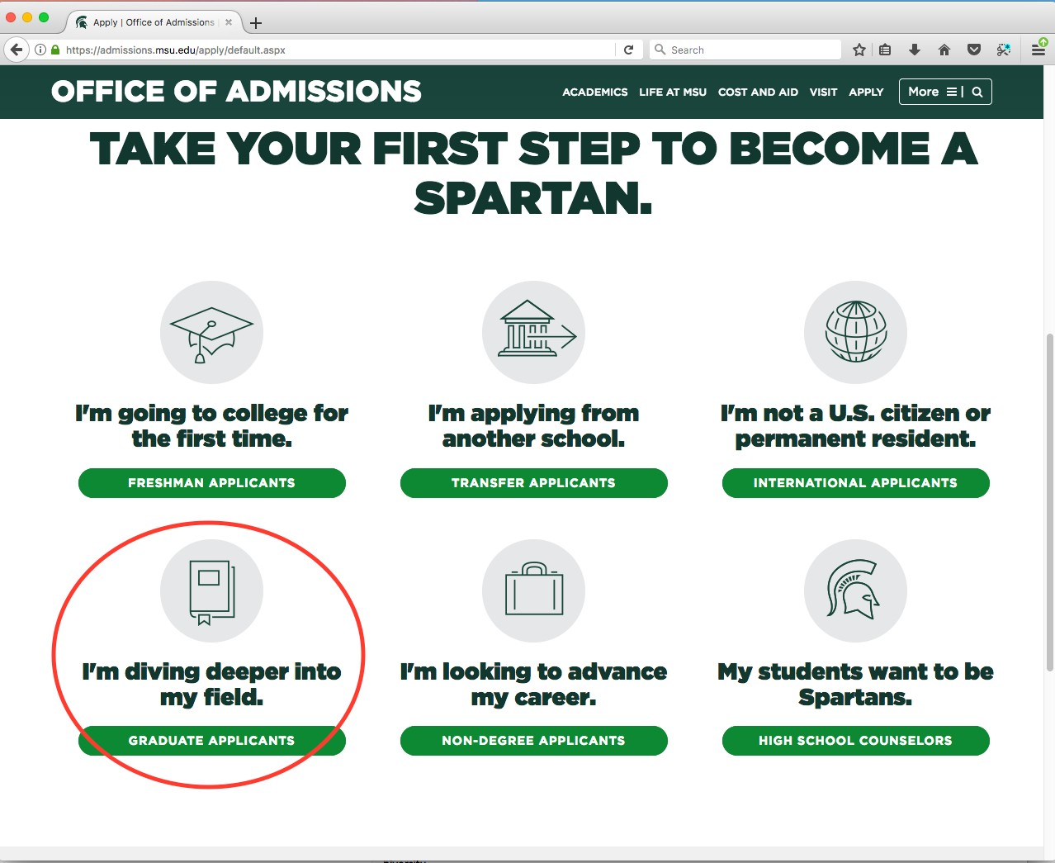

- Click “Start a graduate application”

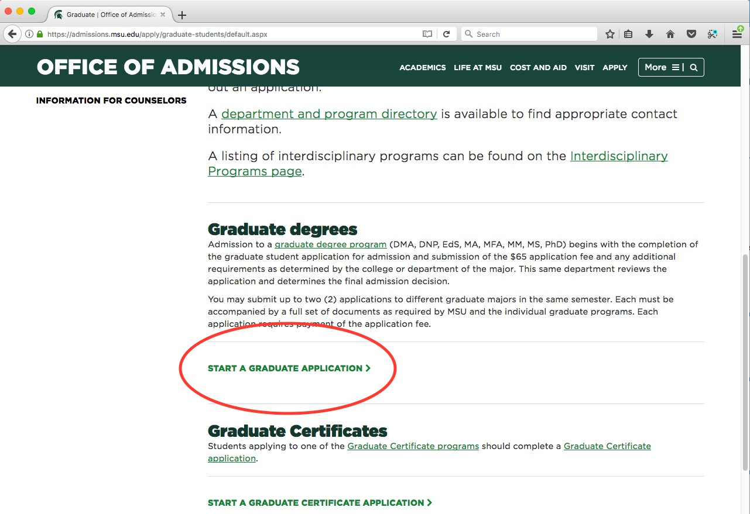

- Click “New application” (this is also where you will come to work on a saved application, if you cannot finish the form in one sitting)

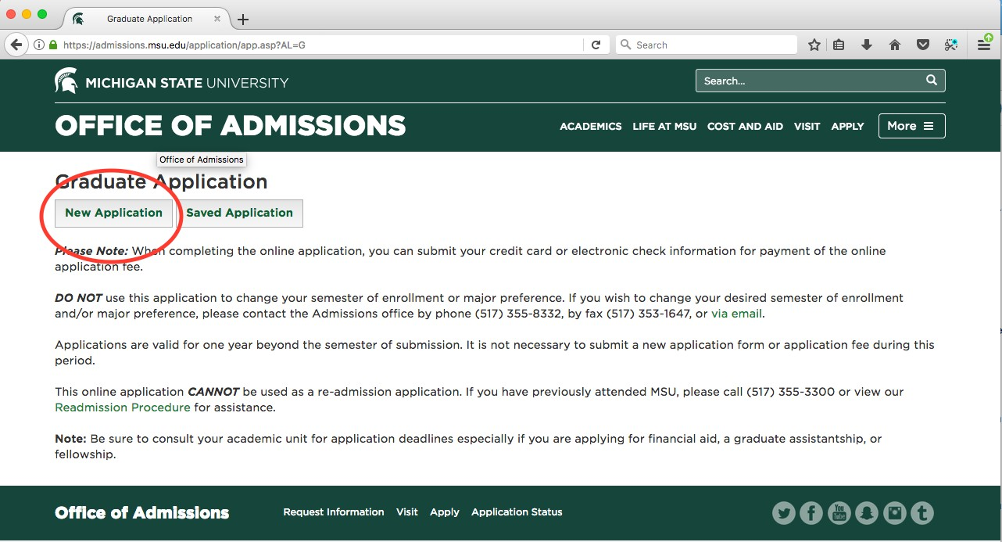

- Fill out the form with your personal and contact information, and click “I agree… Create my Application.” If you attended MSU before, use your PID (MSU personal identifier). If you have not attended MSU before, leave that field blank.

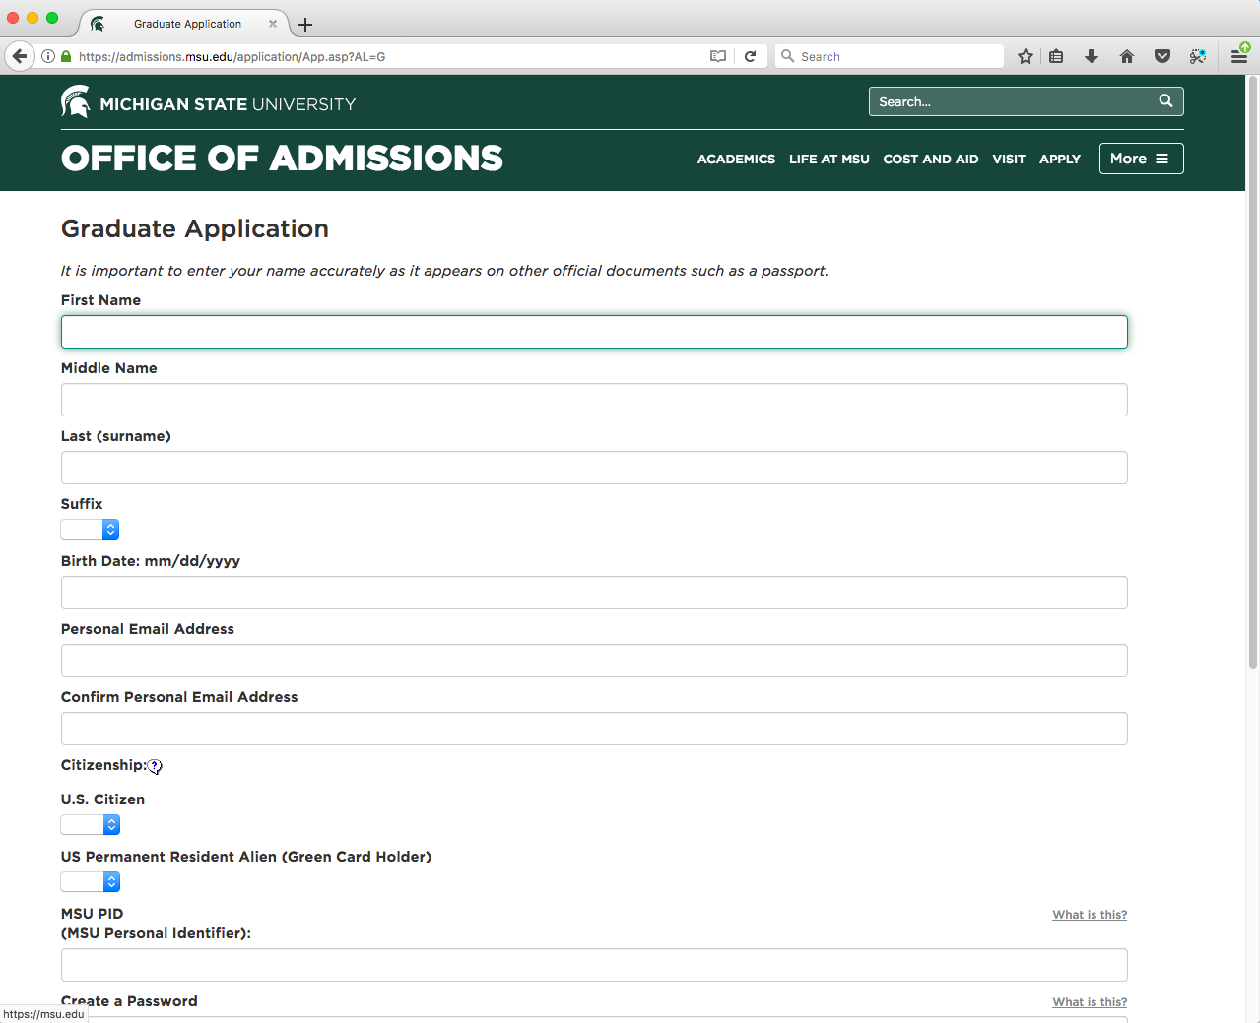

- Look for the email from MSU’s Office of Admissions. This email will contain your applicant ID, which you will use with the password you created in the “Create my Application” form to sign in and enter additional information.

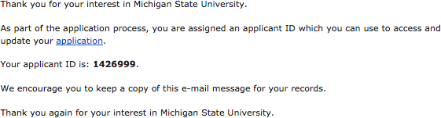

- In the application portal, you will see the sections of the application form as well as buttons that provide detailed instructions, save your application (it also saves automatically as you move between sections), and submit your completed application form. Click the blue speech bubbles for additional information about the form.

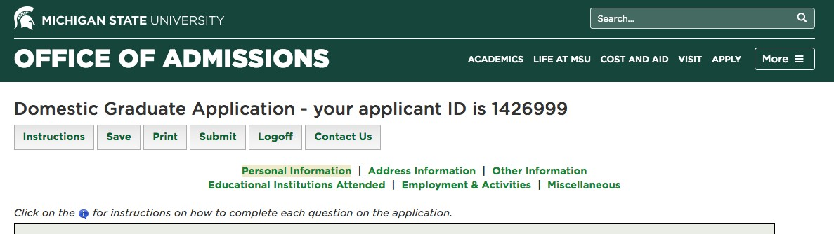

- Fill out the sections of the application form. NOTE: You do NOT need to provide answers to the “Departmental Questions”.

- When you are done filling out the six sections of the application, click submit. This will take you to a page where you can pay the $65 (domestic) or $75 (international) application fee. Your application will not be considered unless you pay the application fee. If you do not submit payment immediately, that is OK; just return to your saved application (via https://admissions.msu.edu/apply.asp) and hit “submit” again; that will take you to the payment links.

- Once you pay the application fee, it will take you to the next page where you'll see your full portal laid out. This is where you'll upload your personal and academic statements, and your resume as a “new material”.

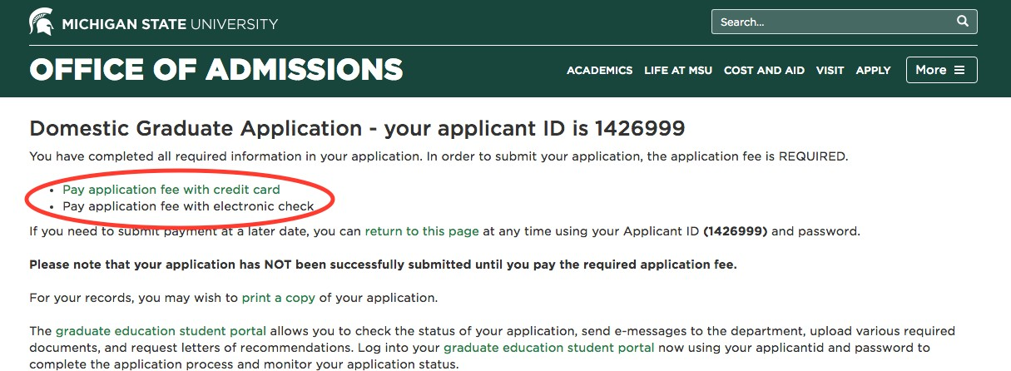

- Once your web application is complete, go to https://admissions.msu.edu/gradportal. This portal is where you will upload your resume (under “file uploads”), enter the contact information for
your 3 letter of recommendation writers, and upload your personal and academic statements
if you did not include them in your web application already (also under “file uploads”). For your recommenders, it is a good idea to ask them beforehand to write your letters, and let them know that a request is coming.
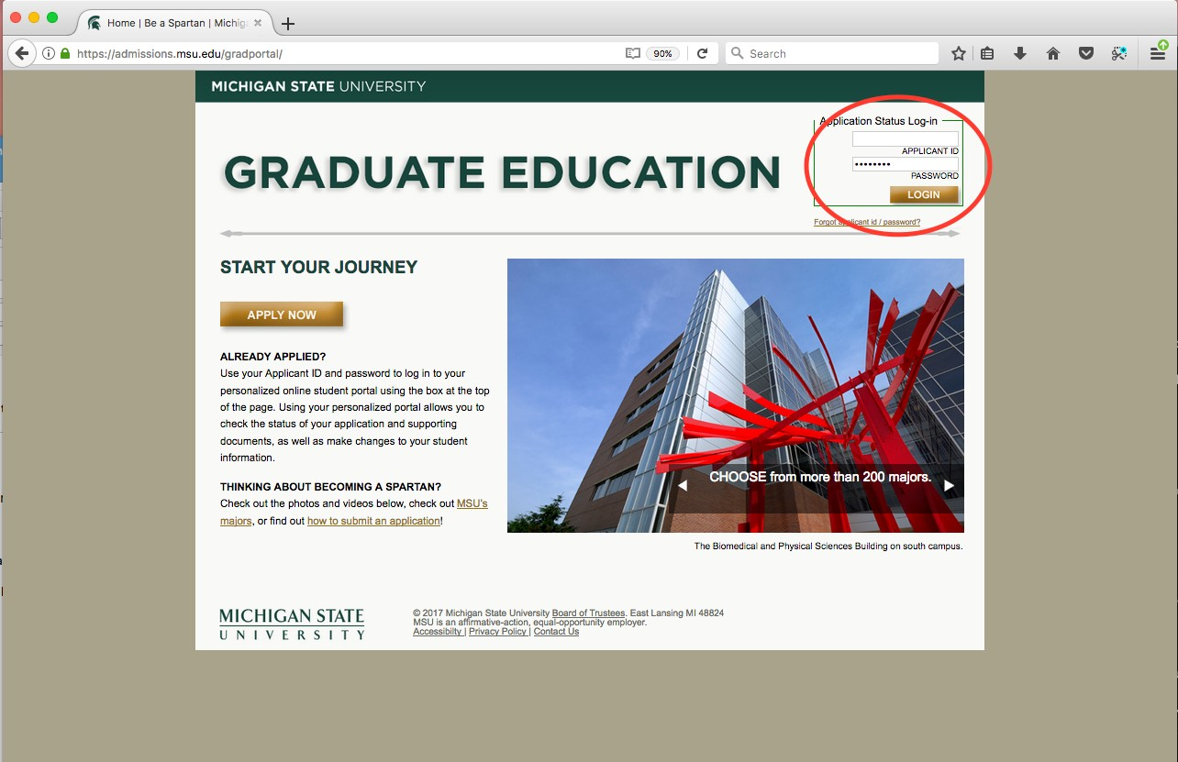
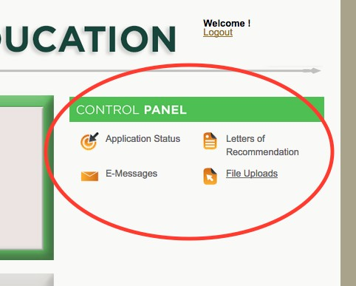

- Request official transcripts from your past colleges/universities and have them
electronically sent to stratcom@cas.msu.edu. After they're requested, we'll pull and upload to your portal for you.

If you have any questions, send an email to dippel@msu.edu.

MSU Strategic Communication Master’s Program Application Checklist

- Completed and submitted web application form

- Paid application fee

- Uploaded Resume

- Submitted Personal and Academic statements

- Submitted email addresses for three letter of recommendation writers

- Requested transcripts to be sent electronically to stratcom@cas.msu.edu from previous higher education institution(s)

