MSU Graduate Application Aid

2021

This job aid provides an in-depth look at the student experience when applying to the Strategic Communication Online M.A. or Strategic Communication Graduate Certificates at MSU. The application is the same.

To begin the graduate application process:
Go to: https://explore.msu.edu/apply/
__________________________________________________________________

- First time users: Click on Create an Account
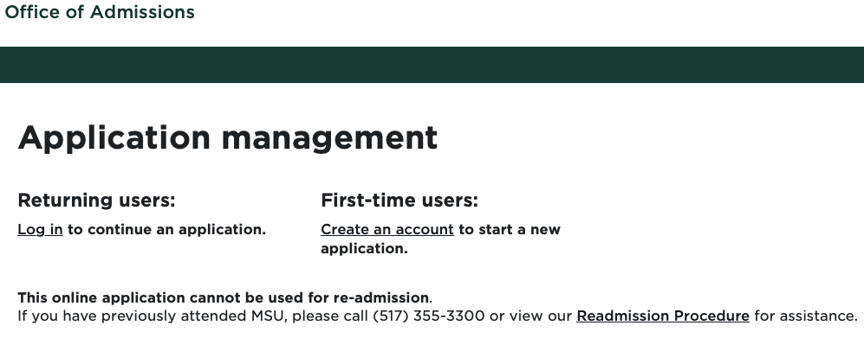
Image 1: Log in screen
___________________________________________________________________

- Enter email address, first name, last name, and birthdate. Click, Continue.
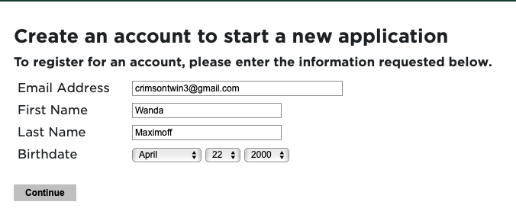
Image 2: Create an account Log In

- A temporary PIN was sent to your email address. Open your personal email address to find an email from Michigan State University, and enter the PIN, and confirm your birthdate.
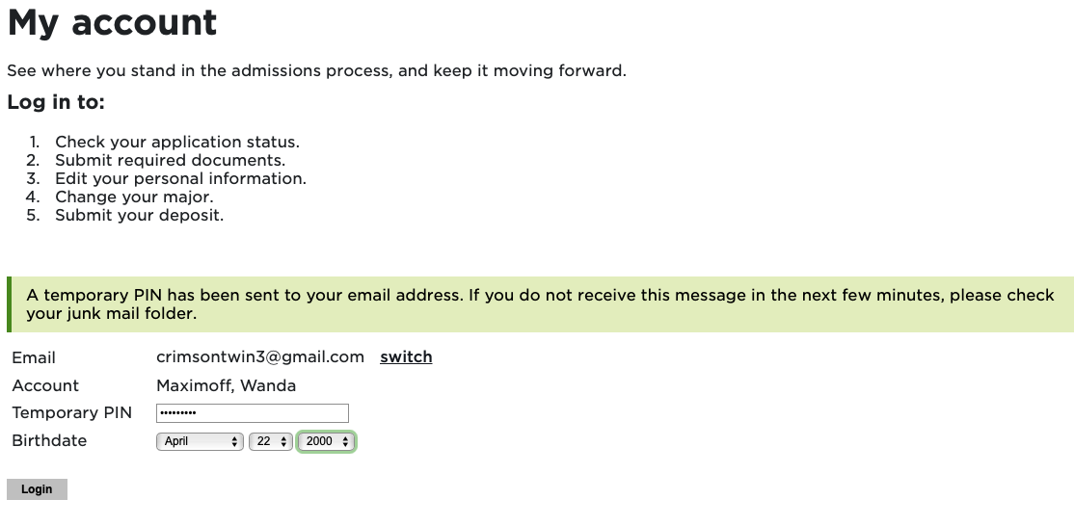
Image 3: Confirm account
__________________________________________________________________

- Create account password.
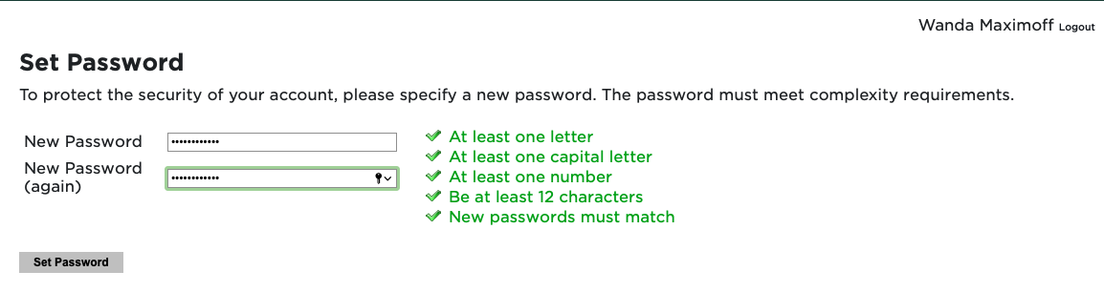
Image 4: Confirm account password

- Begin completing your application. Click on Start New Application

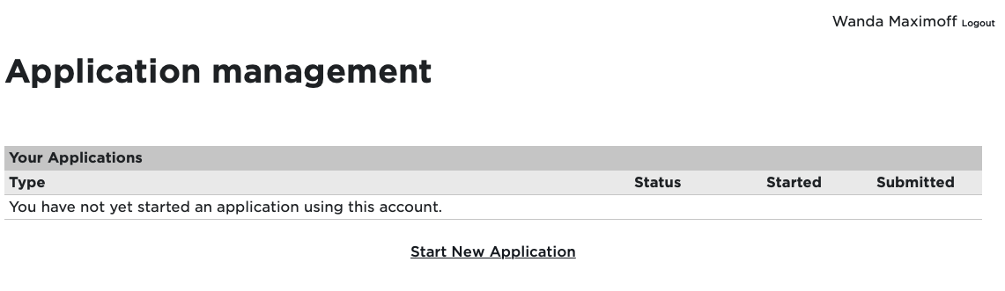
Image 5: Start New Application
___________________________________________________________________

- Choose the type of application (Graduate) then select Create Application.
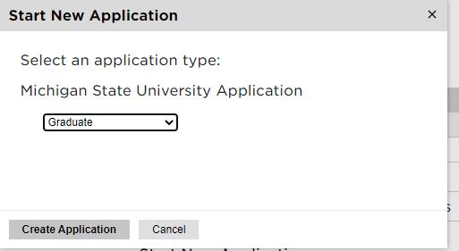
Image 6: Create Application

- Next, provide Personal Background information

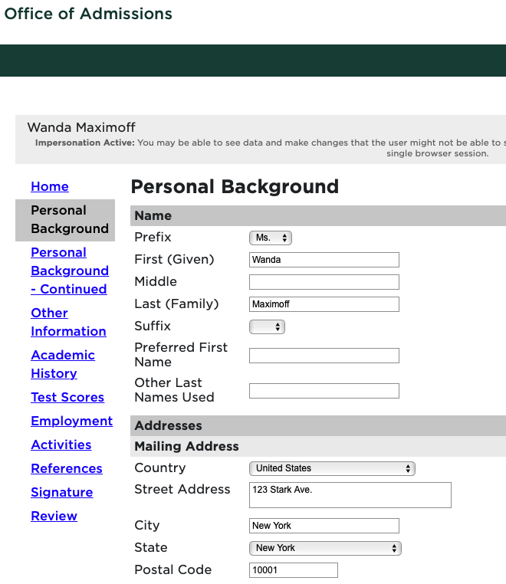
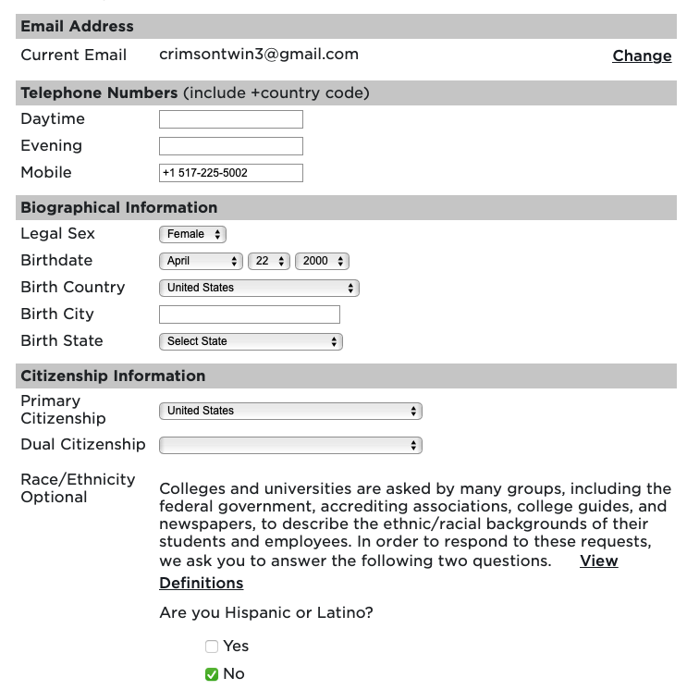
Image 7 and 8: Personal Information
Once all information is completed, select Continue.
___________________________________________________________________

- Complete additional information on the Personal Background – Continued section

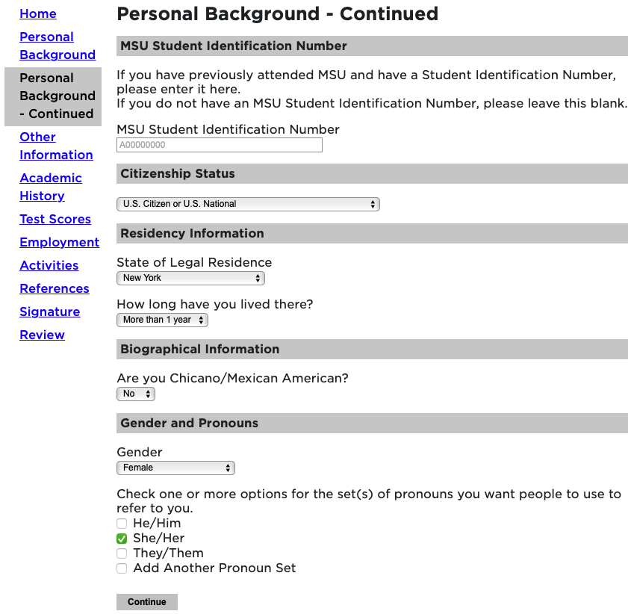
Image 9: Personal Information continued
Once all information is completed, select Continue.

___________________________________________________________________

- Complete additional information about Enrollment Information, Communication preferences, and Financial Aid. When selecting your major preference, please select “Strategic Communication (Online Program) (Masters)” even if you are applying to one of the MSU StratCom certificates. If you apply to a certificate, please email Jason Archer, program director, at jason@msu.edu with the certificate you’d like to pursue.
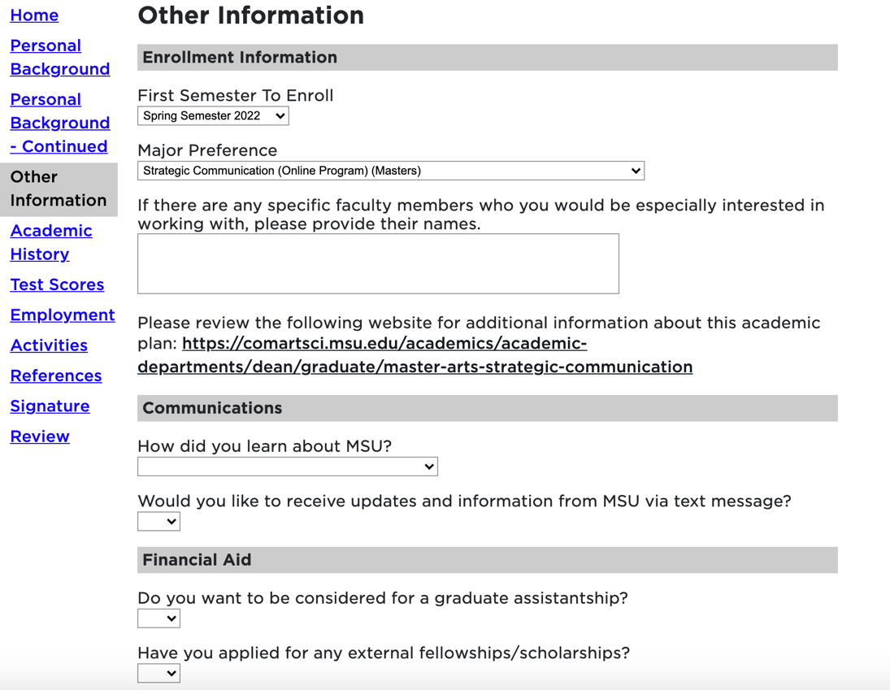
Image 10: Other Information

Personal Statement and Academic Statement: To add your files, begin by clicking on Choose File. Locate your file from your device and click Upload.
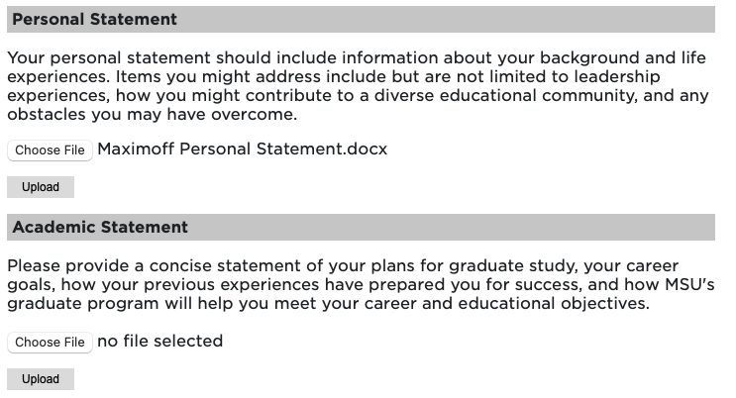
Image 11: Statements
__________________________________________________________________

- COVID-19: If you would like MSU program staff to know information regarding hardships or your experience during the COVID-19 outbreak.
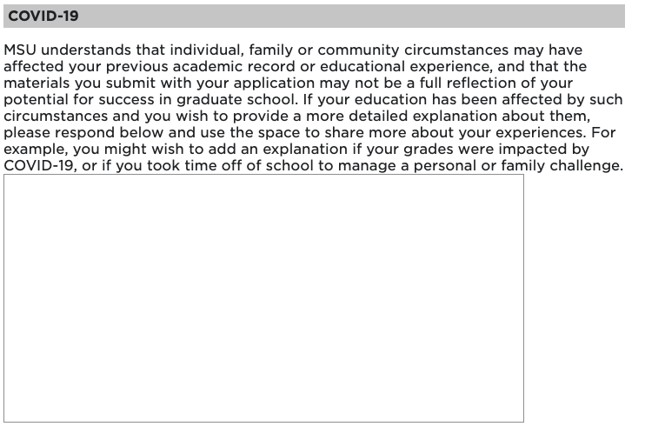
Image 12: COVID-19

- Complete the required Conduct Questions
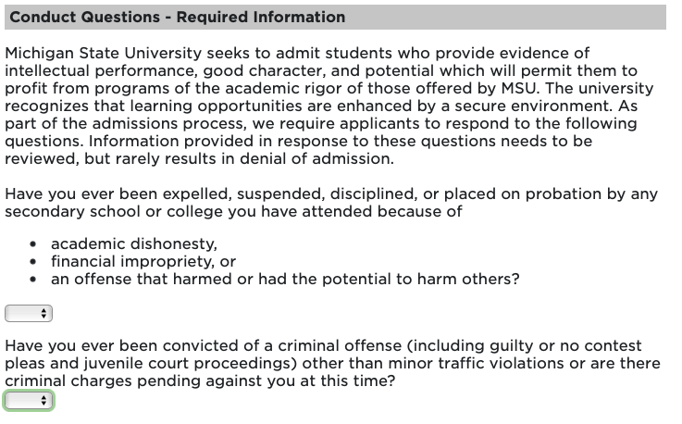
Image 13: Conduct Questions

Once all information is completed, select Continue.
___________________________________________________________________

- Include all Academic History Information. To begin: click on Add Institution.

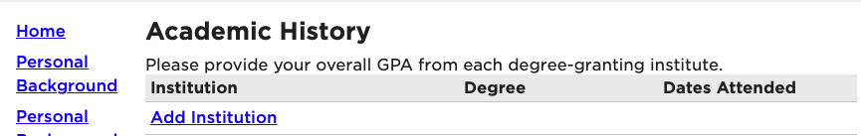
Image 14: Add your previously attended institutions

Next, begin typing in the name of the previously attended university, and it will populate all the institution information.
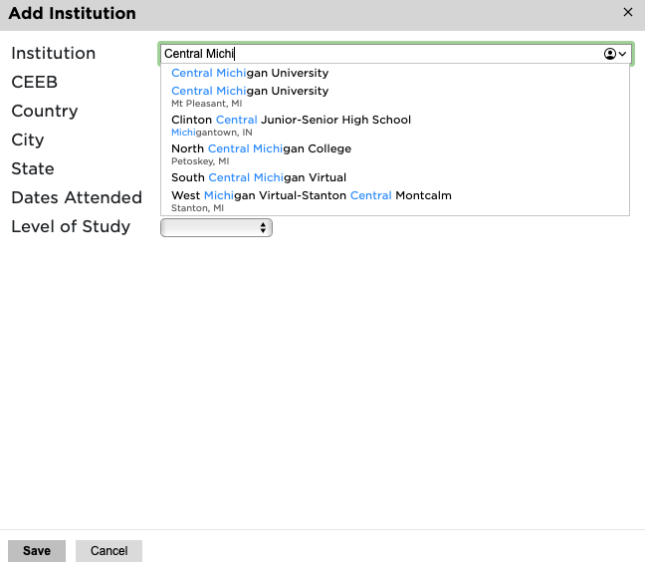
Image 15: Add previously attended institutions

Add the Dates Attended and Level of Study, Degree, Major, etc. Then click Save.

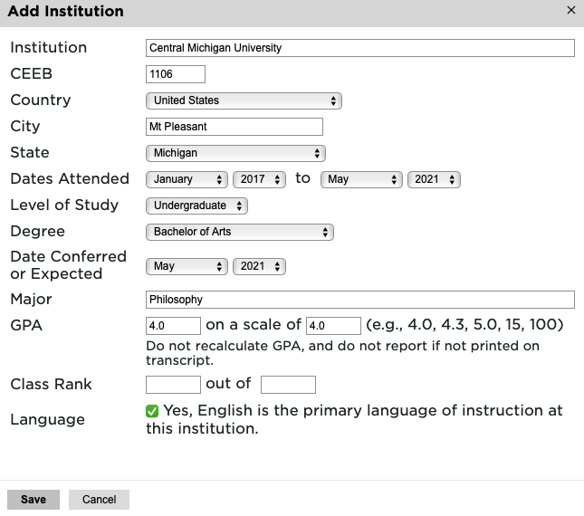
Image 16: Add dates attended, degree, major
___________________________________________________________________

- Test Scores: NOTE: MSU StratCom does NOT require the GRE or GMAT. You can skip this section, unless you’re entering proof of English language proficiency.
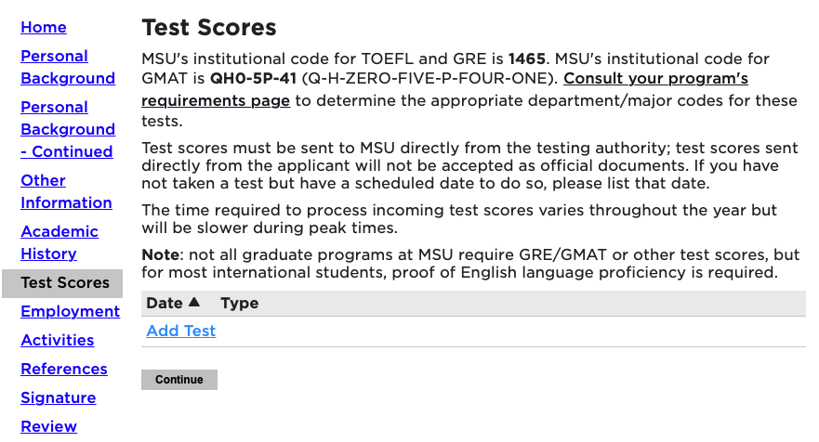
Image 17: Add Test

Next, choose the type of test that you’d like to add. Example: GRE

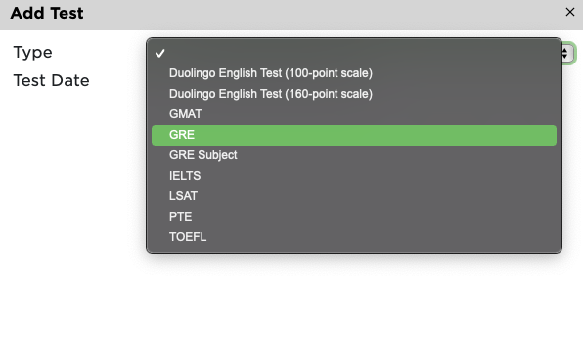
Image 18: Choose Test to add to application

Enter your Test results.
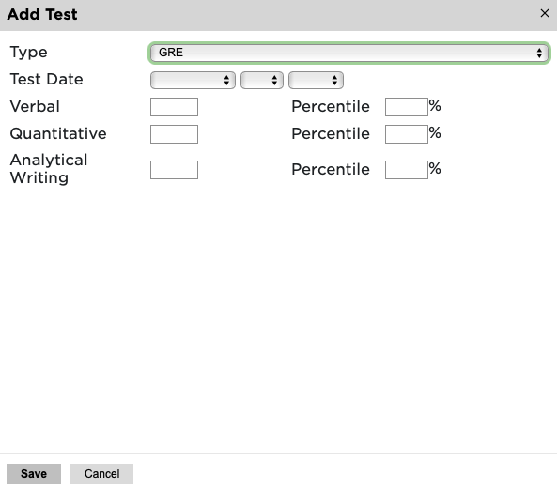
Image 19: Add Test results
___________________________________________________________________

- Employment: To begin adding your employment history, select Add Employer.
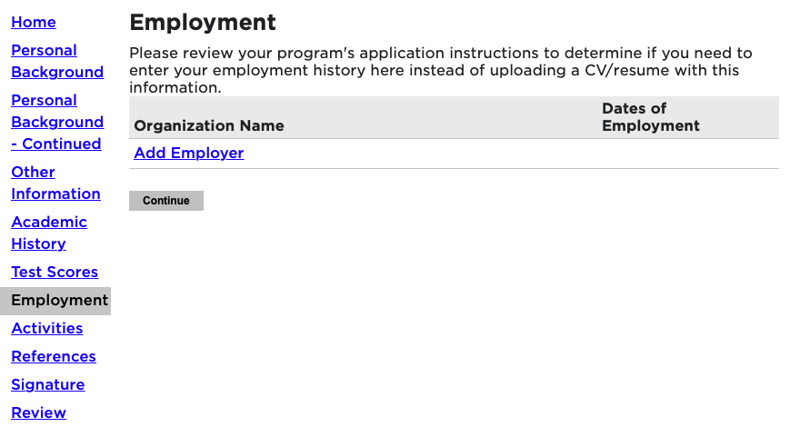
Image 20: Add Employment history

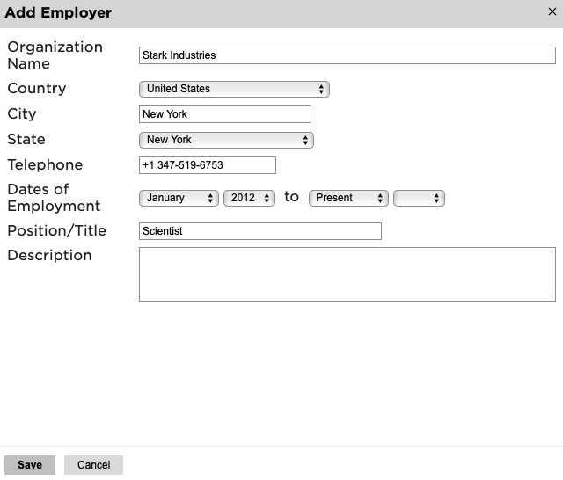
Image 21: Add Employer information

Once all employer information is added, click Save.
Continue adding employment information and click Continue to complete employment history.

___________________________________________________________________

- Activities: If your program requires activities or experiences prior to graduate school, please include that information by selecting Add Activity. You can also upload your résumé or curriculum vitae.

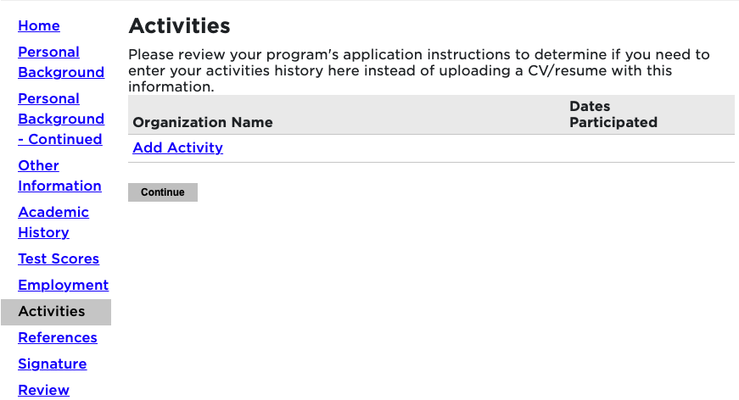
Image 22: Add Activity
Complete the information to add an activity.
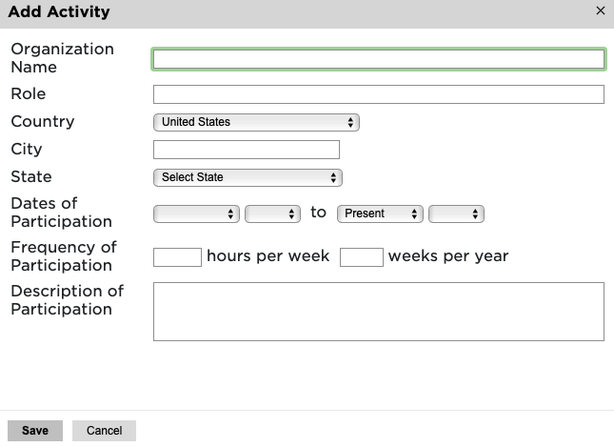
Image 23: Add activity
- References: To obtain letters of recommendation, please add your recommender's information by selecting Add Recommender.

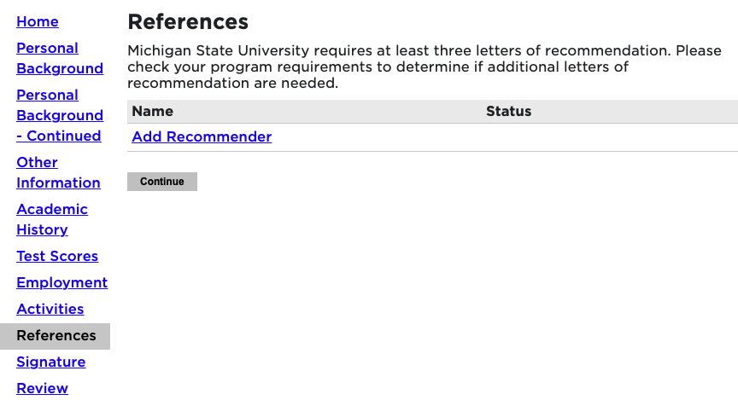
Image 23: Add Recommender
Include all contact information for your recommender. Most graduate programs require three letters of recommendation. Make sure to include all three recommenders. Example below:
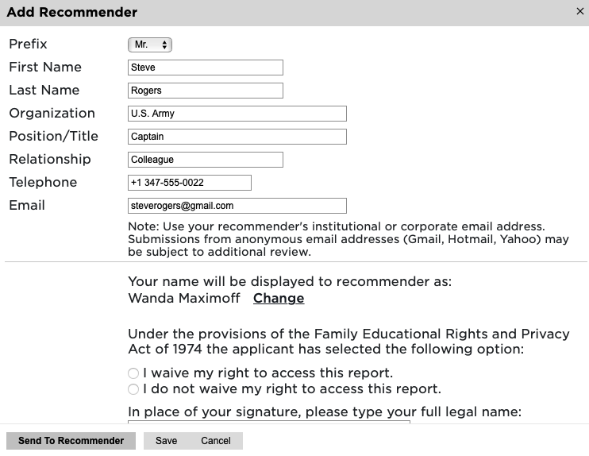
Image 24: Add Recommender information
Once you’ve completed the contact information, selected the waiver decision, and typed your full name as a signature, select Send to Recommender (or click Save to enter details at another time). By choosing Send to Recommender, the system will generate an email to your recommender that will provide details for how to submit their letter.
**Students will need to include 3 letters of recommendation for the graduate application.

- Provide your signature electronically by typing in your full legal name, then select Confirm.

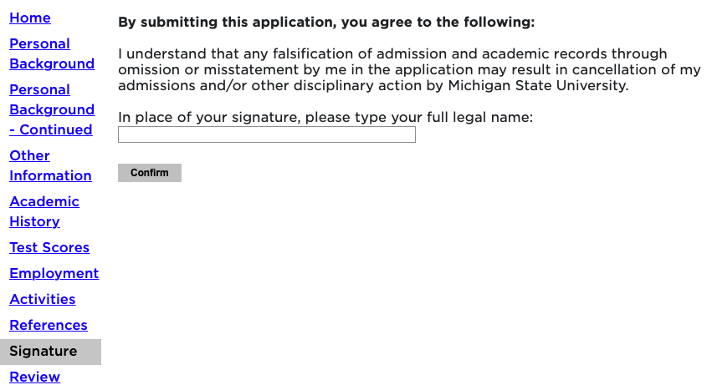
Image 25: Include your electronic signature
___________________________________________________________________

- The Review section will provide you with a list of potential errors if a section has not been completed. Please make sure to return to those sections and make the appropriate corrections before finalizing the application and submitting your payment.

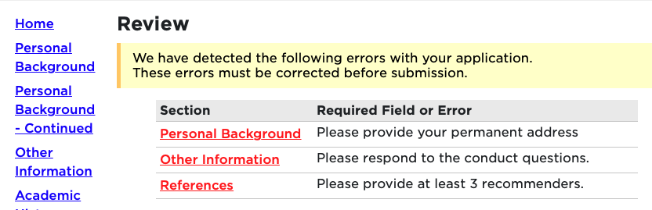
Image 26: Review and update any remaining details for the application.
- Once you have finalized your application, you will now complete the payment. Click on Submit Payment.
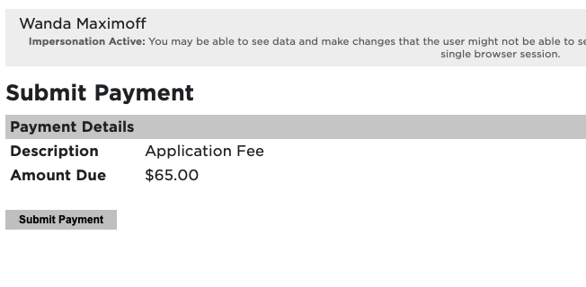
Image 27: Submit payment
Review the information and click on Continue.
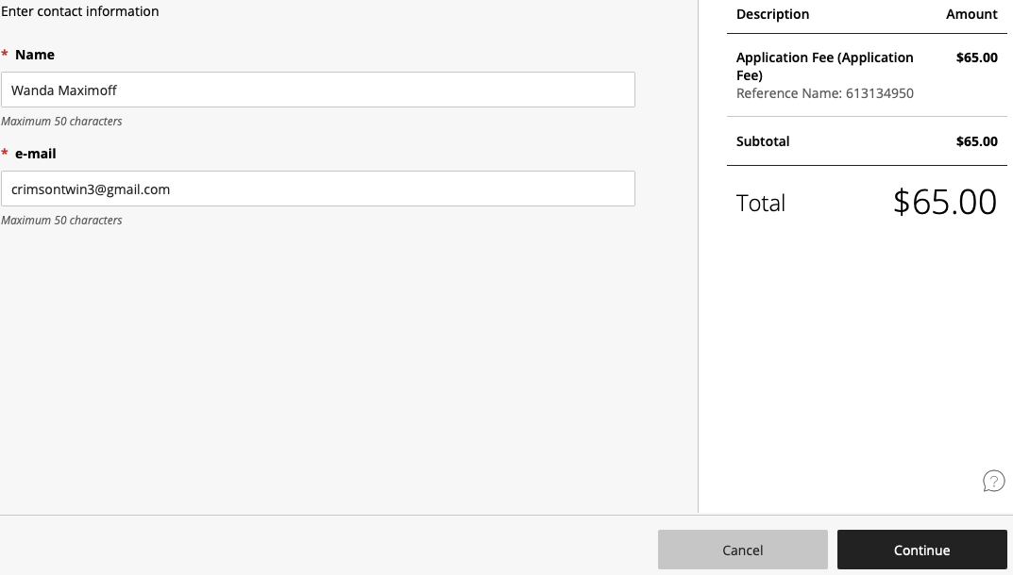
Image 28: Review payment submission information

Next, choose your method of payment (Apple Pay, Credit/Debit card, or Bank account Information).
Enter all information required and click Continue.

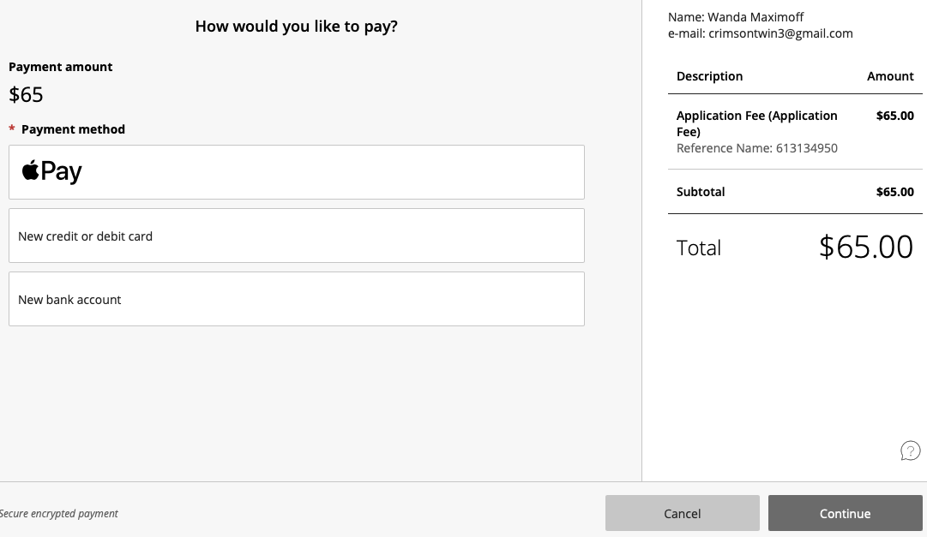
Image 29: Add payment information

Select Continue to confirm your payment has been submitted.

Students will receive an email from Michigan State University confirming the application has been submitted.
_________________________________________________________________

Final Steps:
Over the next few days and weeks, students can now log in to the student portal to review your application status updates, by going to https://explore.msu.edu/apply/. Choose the Returning Users: Log In link.
